Loading

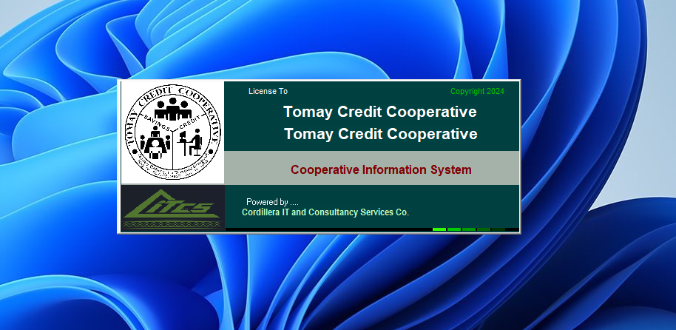

Login Page

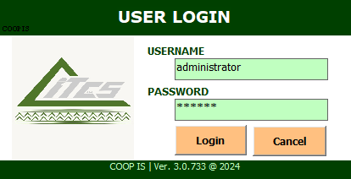

Landing Page

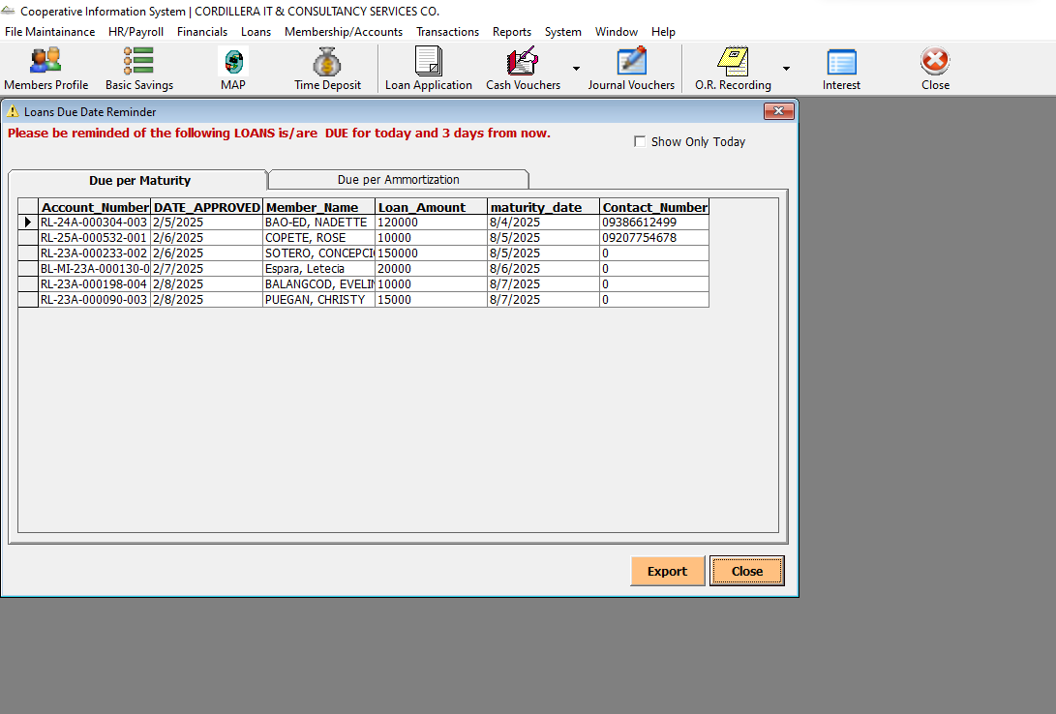

Landing Page -> Due per Amortization

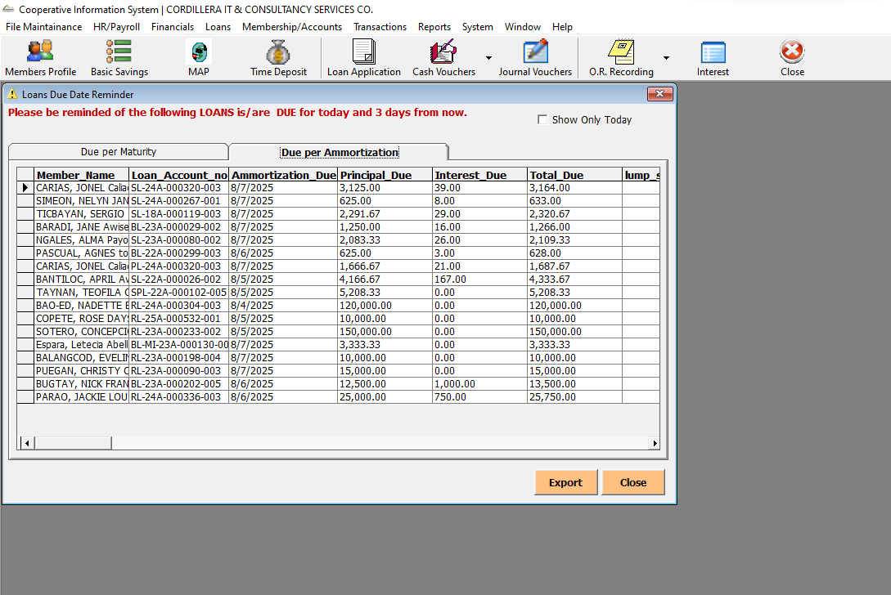

File Maintenance -> Account Type

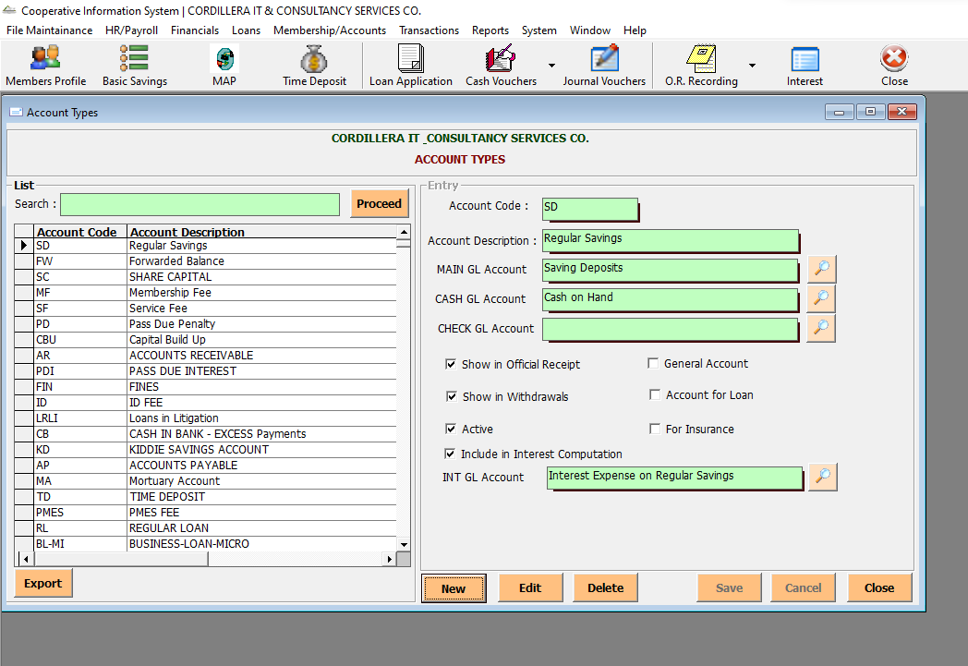

File Maintenance -> Share Capital Setup

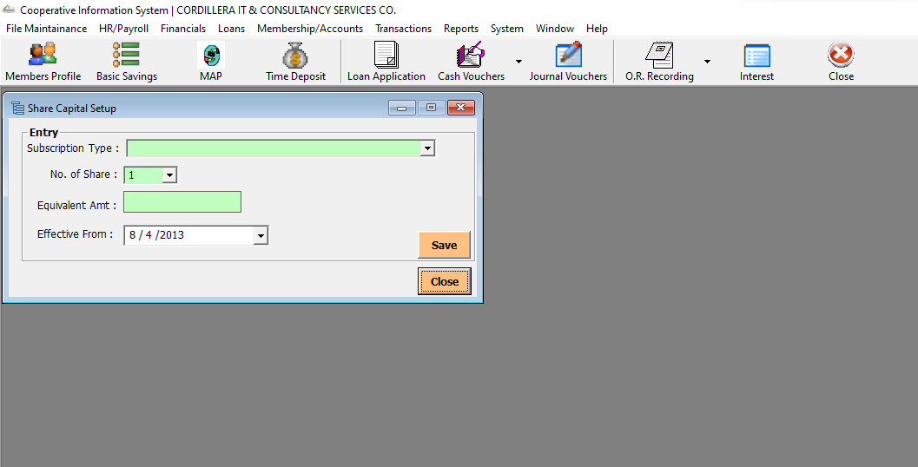

File Maintenance -> Time Deposit Matrix

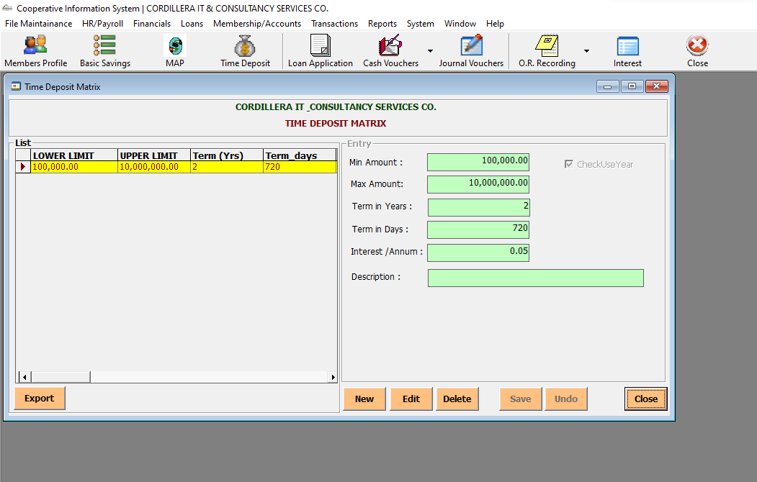

File Maintenance -> Interest Rates

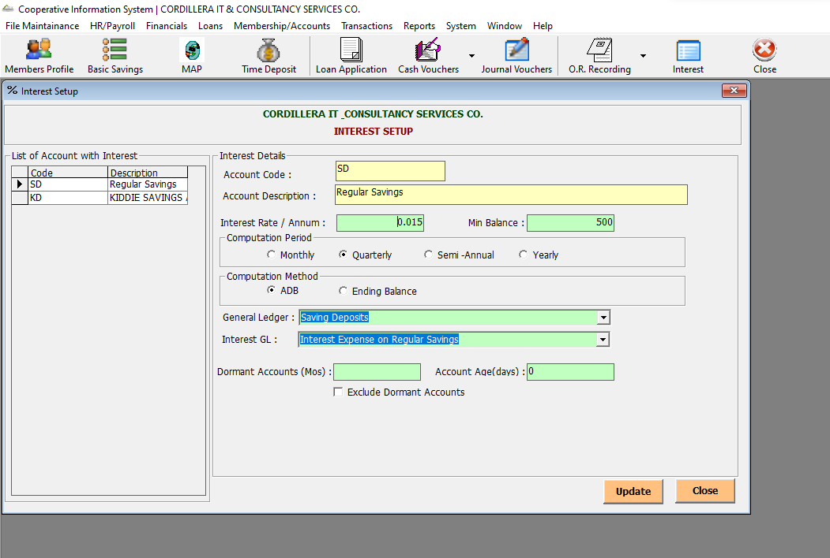

File Maintenance -> OR Management

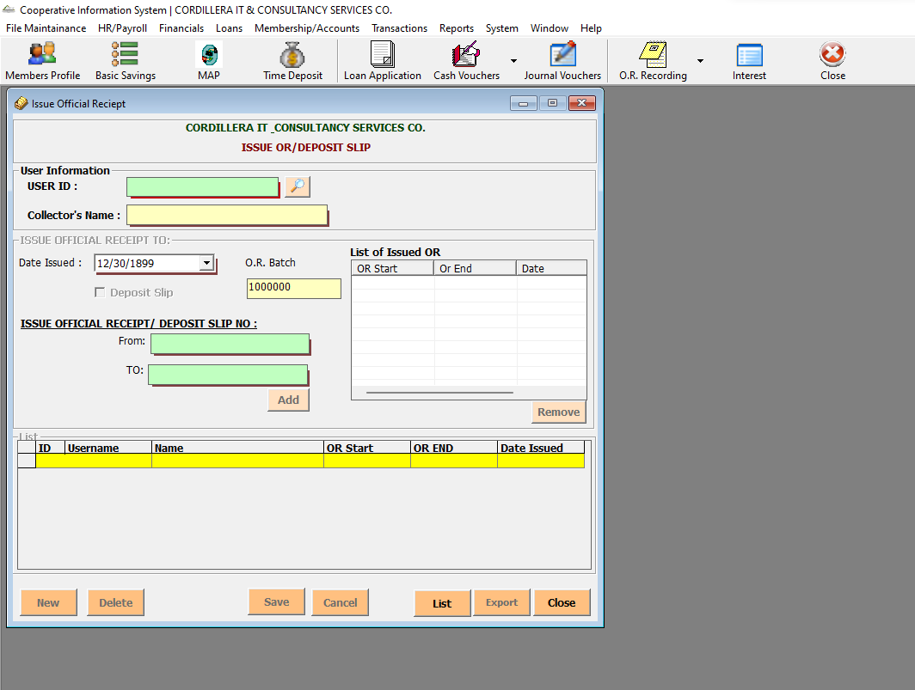

File Maintenance -> Fiscal Year

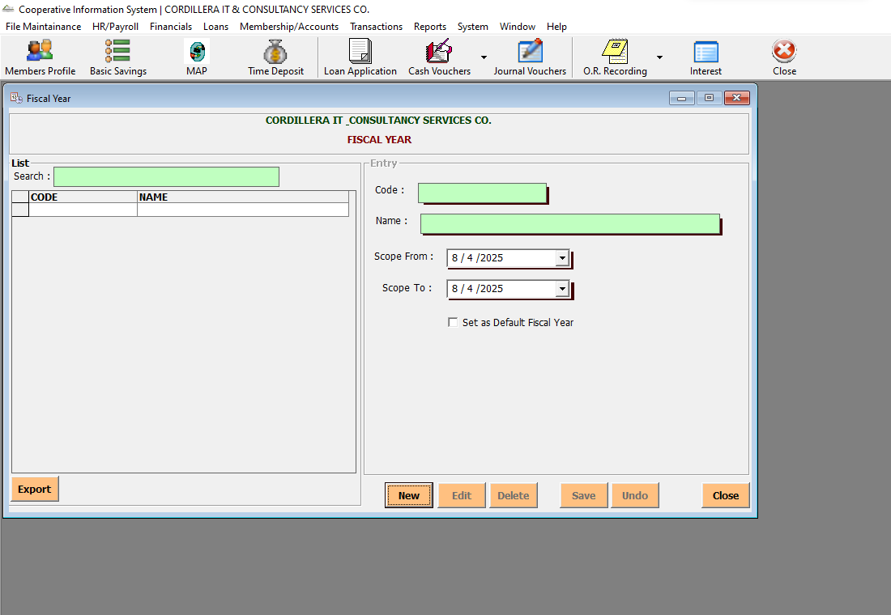

File Maintenance -> Company Profile

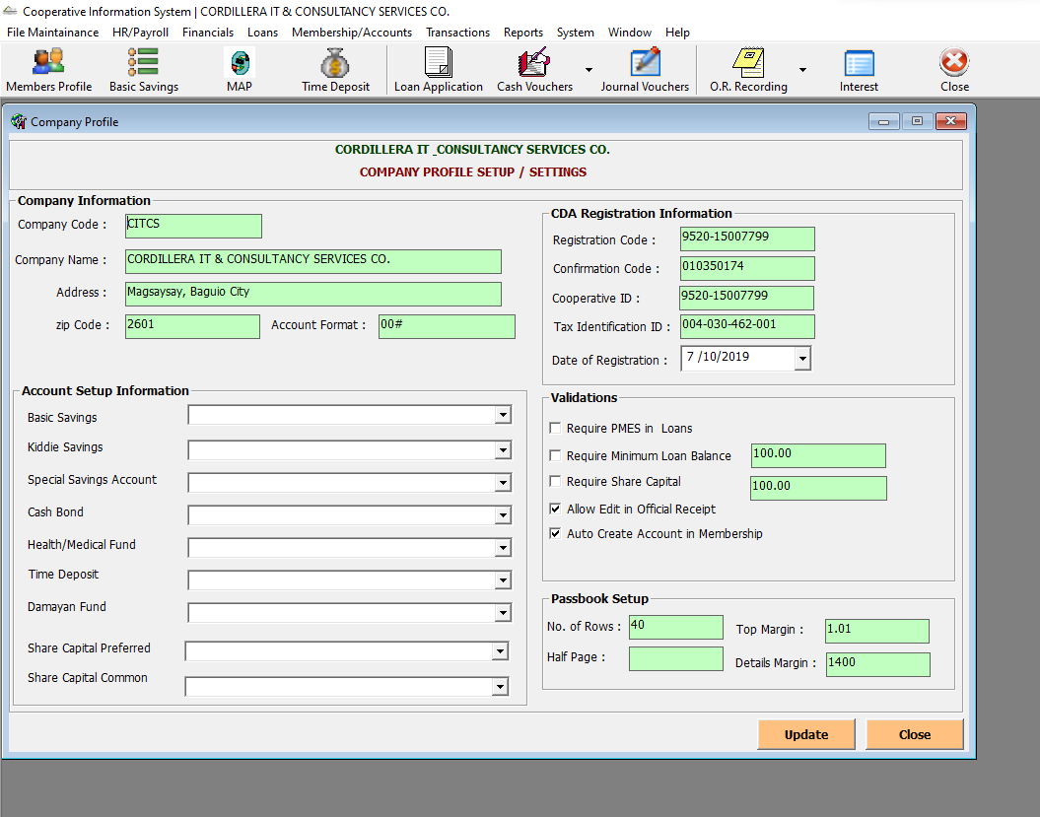

File Maintenance -> Signatories

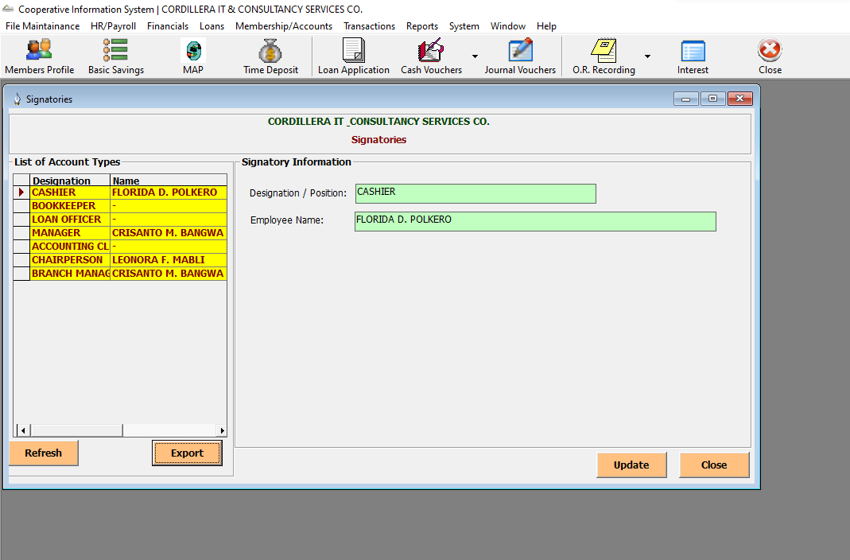

File Maintenance -> Users

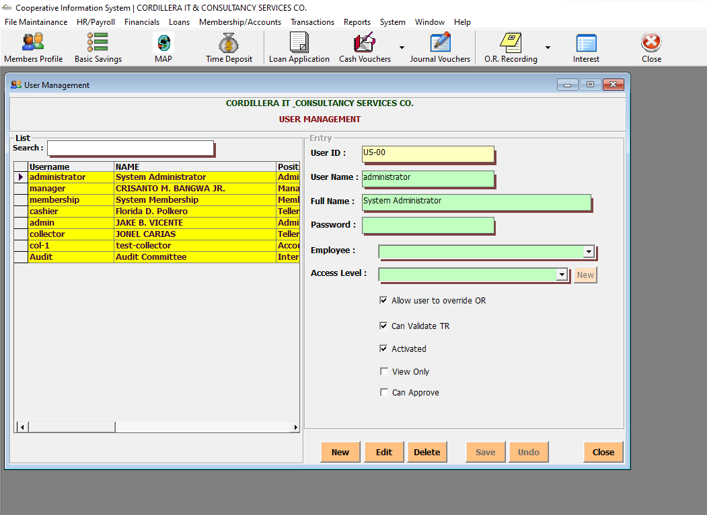

File Maintenance -> User Rights

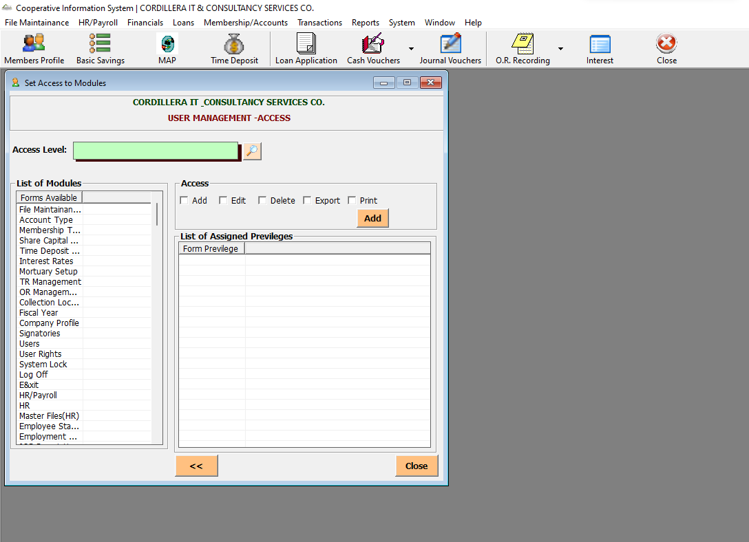

File Maintenance -> System Lock

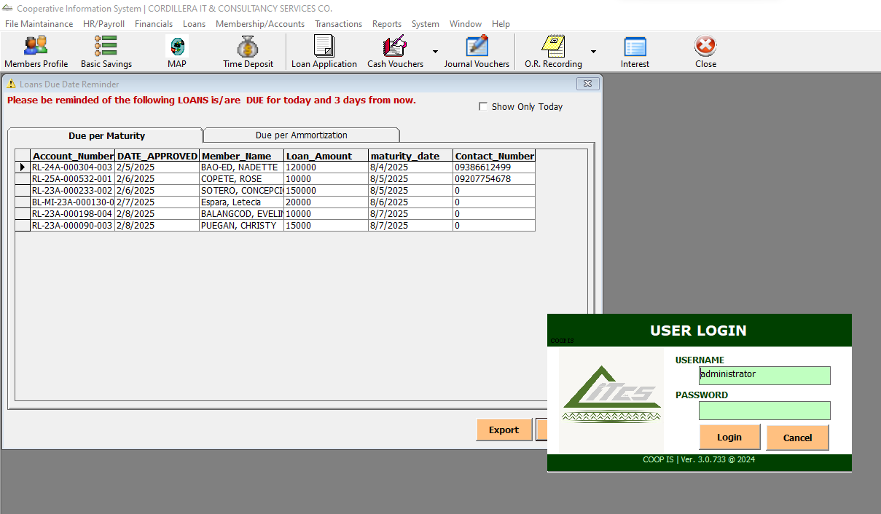

HR/Payroll ->HR-> Master Files (HR) -> Employee Status

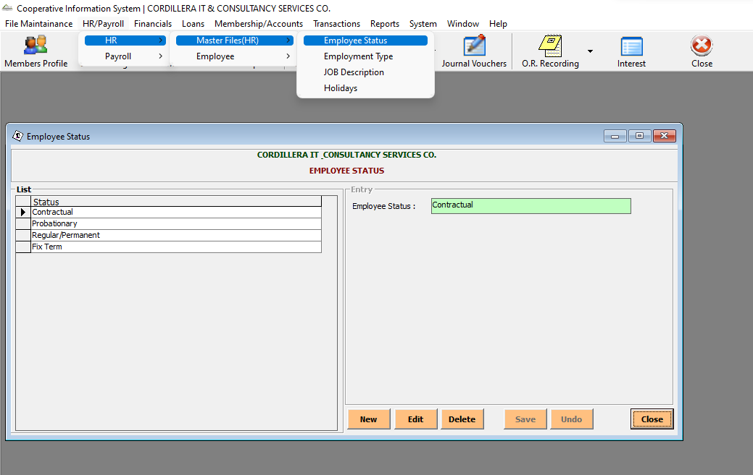

HR/Payroll -> HR-> Master Files (HR) -> Employment Type

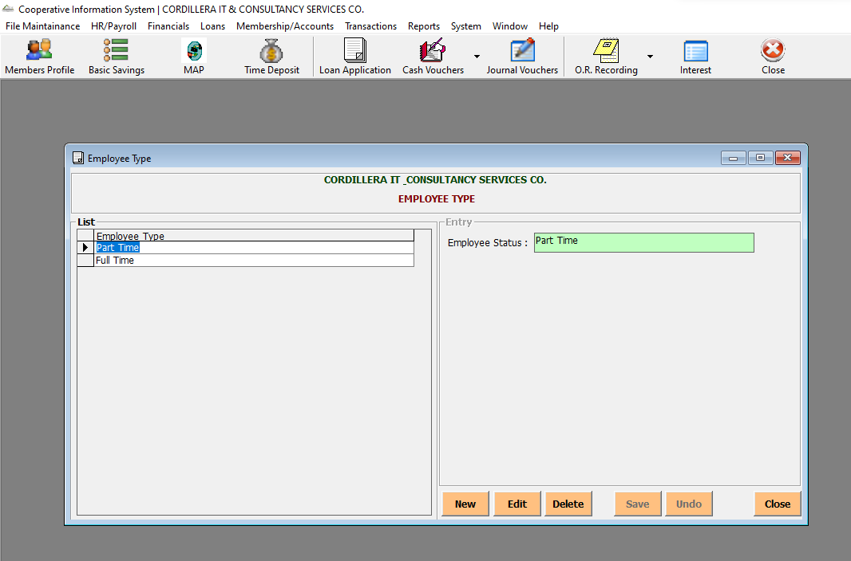

HR/Payroll -> HR-> Master Files (HR) -> Job Description

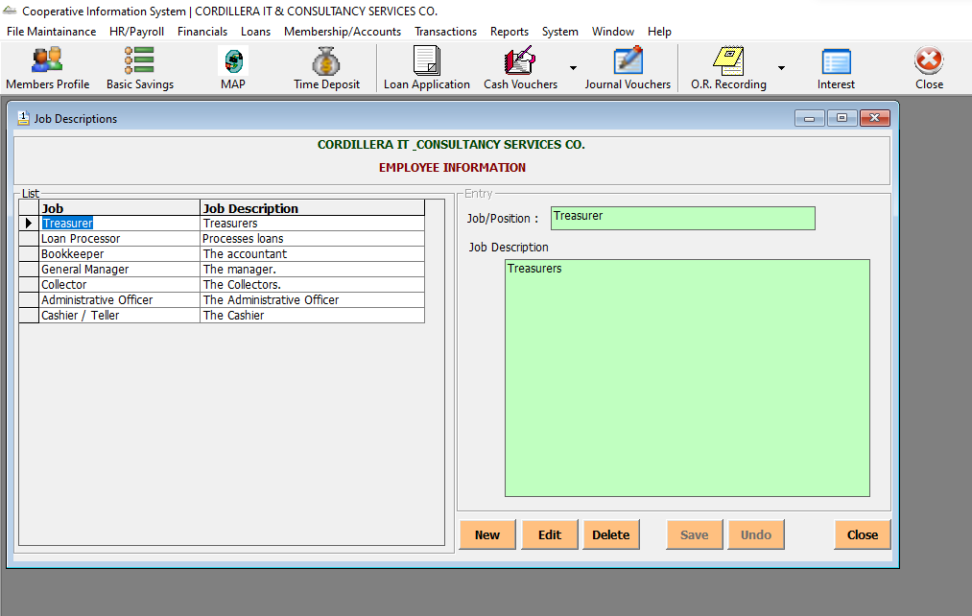

HR/Payroll -> HR-> Master Files (HR) -> Holidays

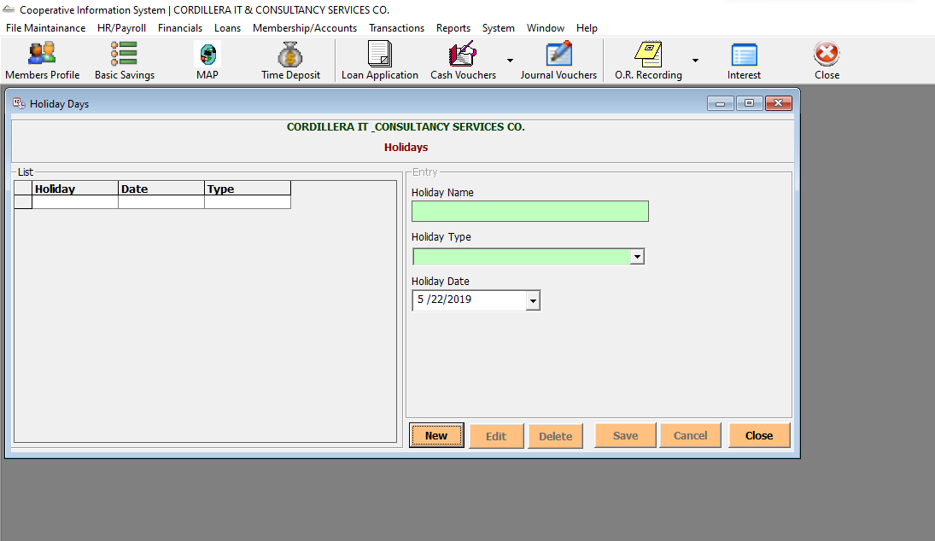

HR/Payroll -> HR->Employee->Basic Information (201)

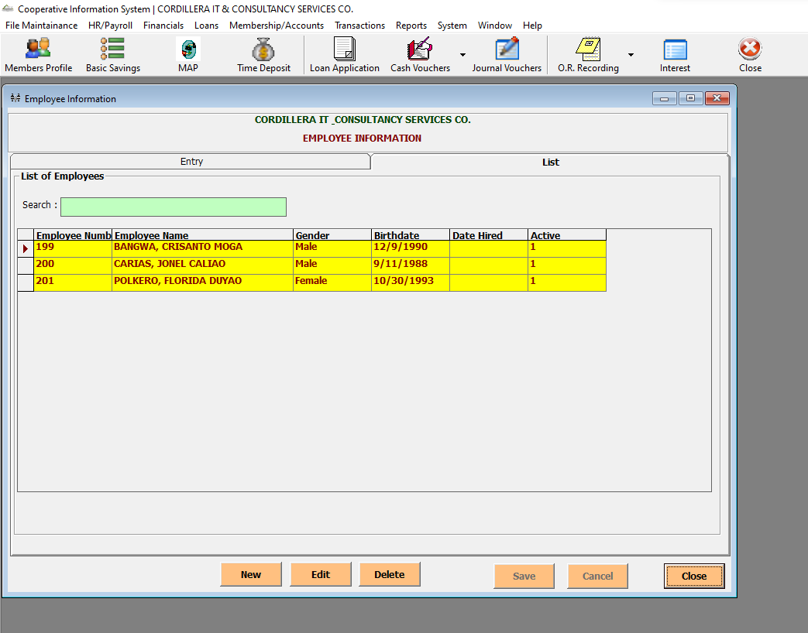

HR/Payroll -> HR->Employee->Service Record

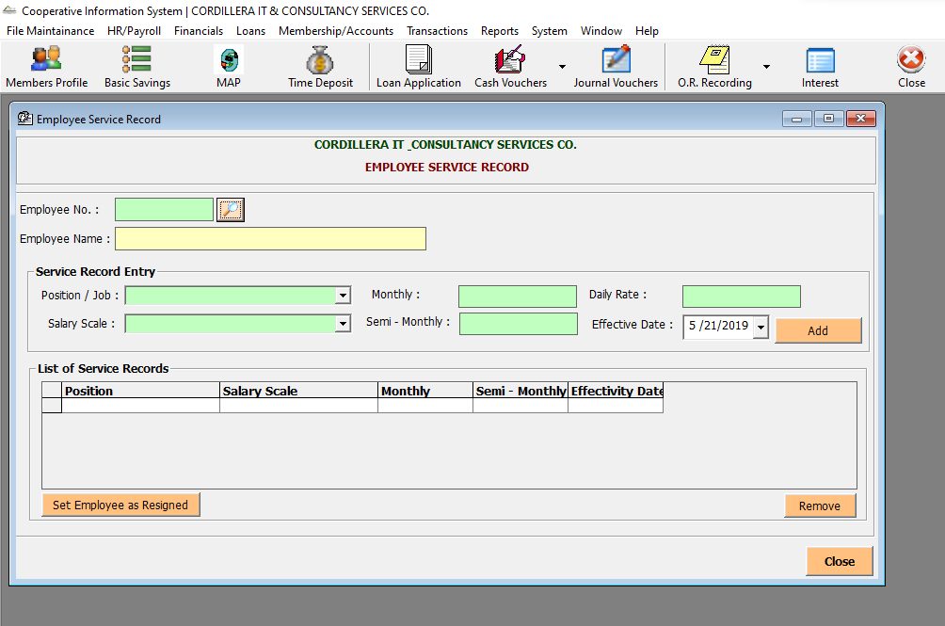

HR/Payroll -> Payroll -> Setup Payroll -> Payroll Periods

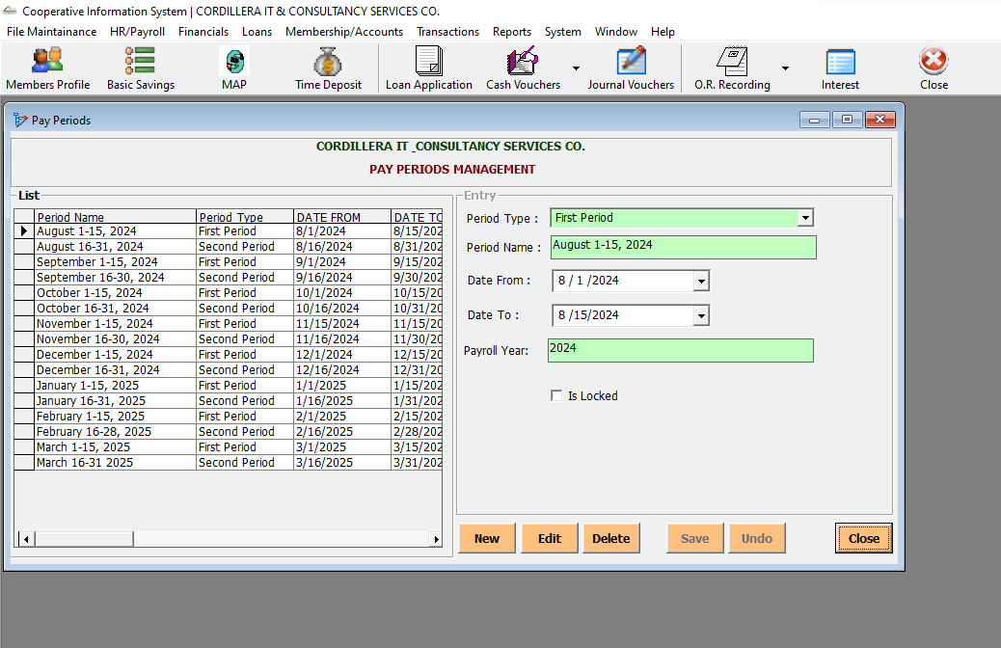

HR/Payroll -> Payroll -> Setup Payroll -> Payroll Deductions

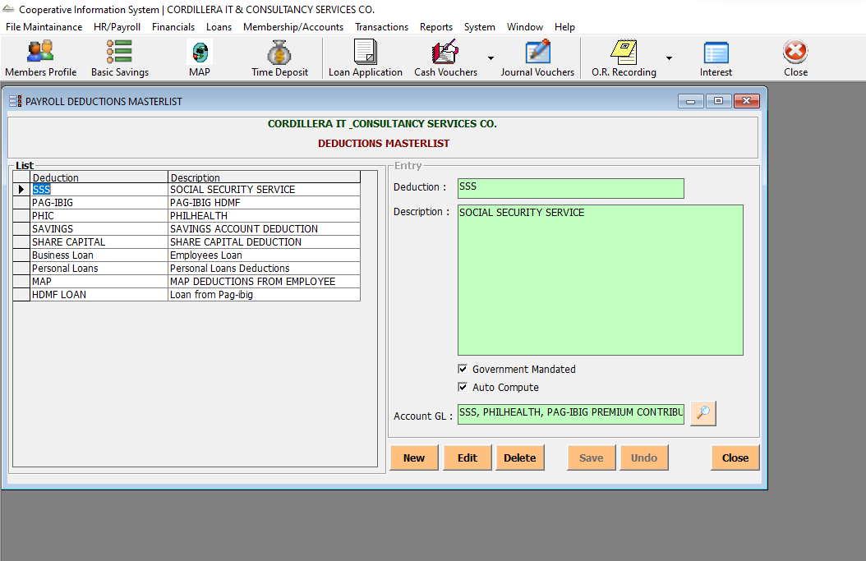

HR/Payroll -> Payroll -> Setup Payroll -> Payroll Benefits

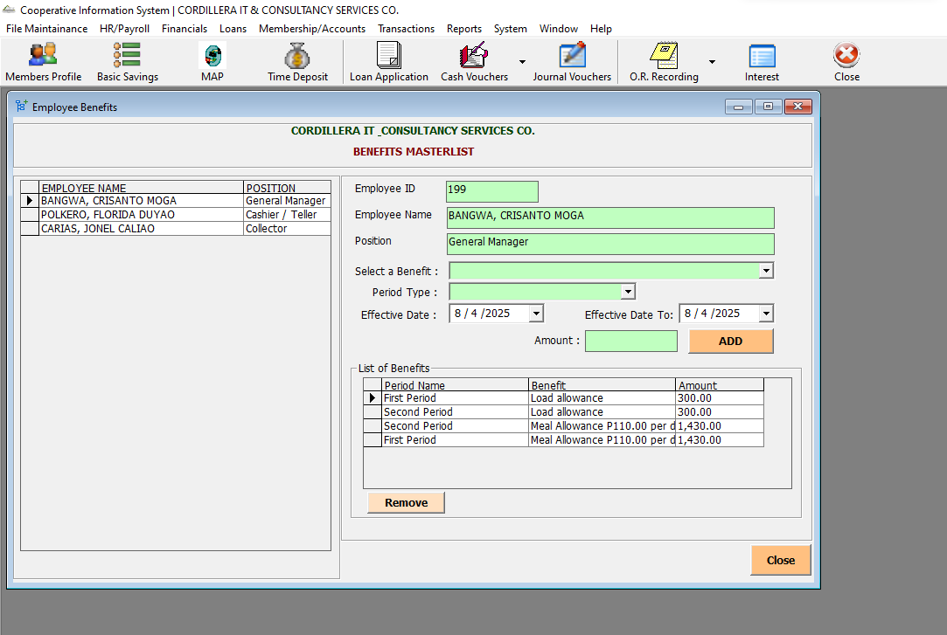

HR/Payroll -> Payroll -> Setup Payroll -> Salary Scale

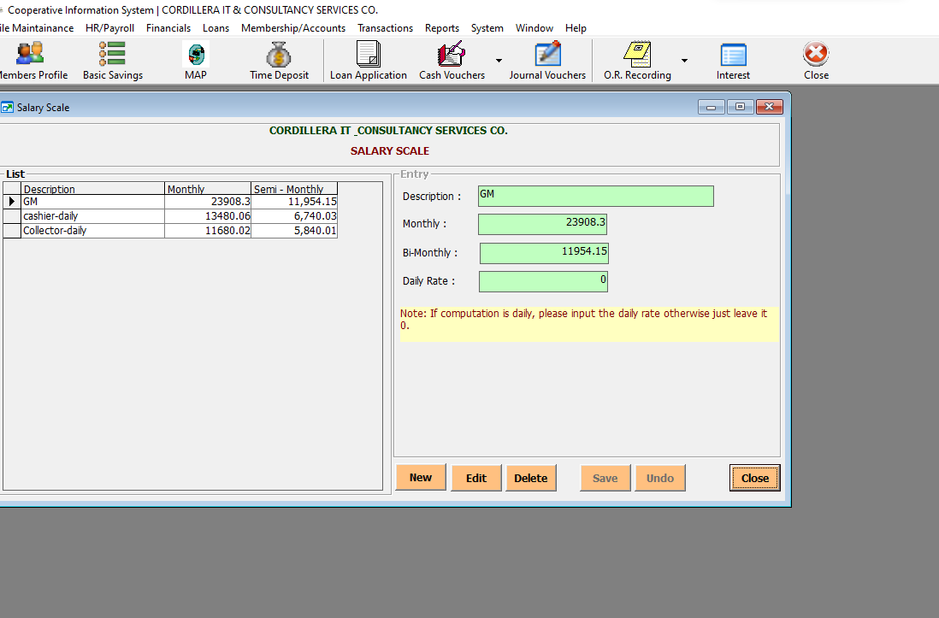

HR/Payroll -> Payroll -> Setup Payroll -> SSS Table

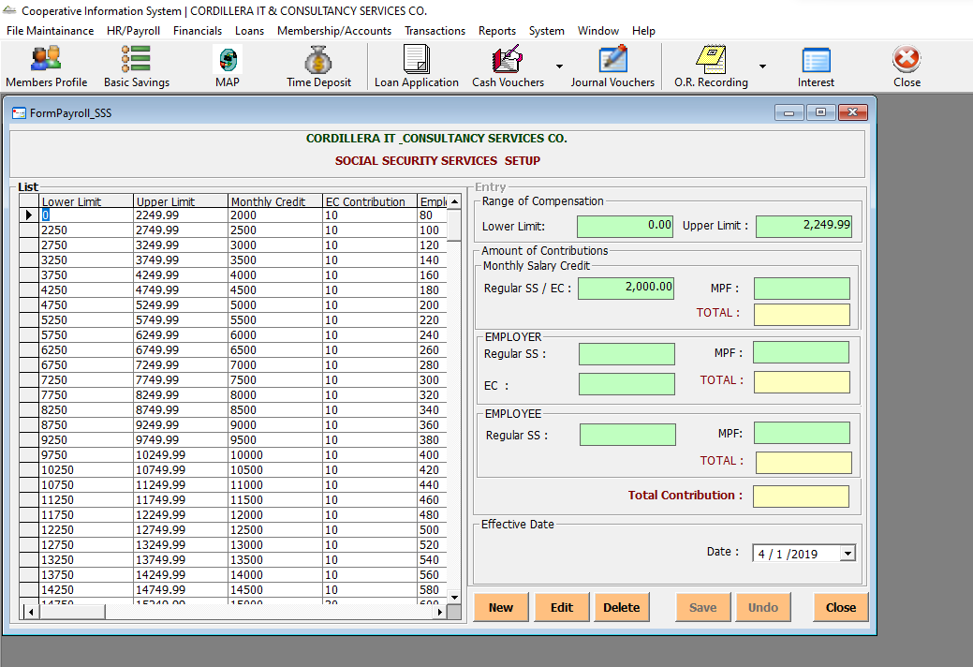

HR/Payroll -> Payroll -> Employee Deductions

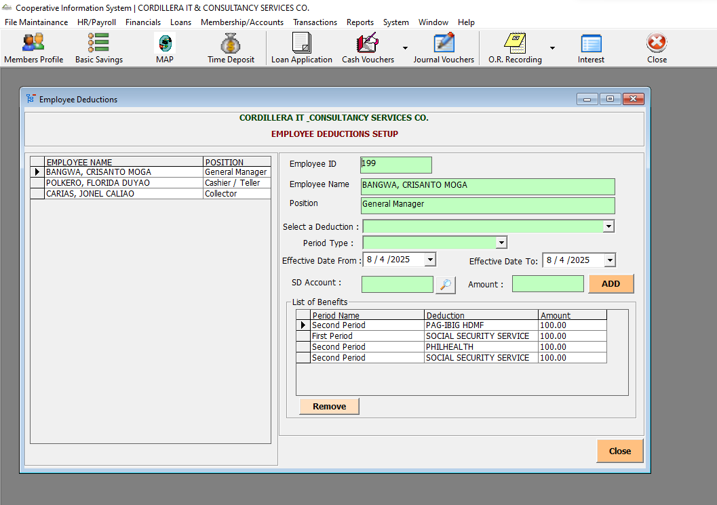

HR/Payroll -> Payroll -> Employee Benefits

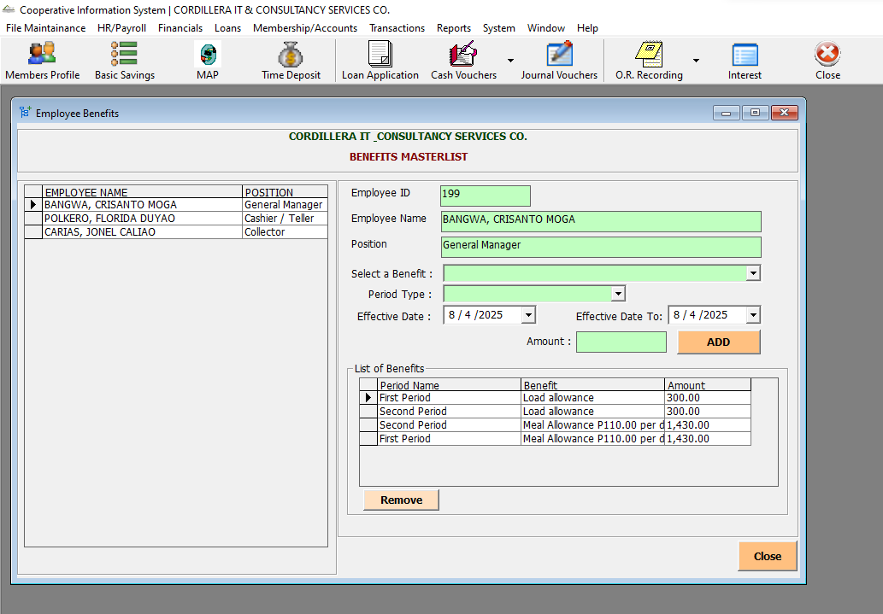

HR/Payroll -> Payroll -> Payroll Entry

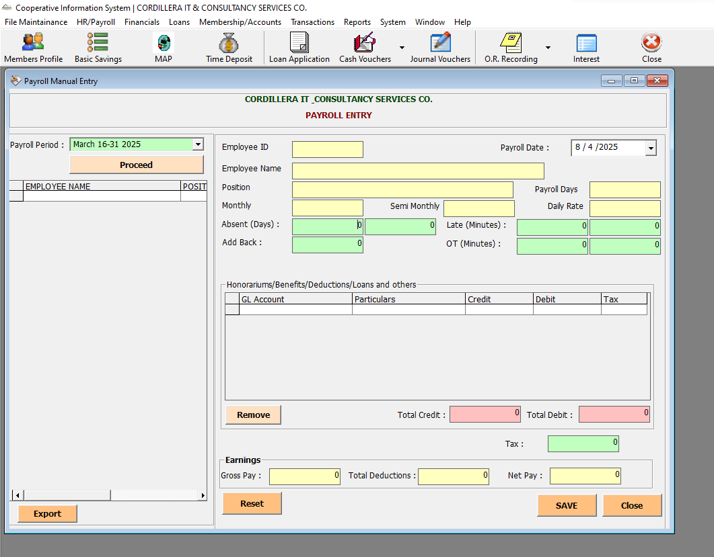

HR/Payroll -> Payroll -> Post SL Payroll Deductions

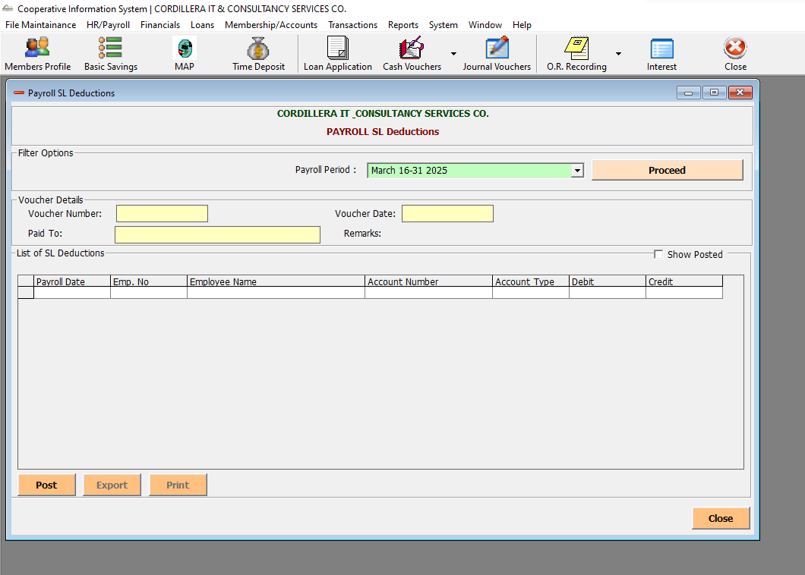

HR/Payroll -> Payroll -> Payroll Reports -> Payroll Summary

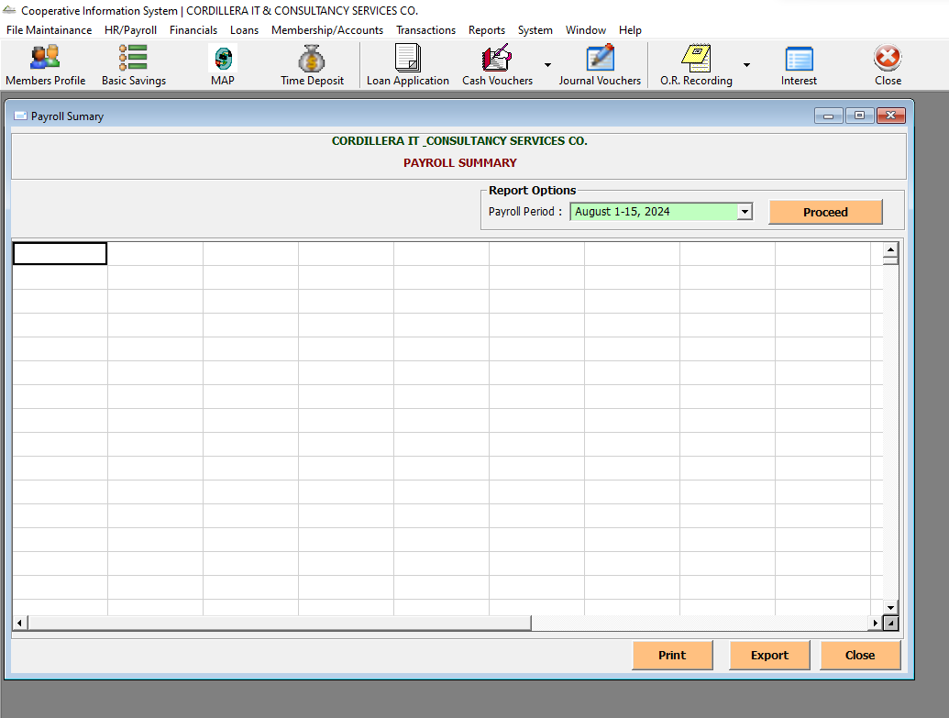

HR/Payroll -> Payroll -> Payroll Reports -> Payroll Payslips

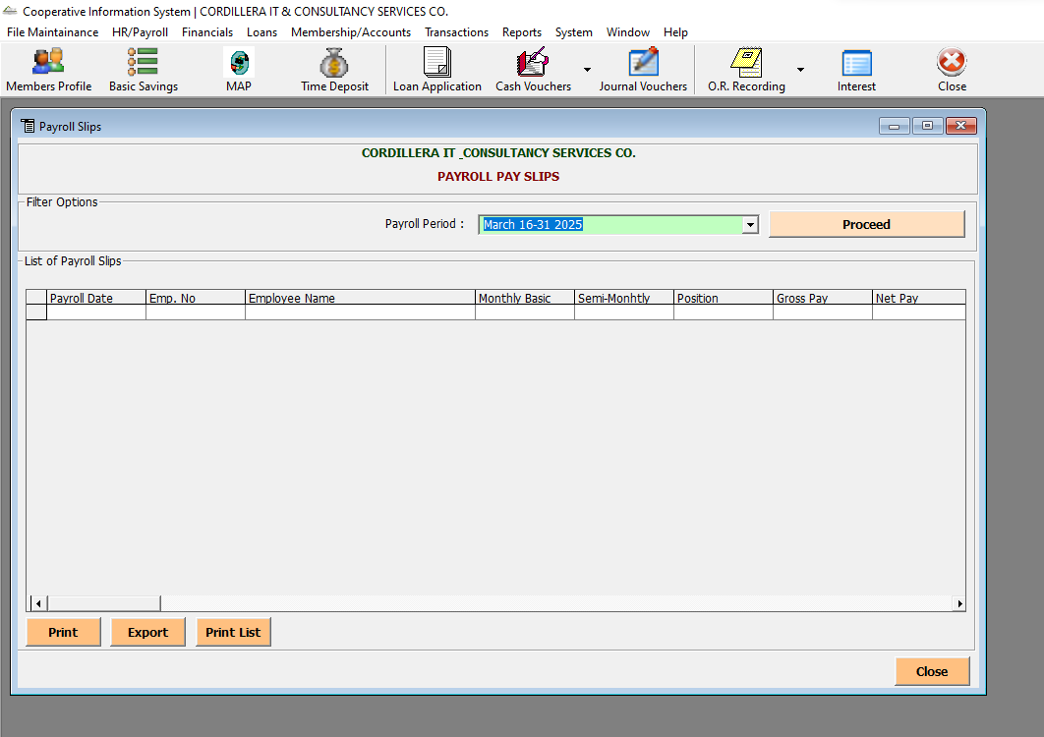

Financials -> Setup -> Banks

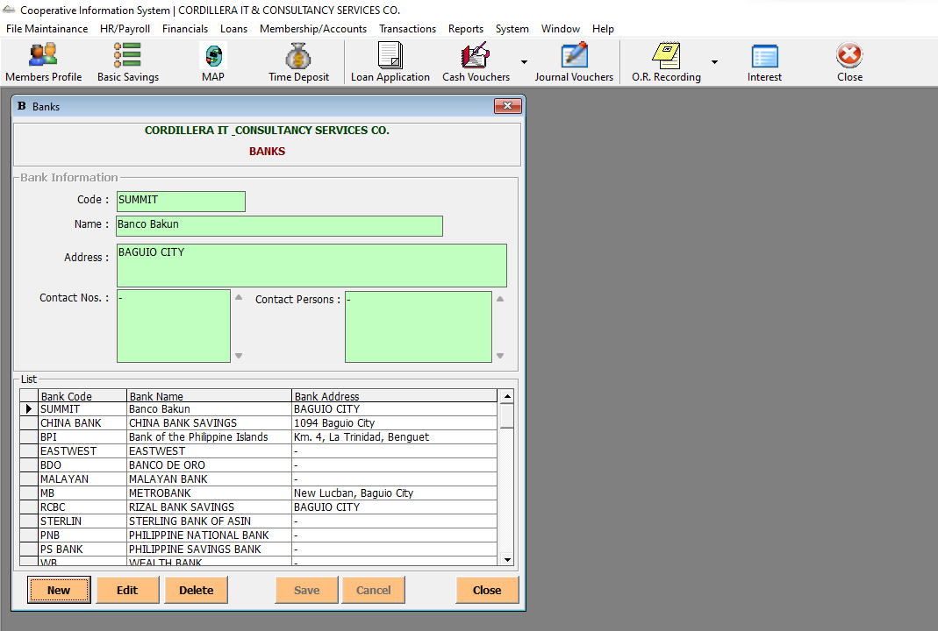

Financials -> Setup -> Bank Accounts

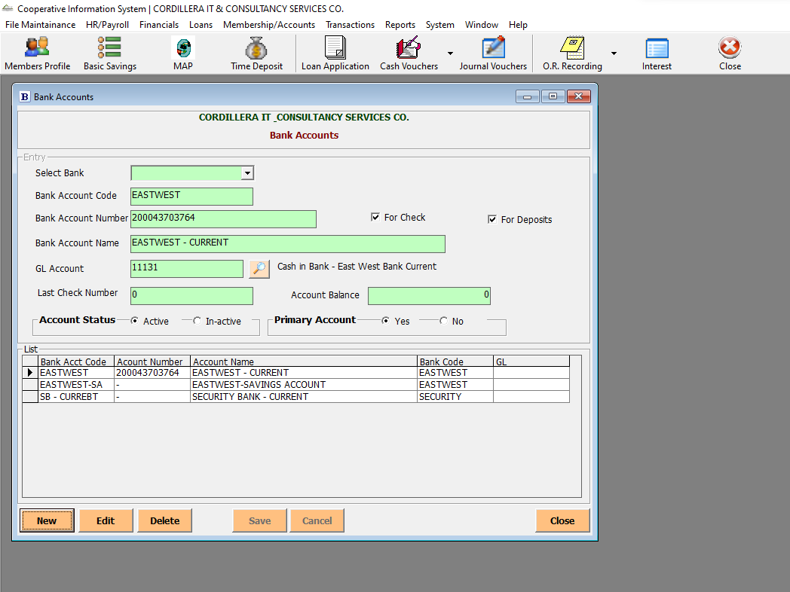

Financials -> Chart of Accounts

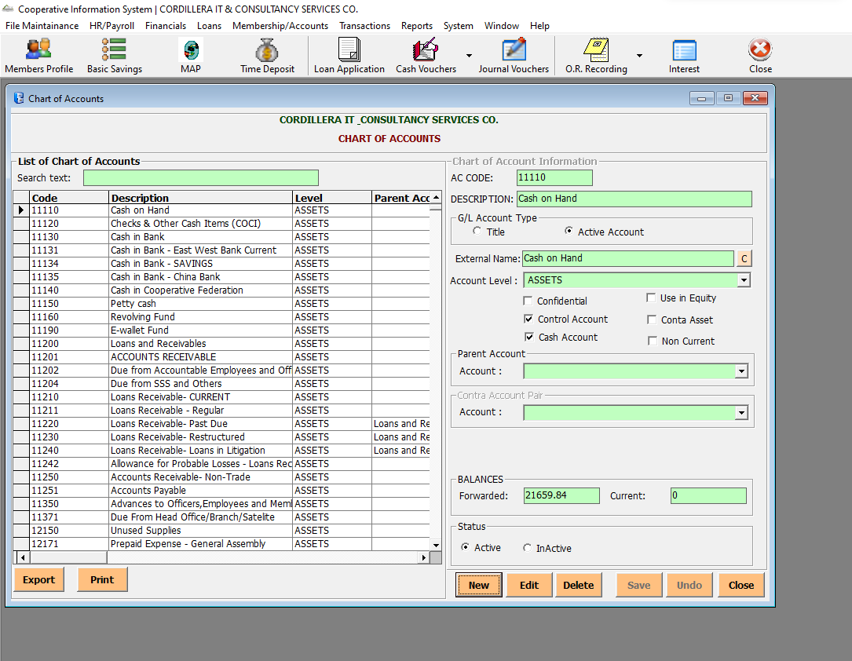

Financials -> Assets

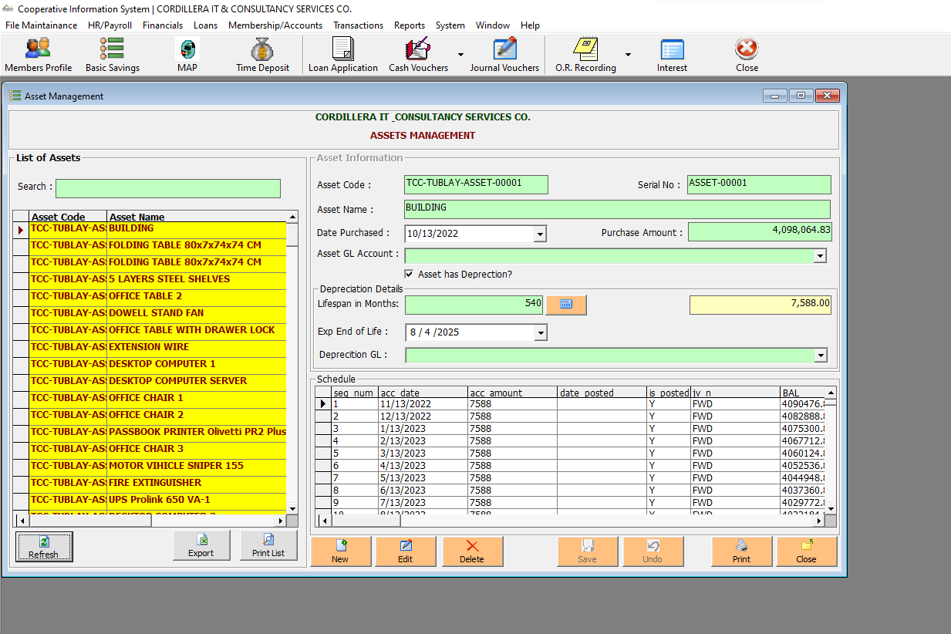

Financials -> Financial Reports -> Cash Receipts

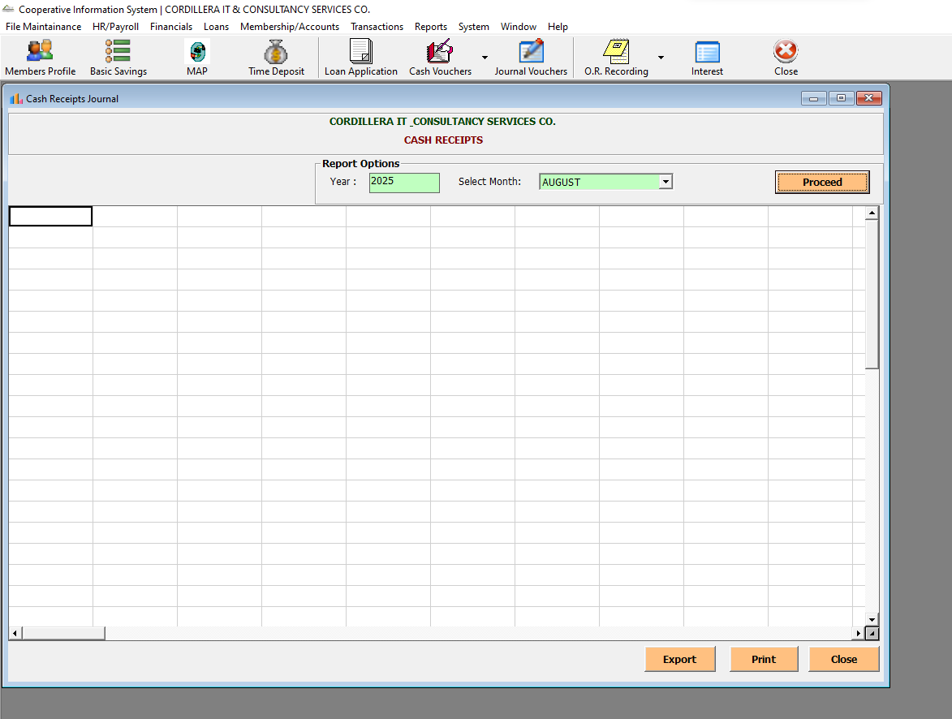

Financials -> Financial Reports -> List of Cash Voucher

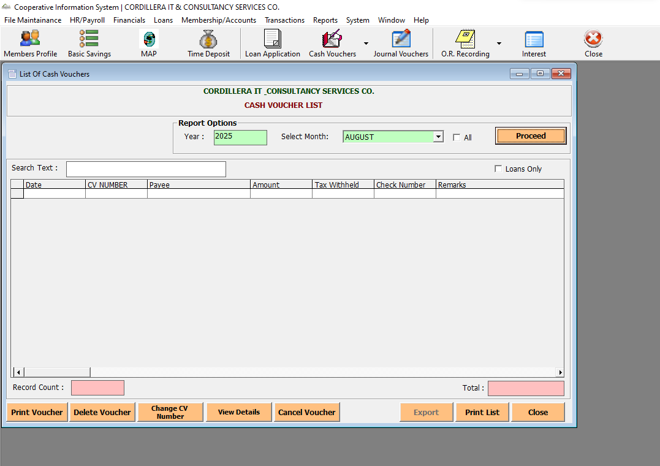

Financials -> Financial Reports -> Sales and Receivables

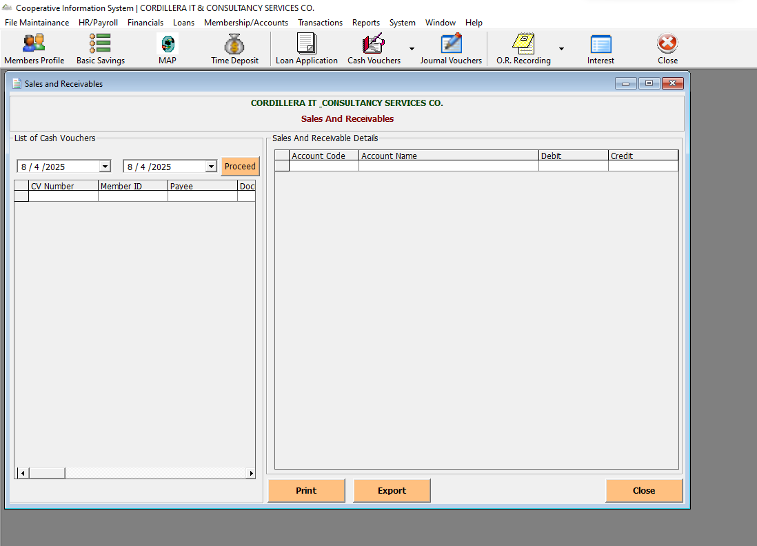

Financials -> Financial Reports -> List of Check Disbursement

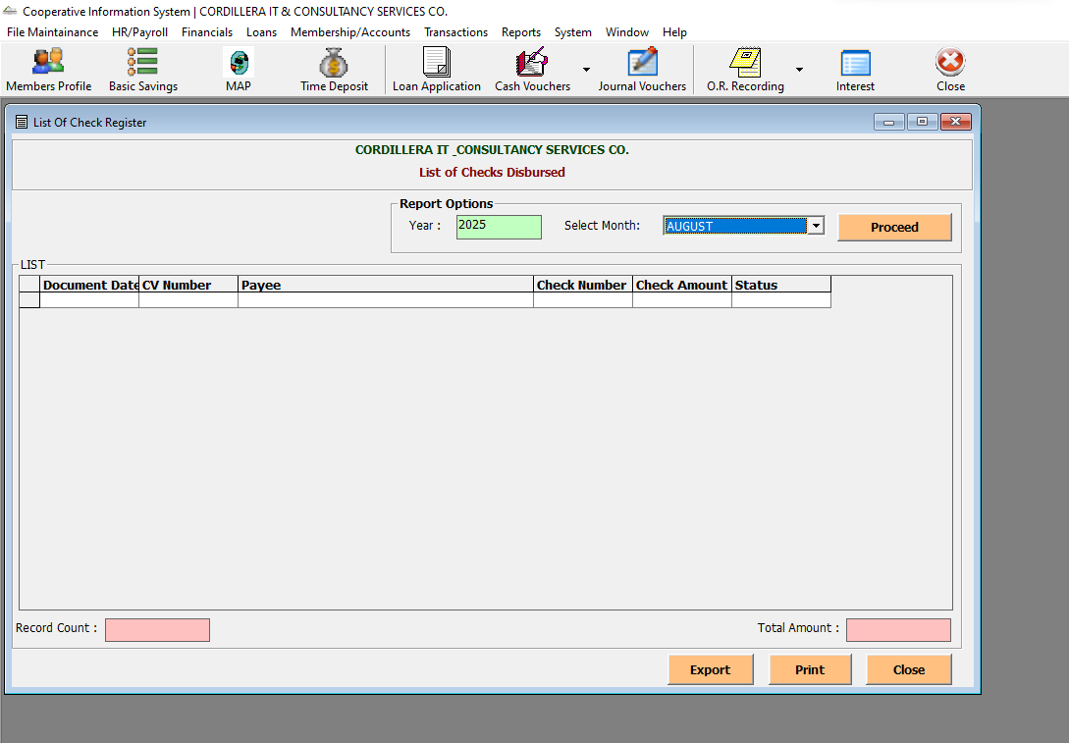

Financials -> Financial Reports -> List of Memo

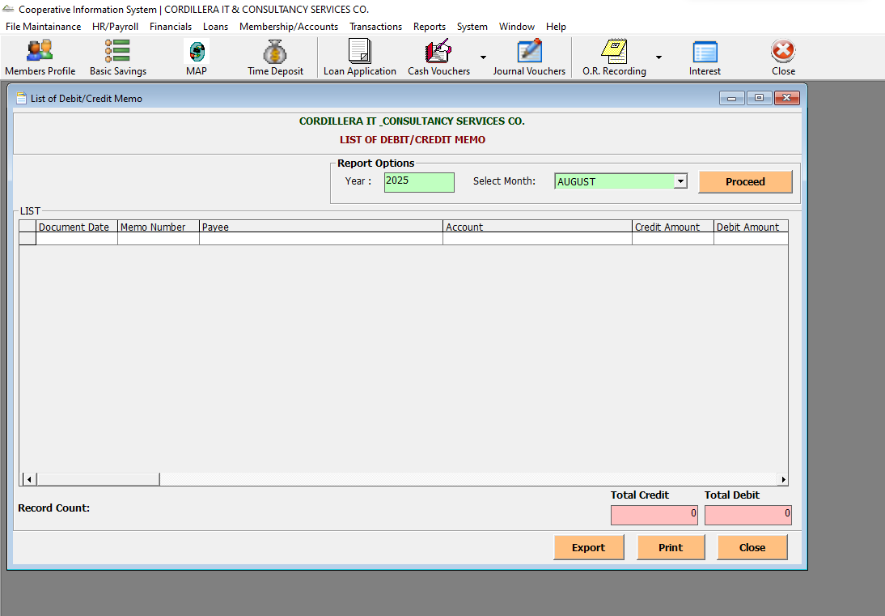

Financials -> Financial Reports -> Cash Disbursement Summary

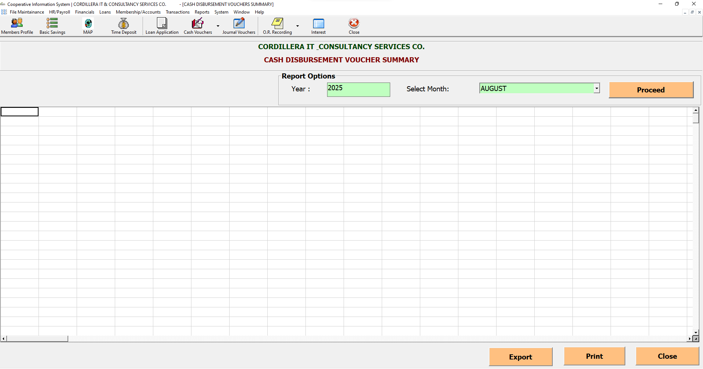

Financials -> Financial Reports -> List of Disbursed Check

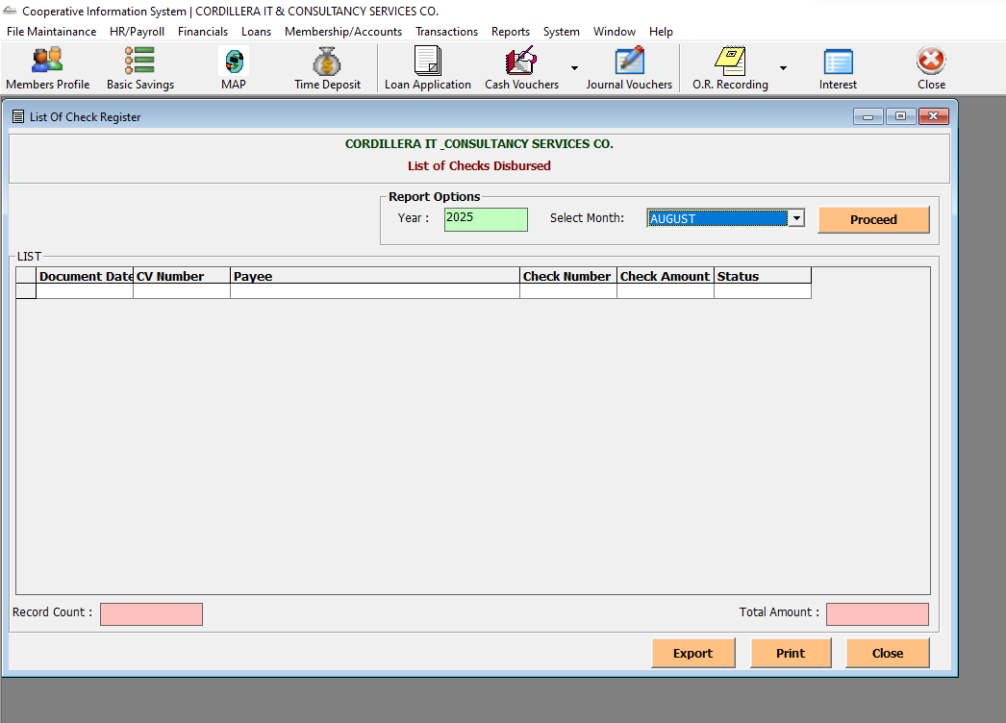

Financials -> Financial Reports -> List of Bank Deposits

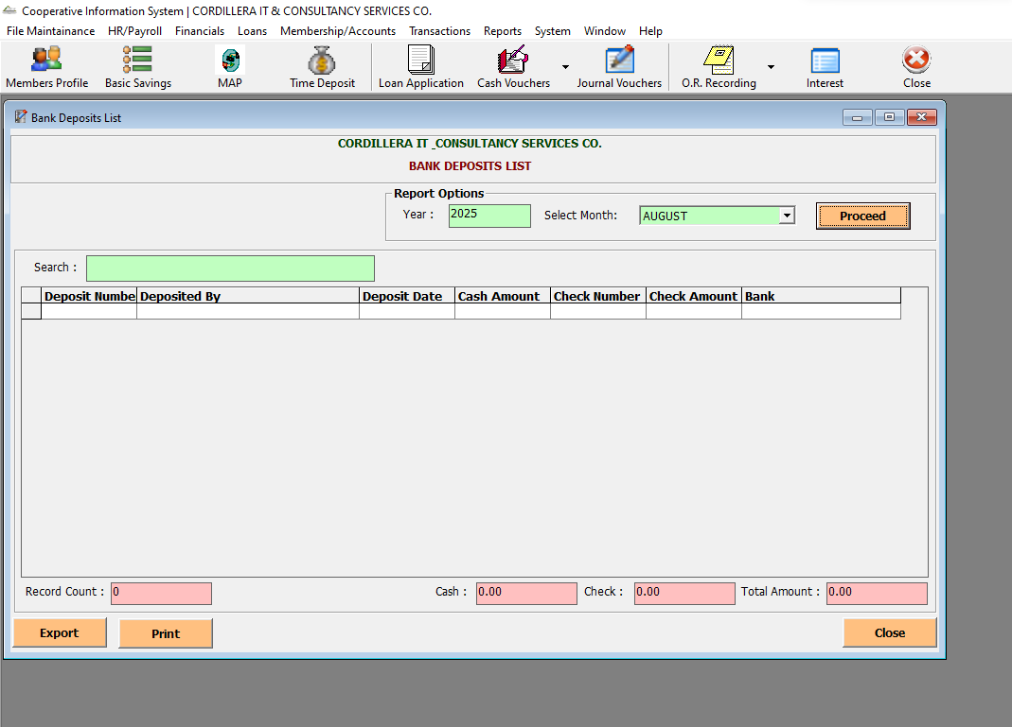

Financials -> Financial Reports -> List of Bank Withdrawals

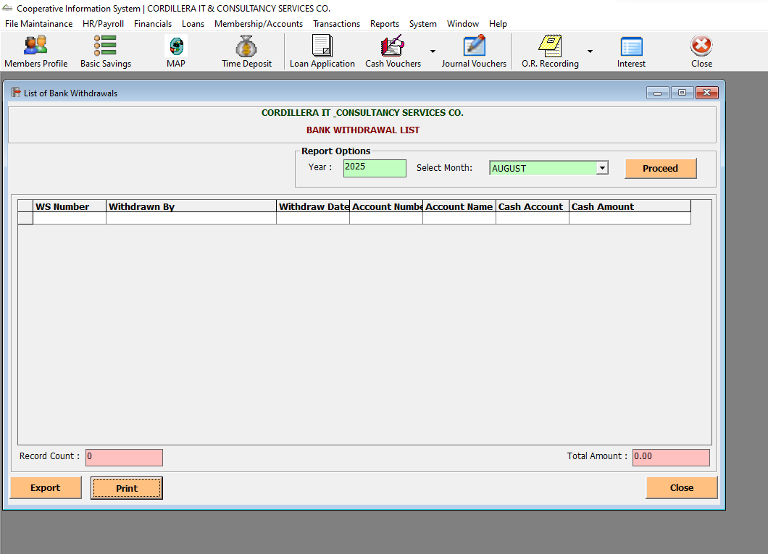

Financials -> Financial Reports -> List of Journal Vouchers

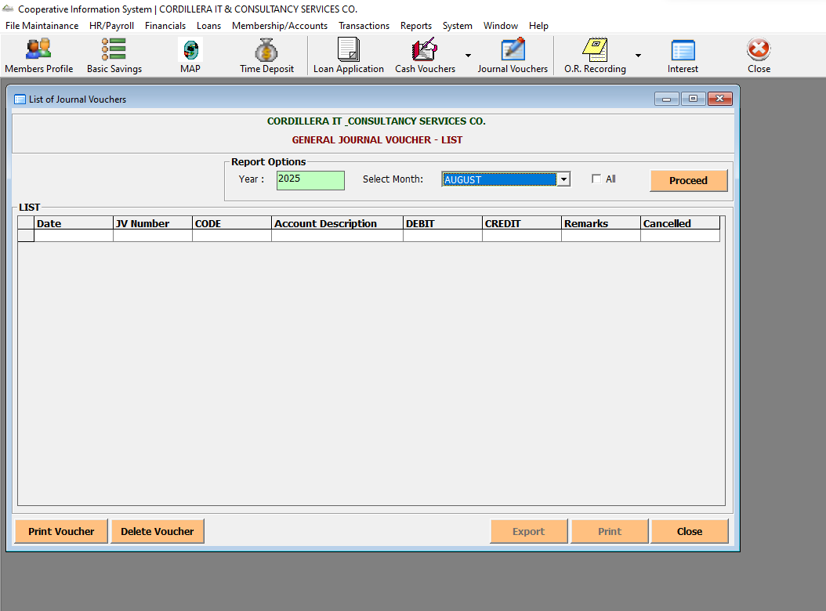

Financials -> Financial Reports -> Journal Voucher Summary

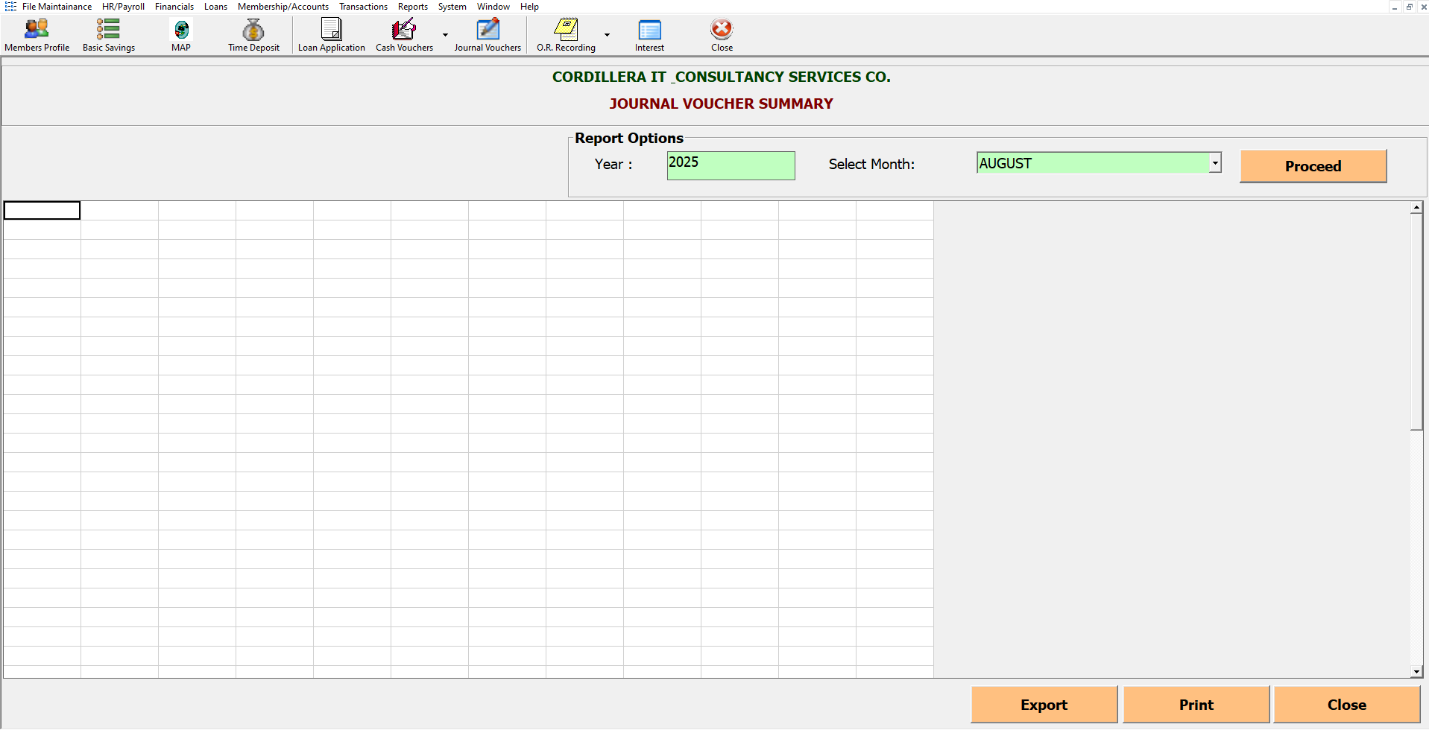

Financials -> Financial Reports -> Depreciation Summary

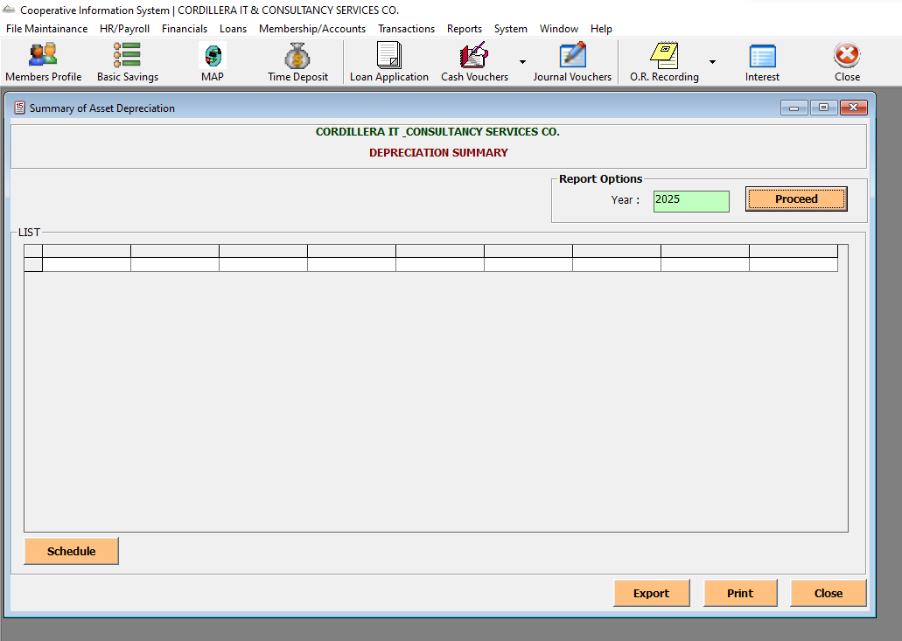

Financials -> Financial Reports -> Financial Statement

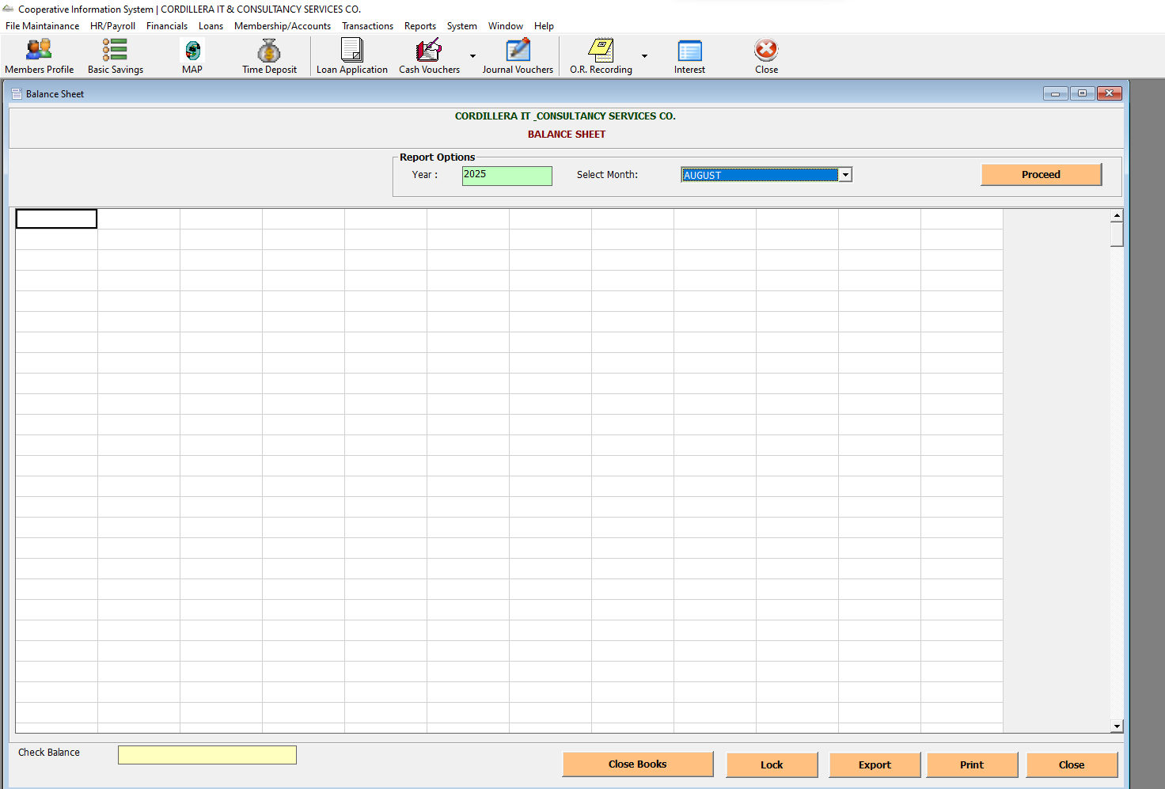

Financials -> Financial Reports -> Income Statement

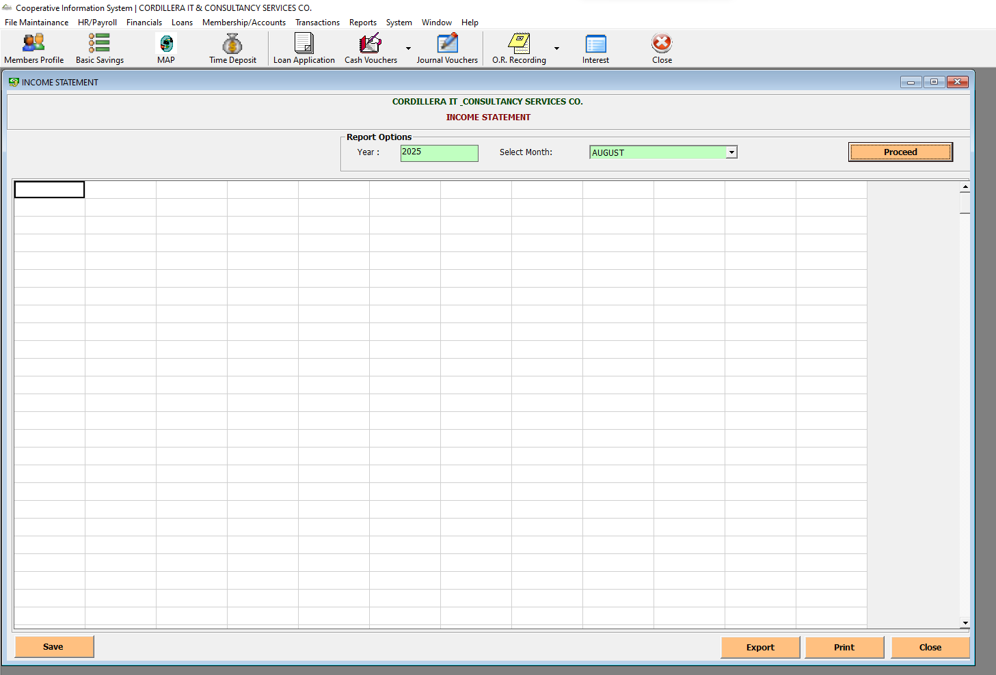

Financials -> Financial Reports -> Trial Balance

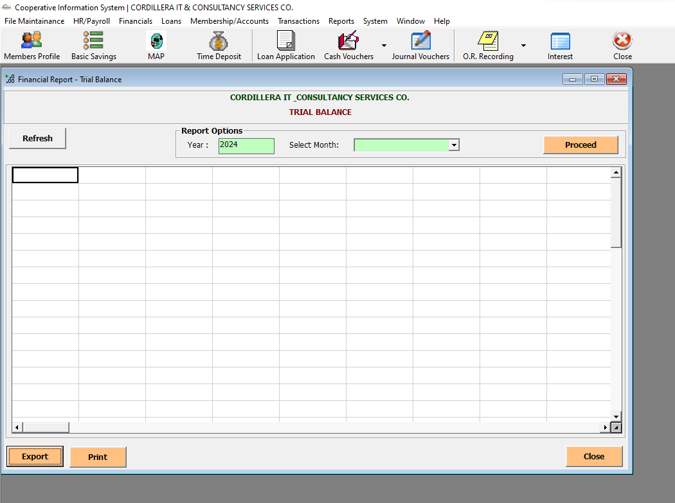

Financials -> Financial Reports -> General Ledger

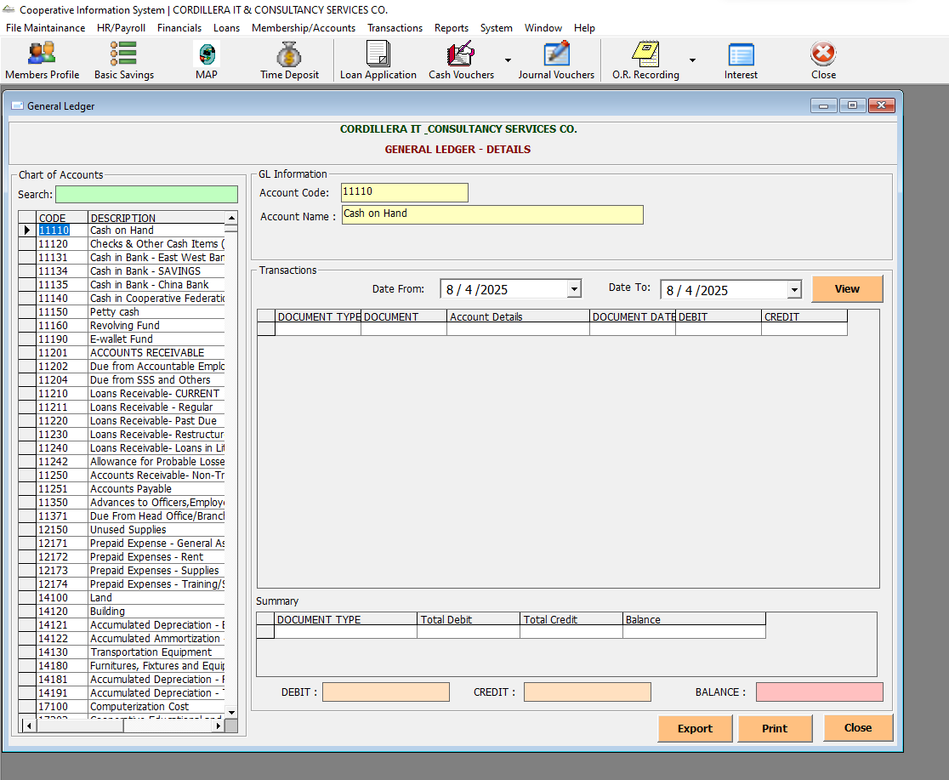

Financials -> Statement of Accounts-> GL Details

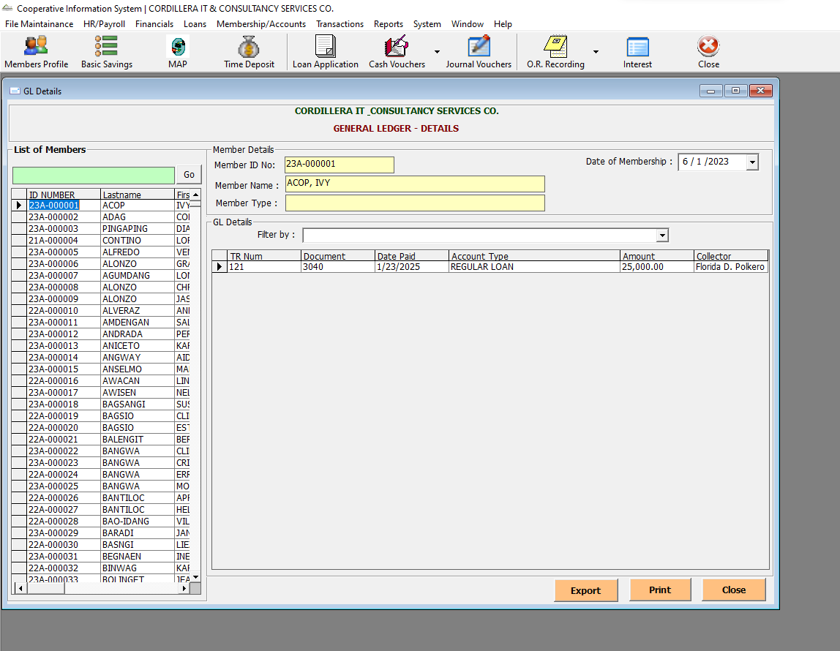

Financials -> Statement of Accounts-> SL Details

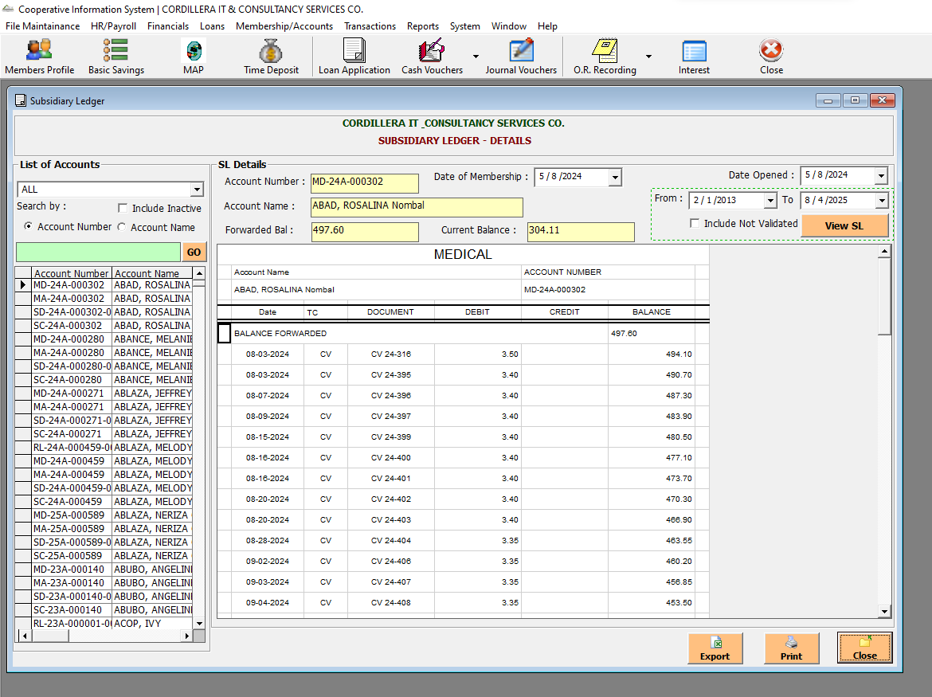

Financials -> Statement of Accounts-> Loans Ledger

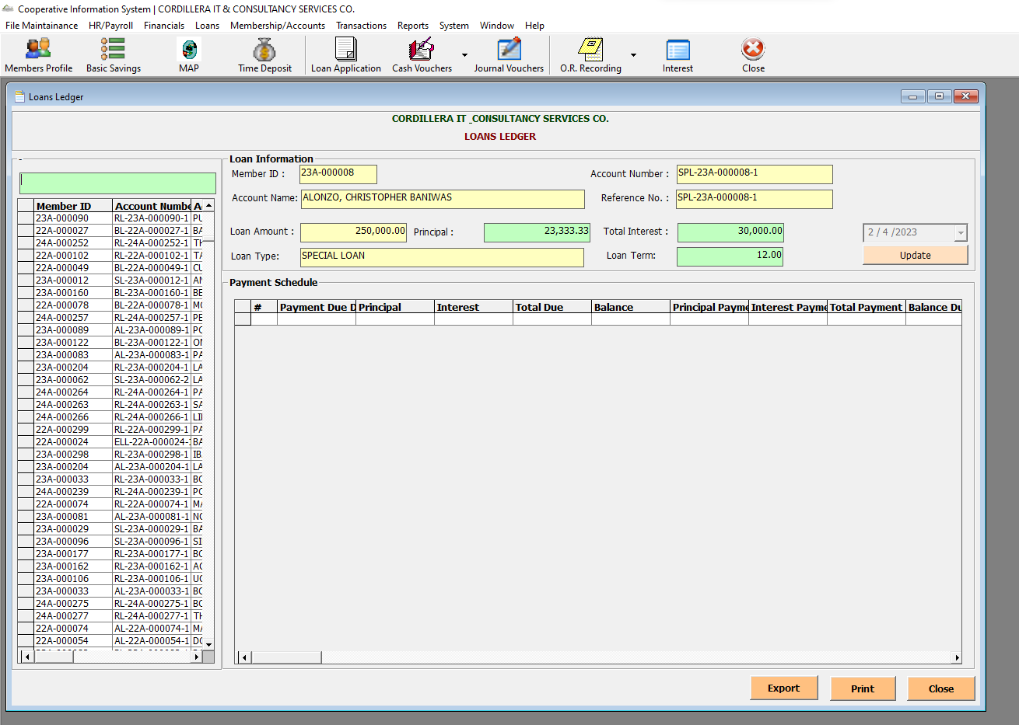

Loans-> Loan Insurance

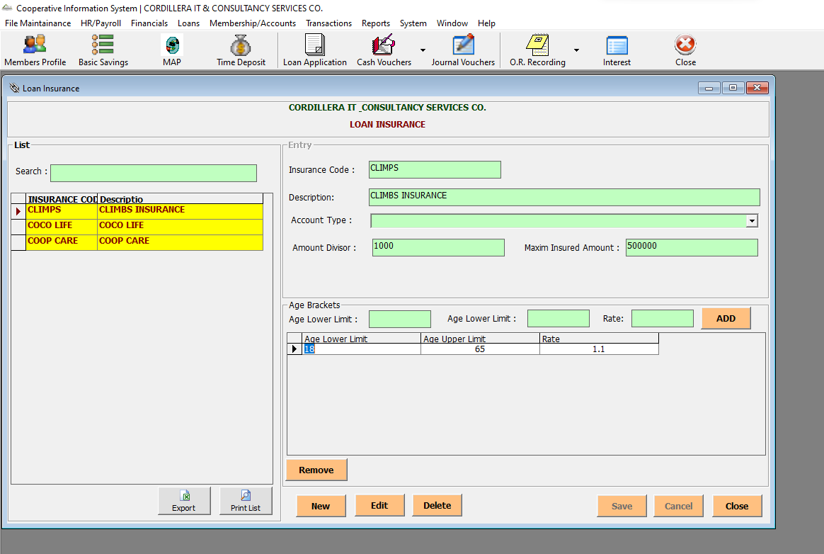

Loans-> Loan Type Settings

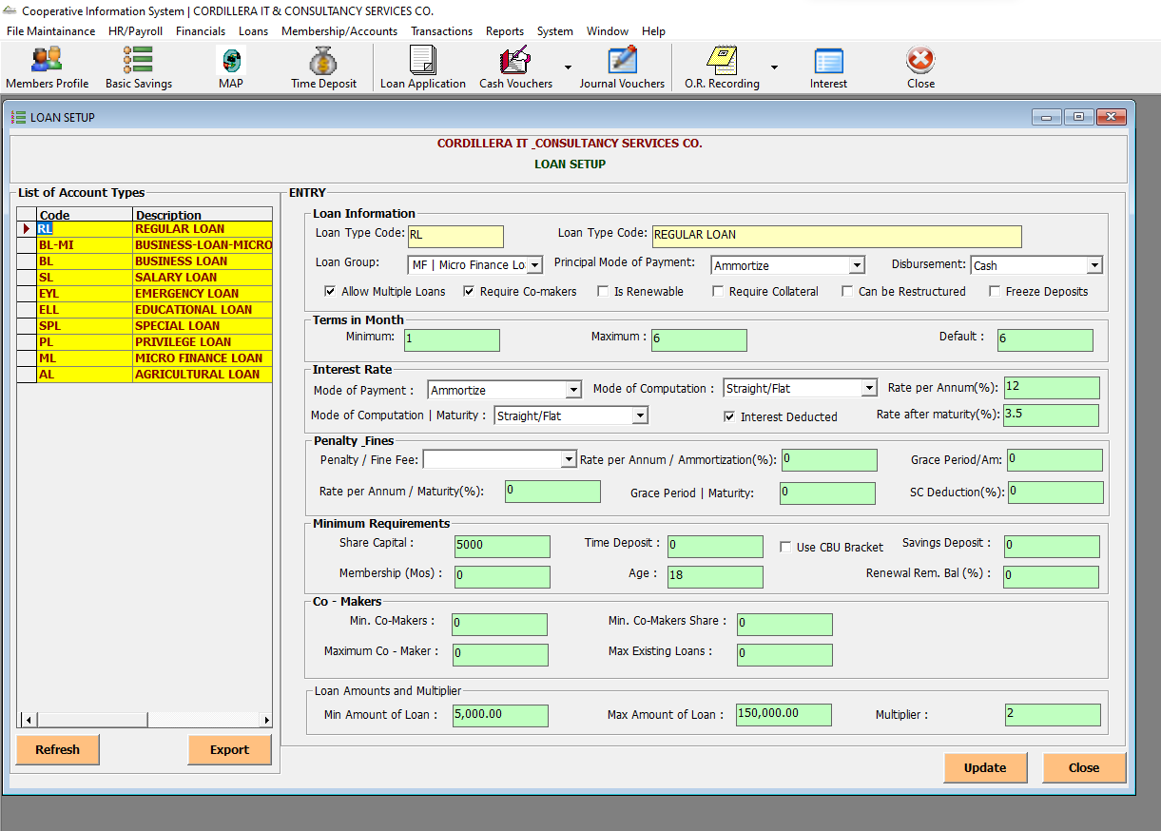

Loans-> Loan Deductions

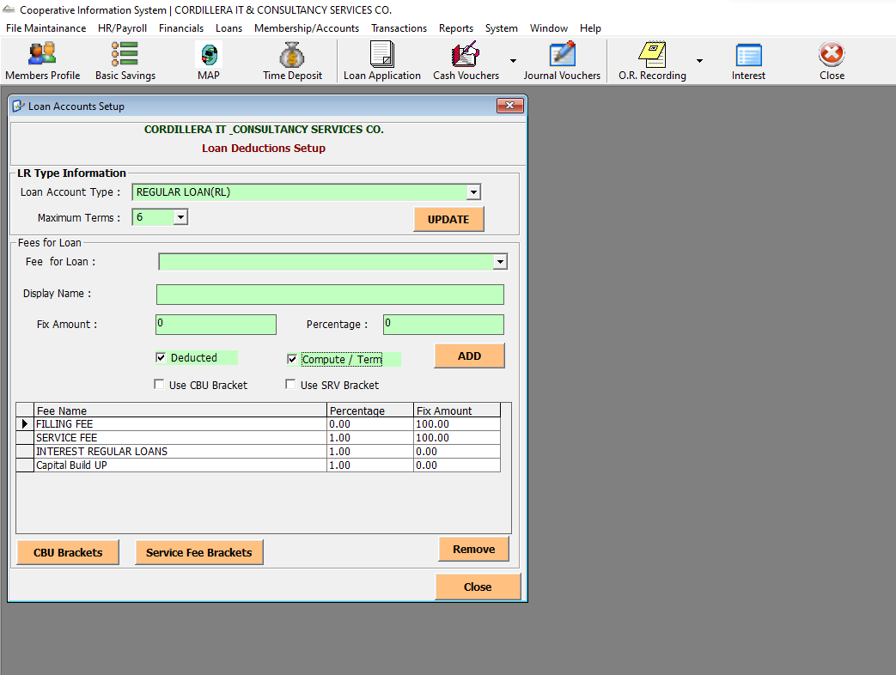

Loans-> Loan Application

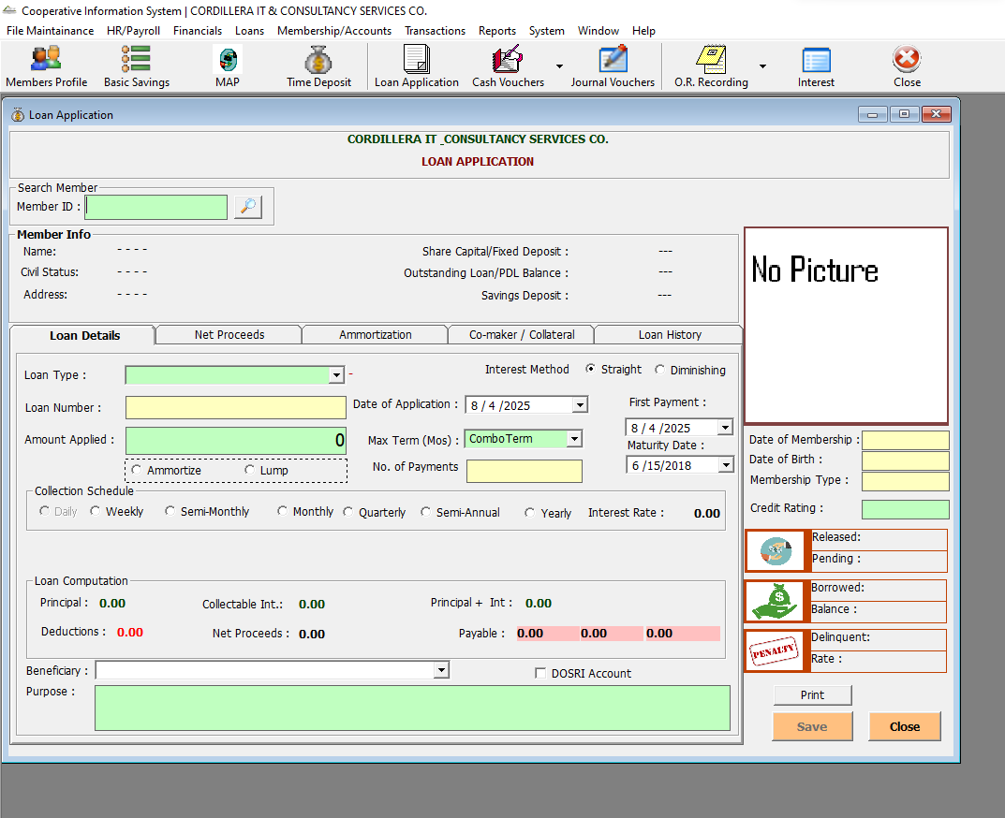

Loans-> Loan Approval

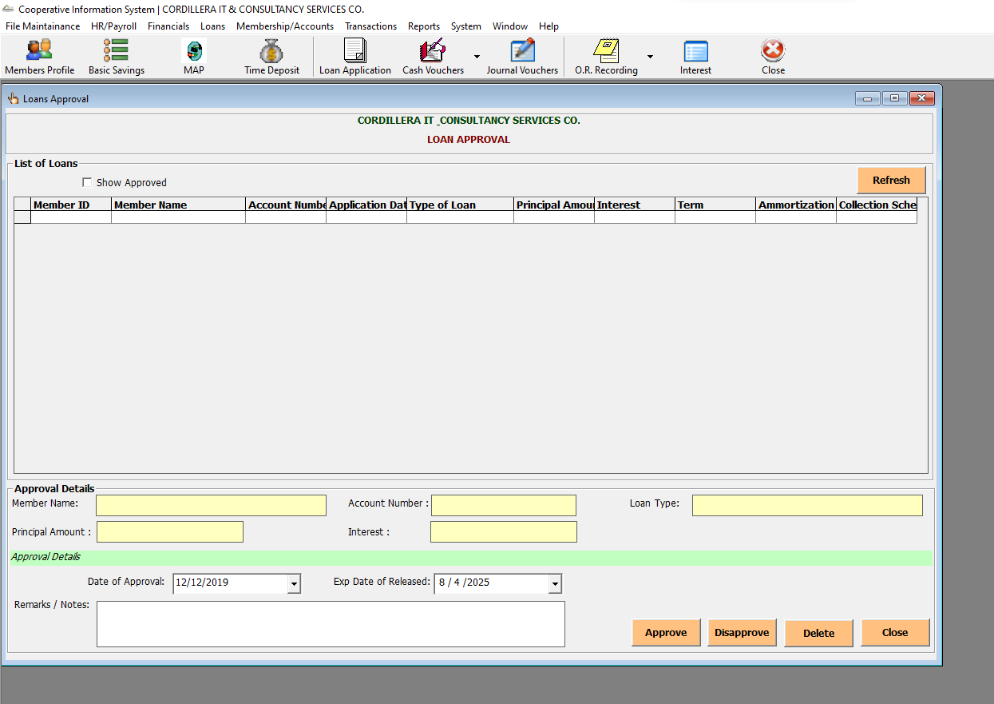

Loans-> Loan Processing

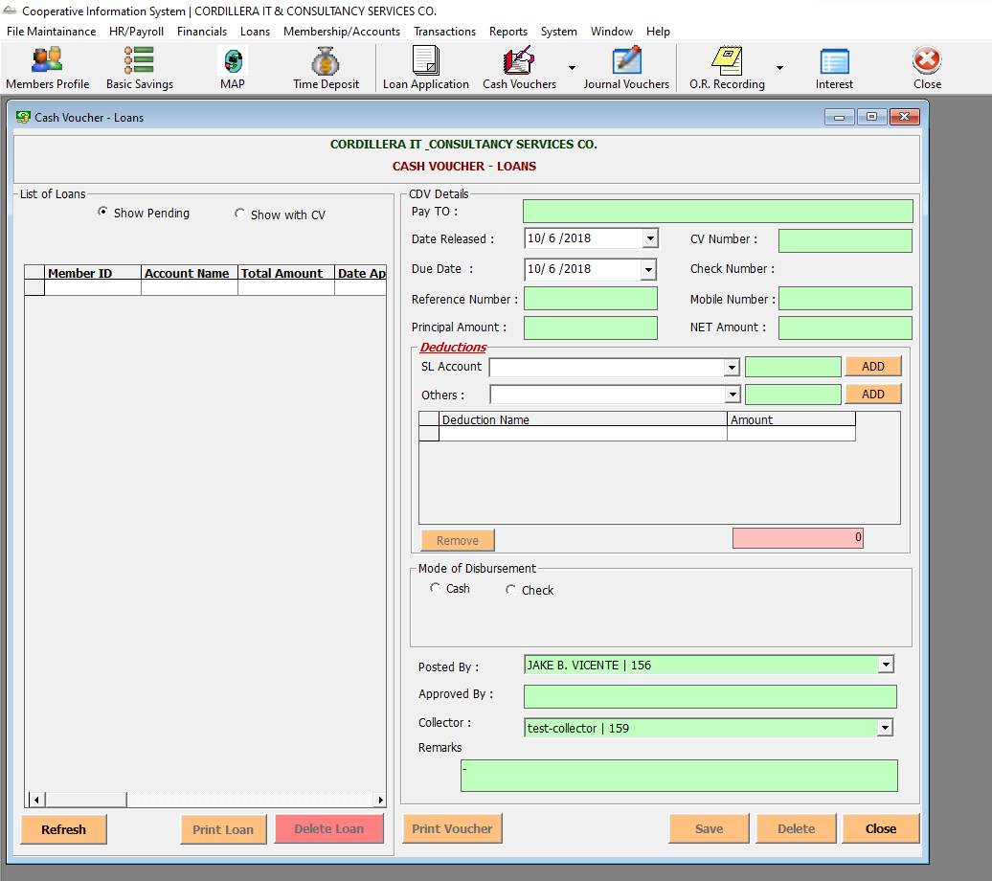

Loans-> Past Due Loans

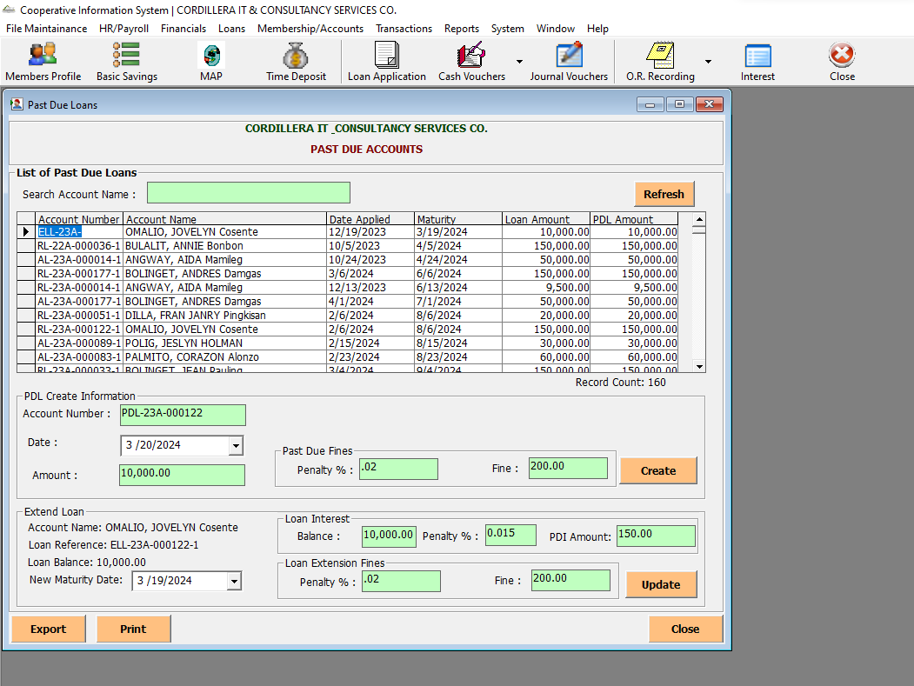

Loans-> Rebates Entry

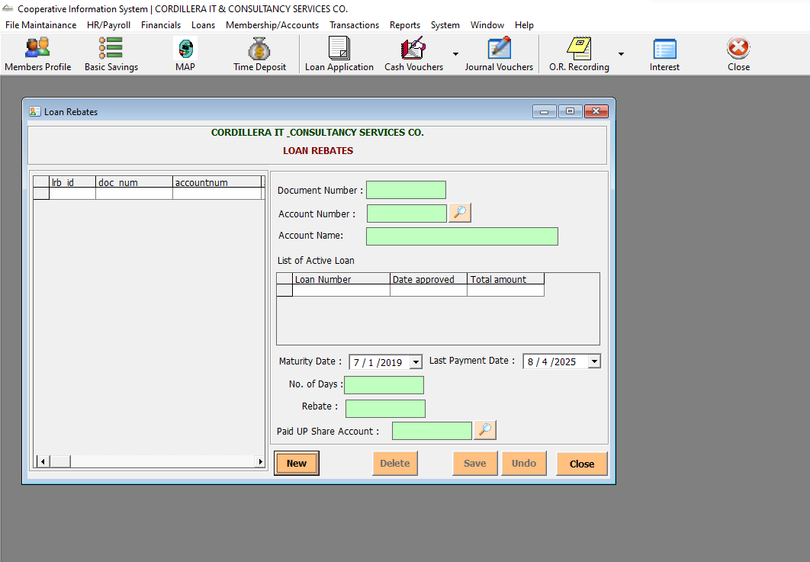

Loans-> Extend Loans

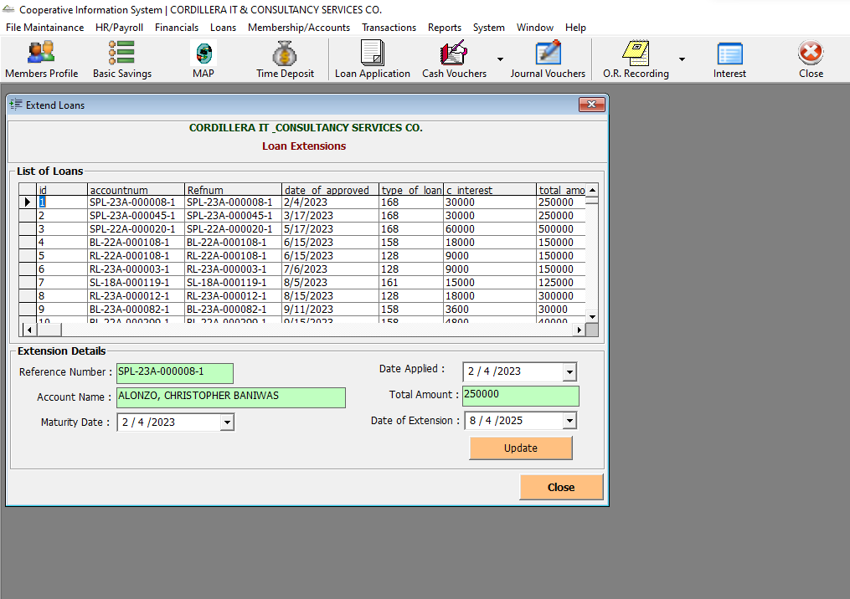

Membership/Accounts-> Membership-> Basic Profile

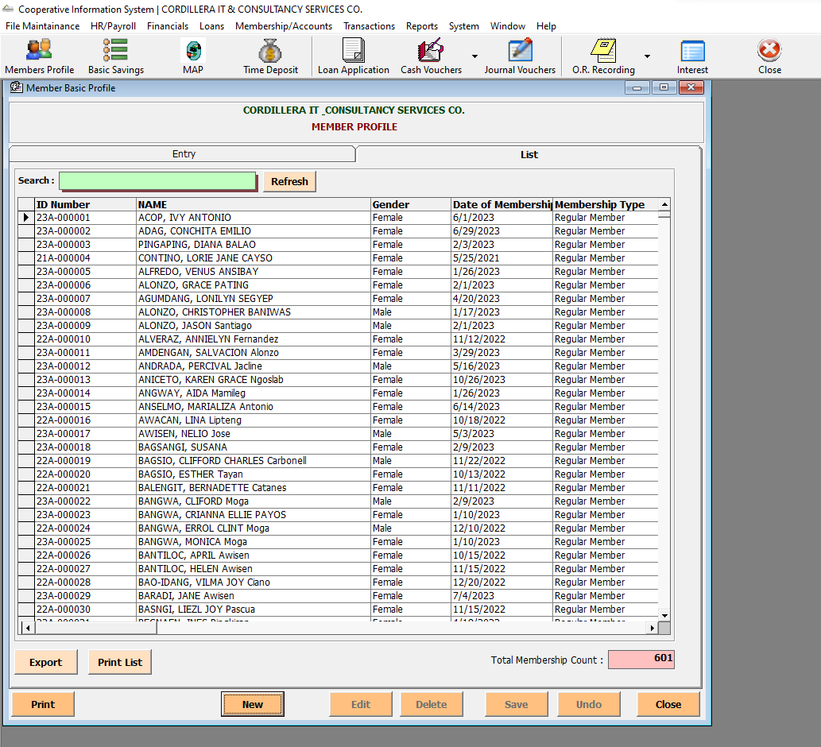

Membership/Accounts-> Manage Accounts -> Share Capital Account

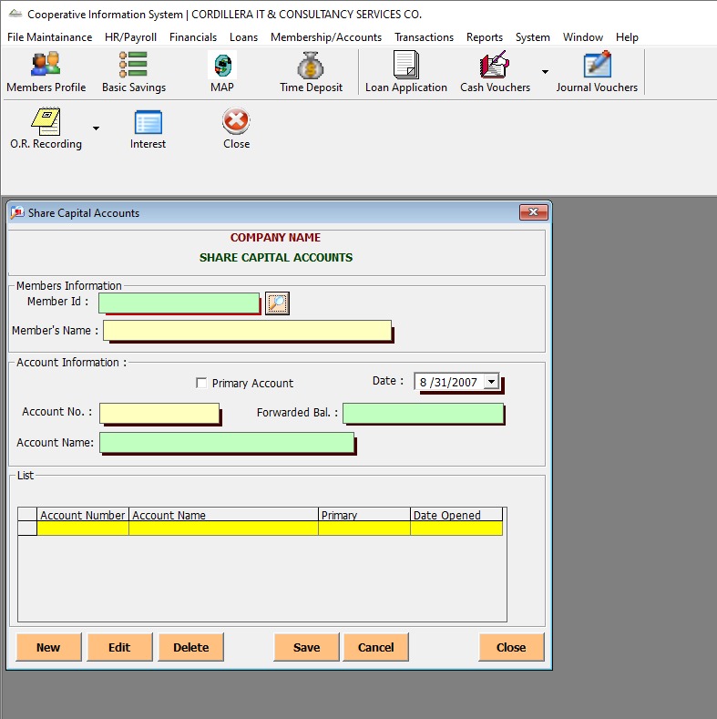

Membership/Accounts-> Manage Accounts -> Basic Savings

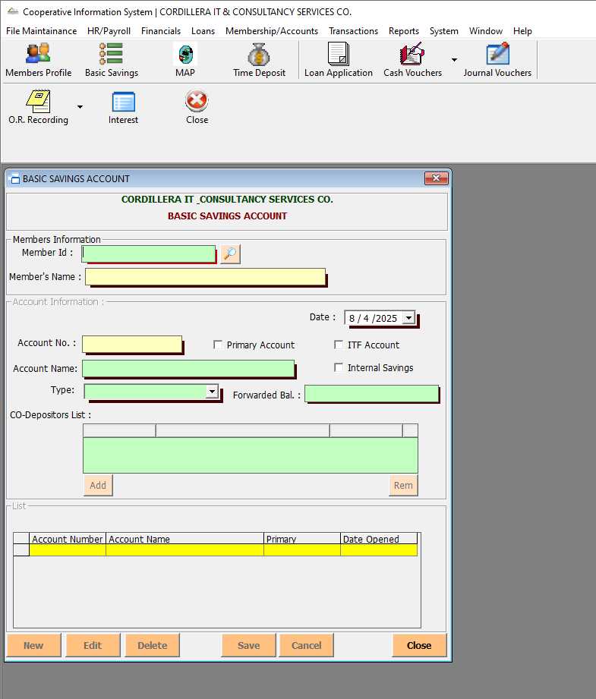

Membership/Accounts-> Manage Accounts -> Special Savings Account

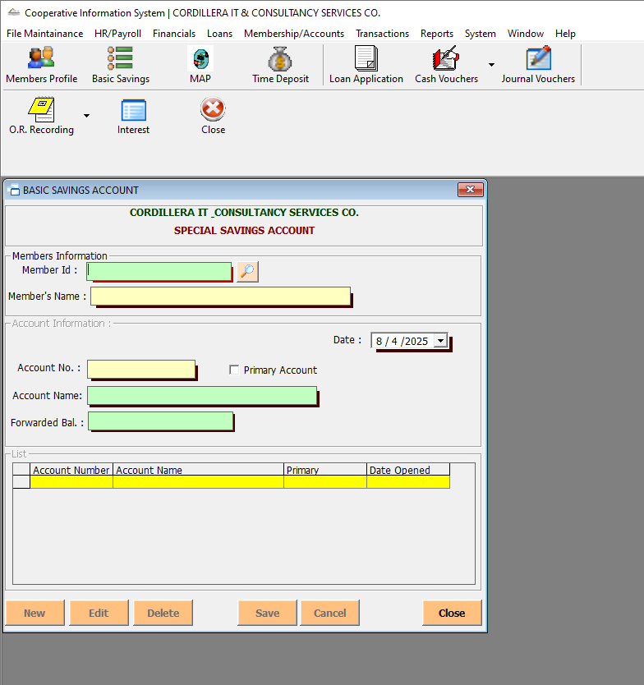

Membership/Accounts-> Manage Accounts -> Cash Bond

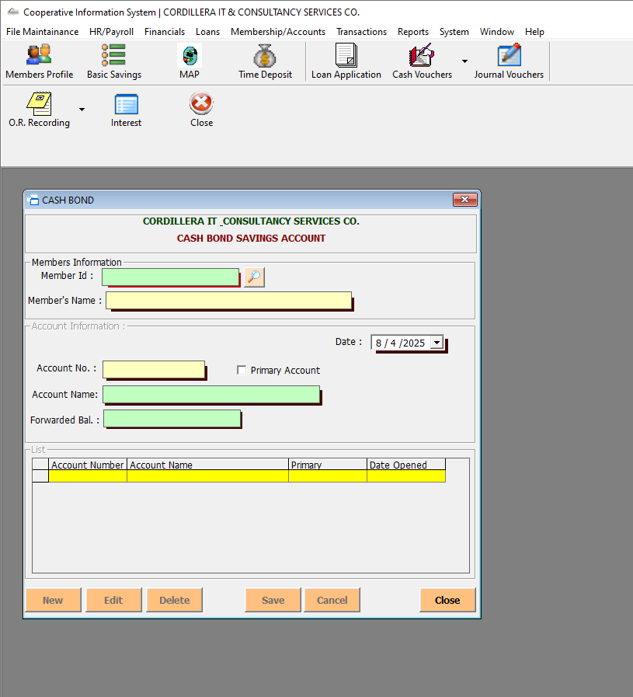

Membership/Accounts-> Manage Accounts -> Kiddie Account

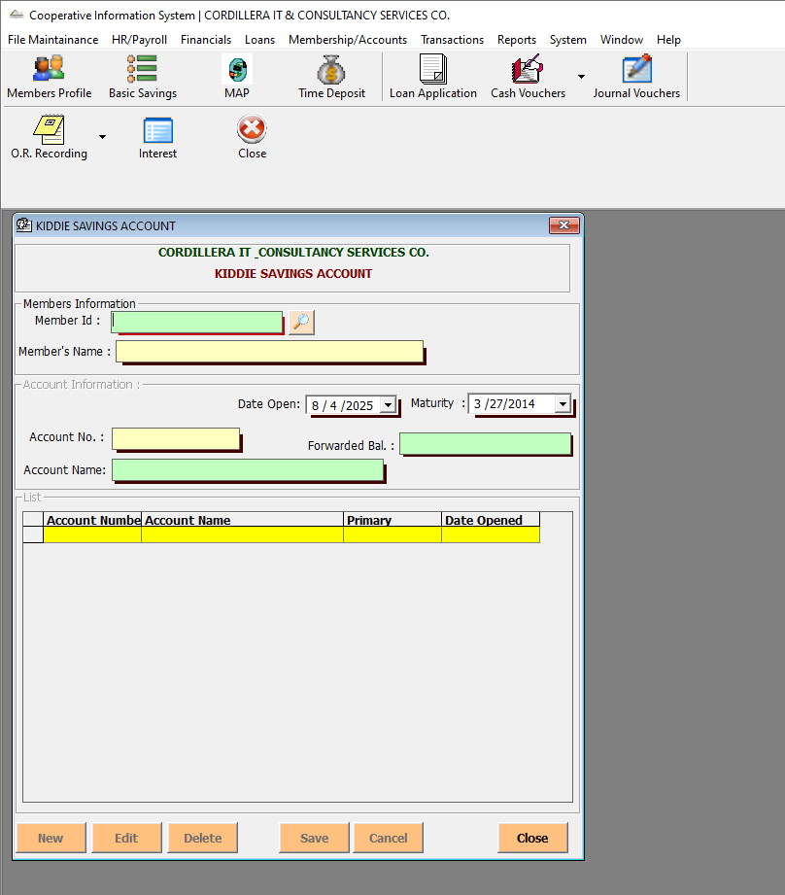

Membership/Accounts-> Manage Accounts -> Mortuary Fund

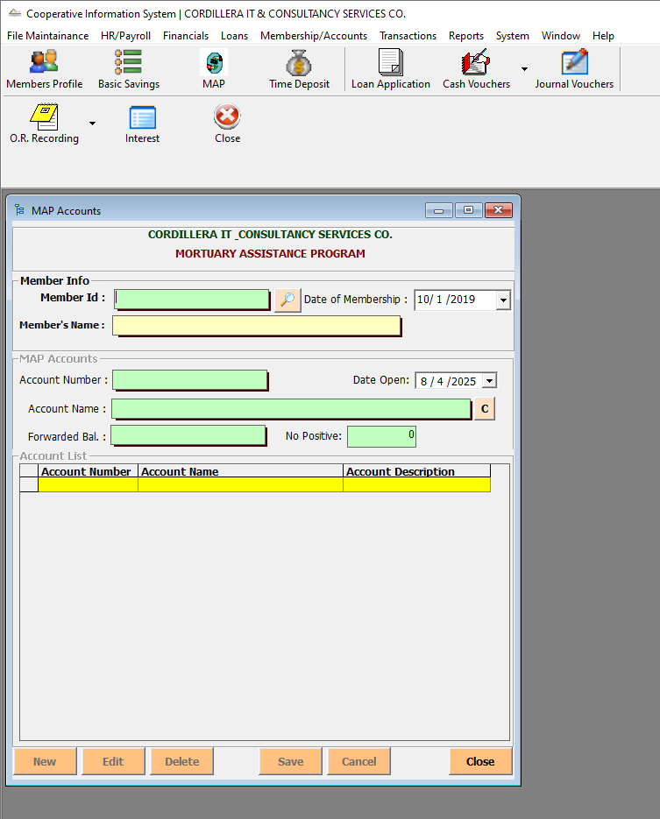

Membership/Accounts-> Manage Accounts -> Time Deposits

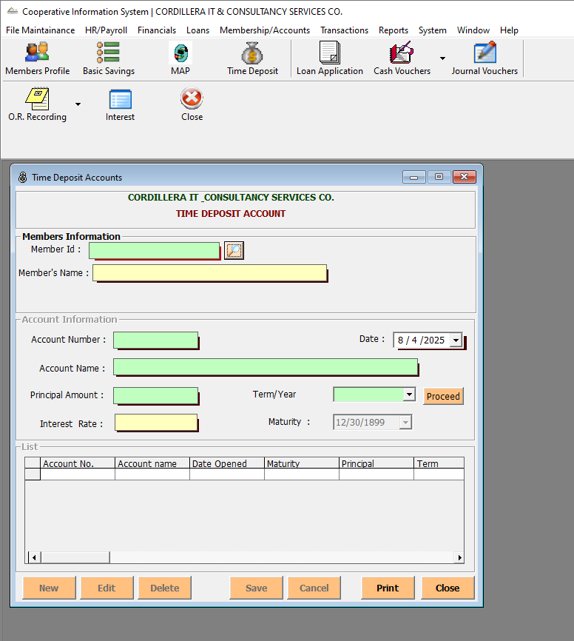

Membership/Accounts-> Manage Accounts -> Update Account Name

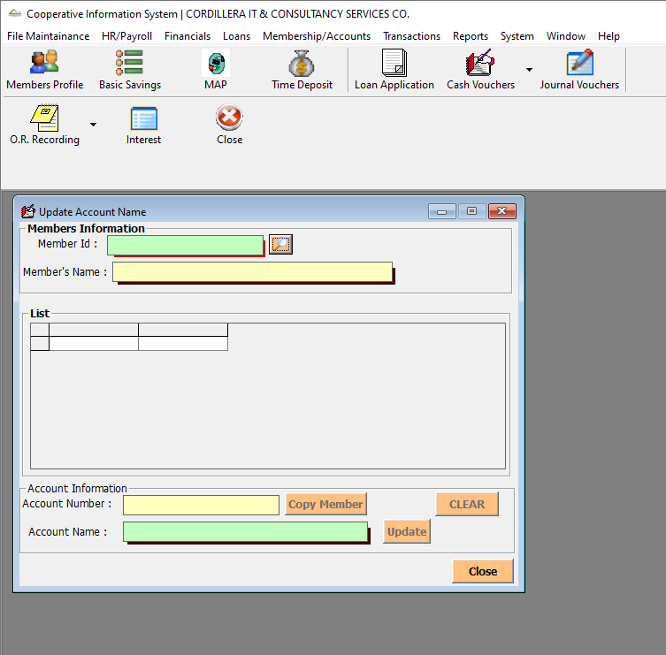

Membership/Accounts-> Manage Accounts -> Freeze Accounts

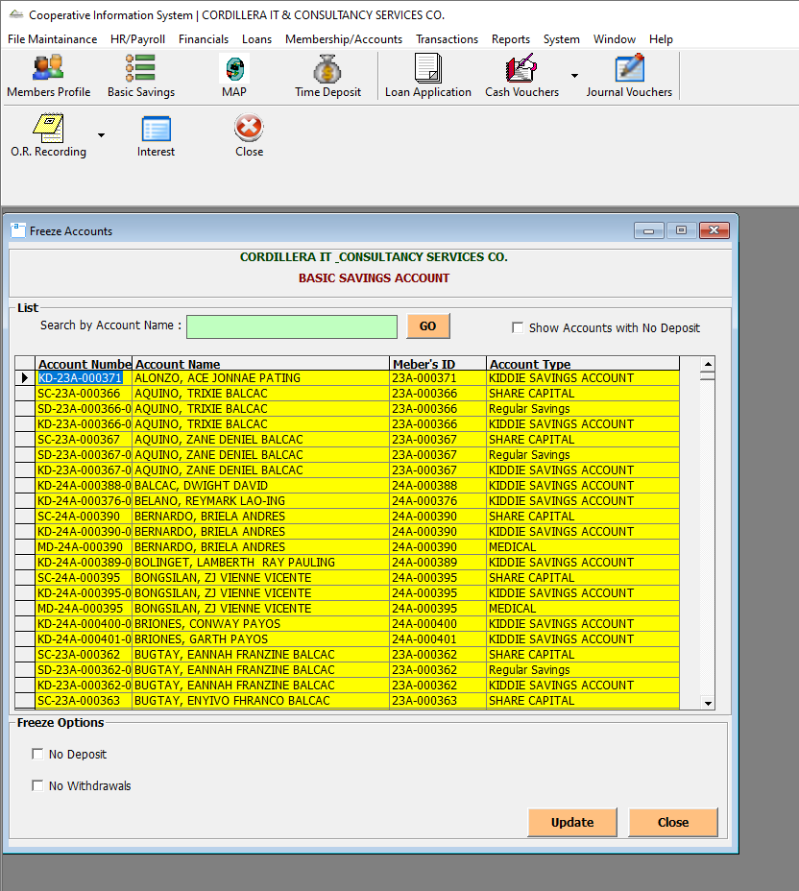

Membership/Accounts-> Manage Accounts -> Close Accounts

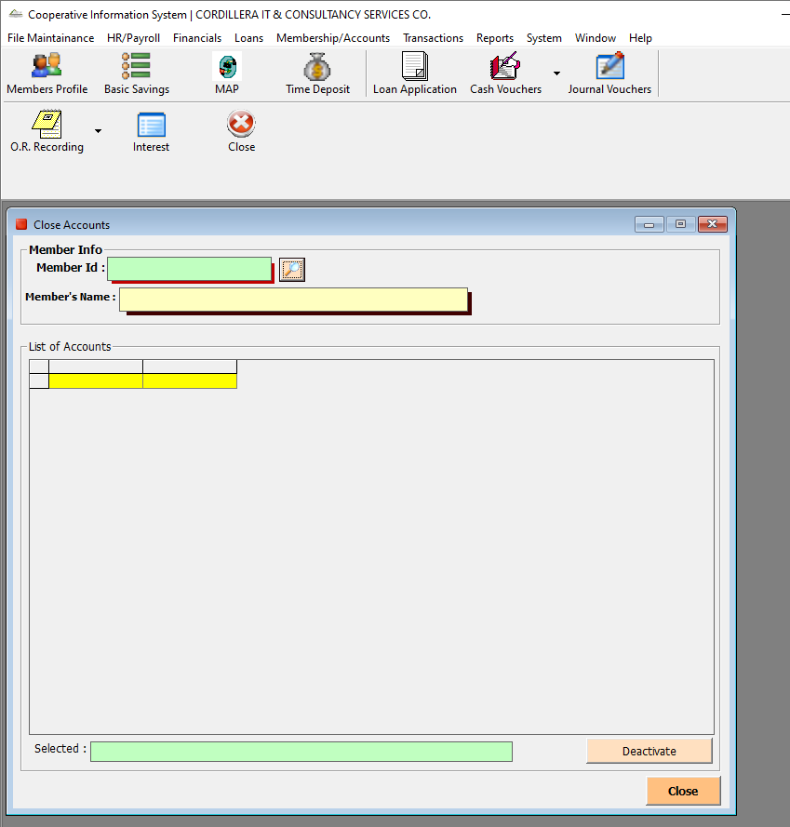

Transactions-> Teller Window

Transactions-> Official Receipt Recording

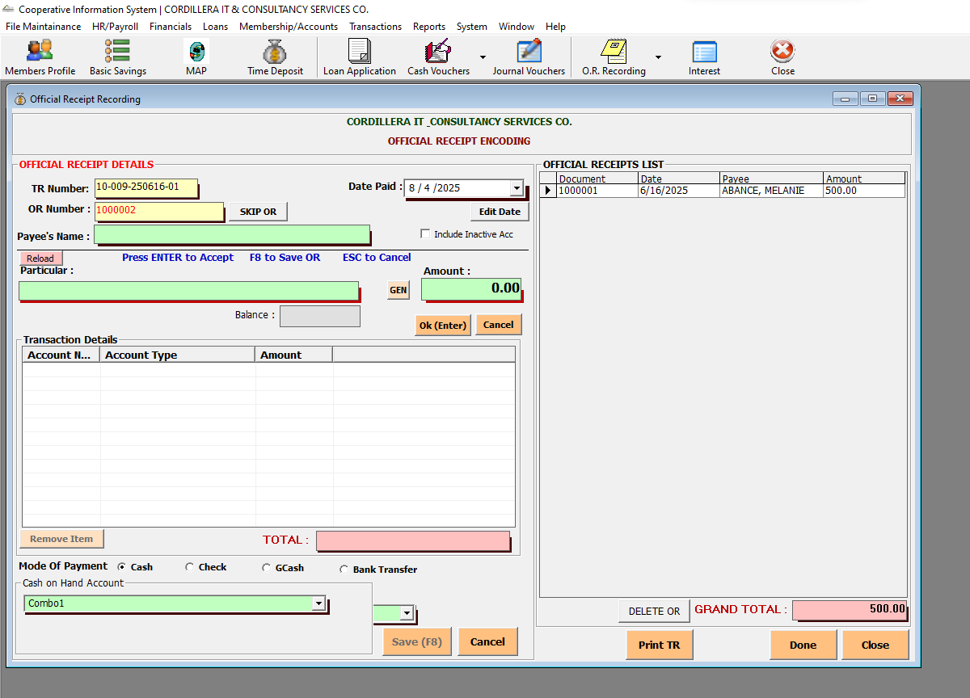

Transactions-> OR Modifications-> Cancel OR

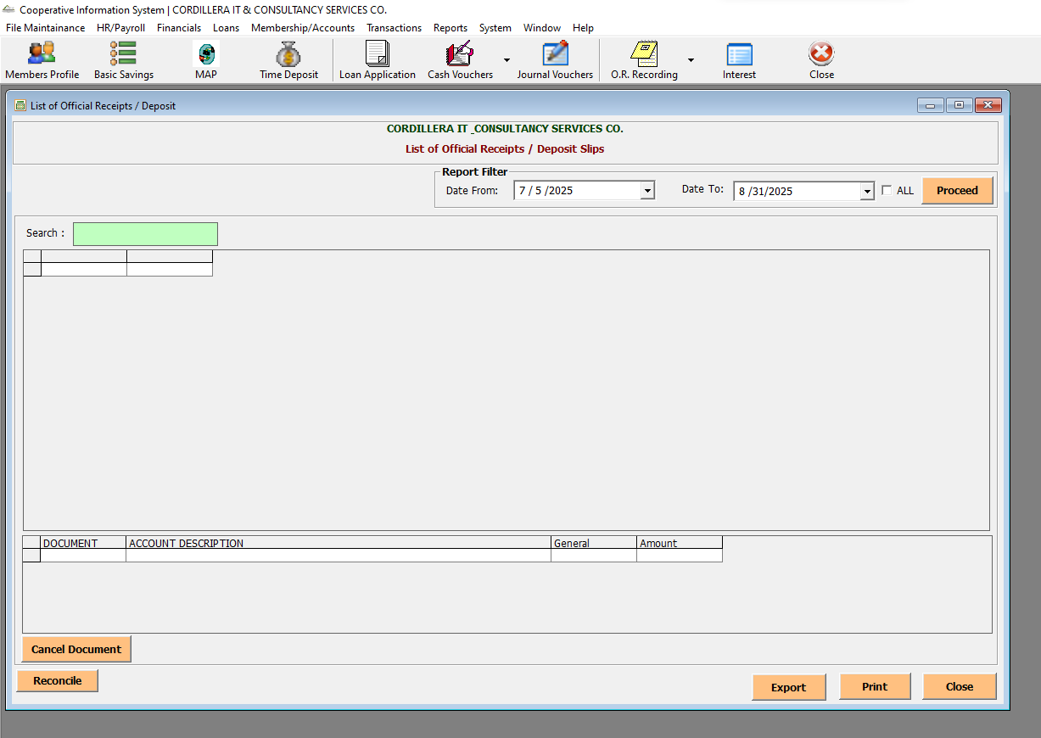

Transactions-> OR Modifications-> Change OR Number

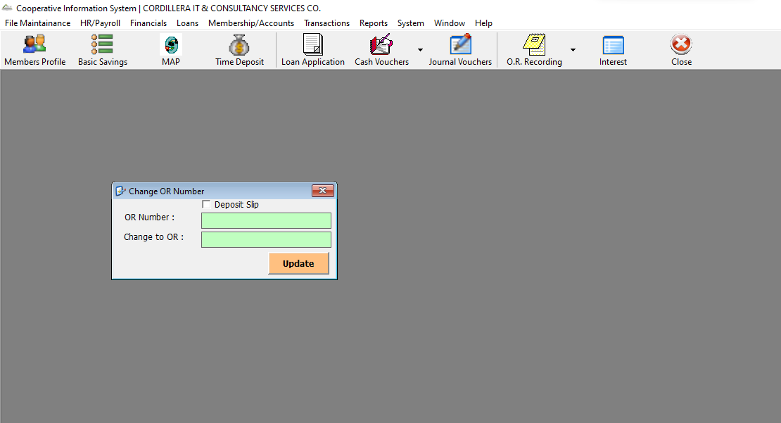

Transactions-> OR Modifications-> Change OR Date

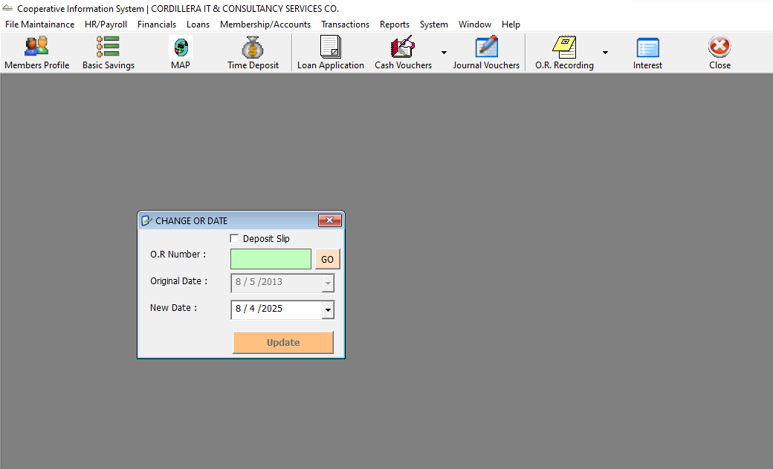

Transactions-> OR Modifications-> Change ORs TR Number

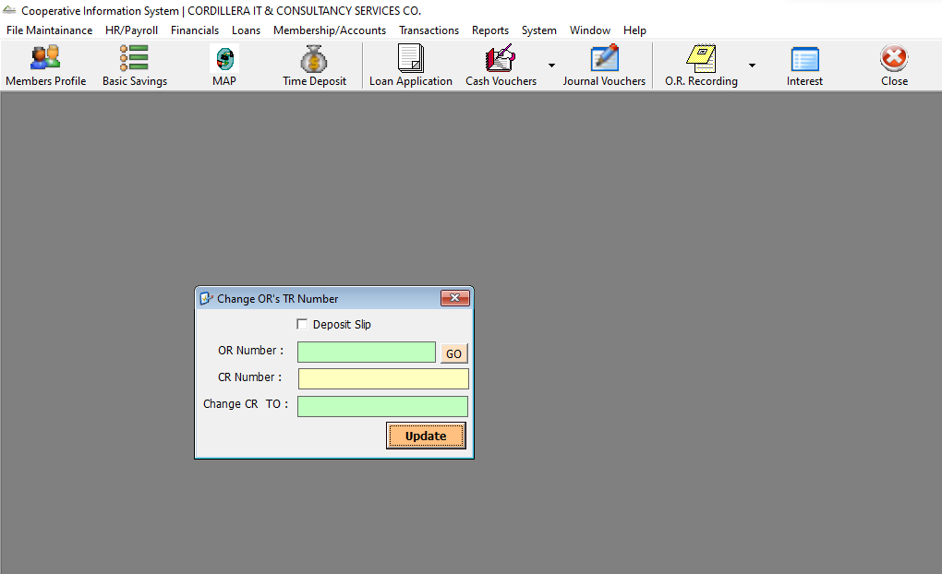

Transactions-> OR Modifications-> Modify Deposit Slip

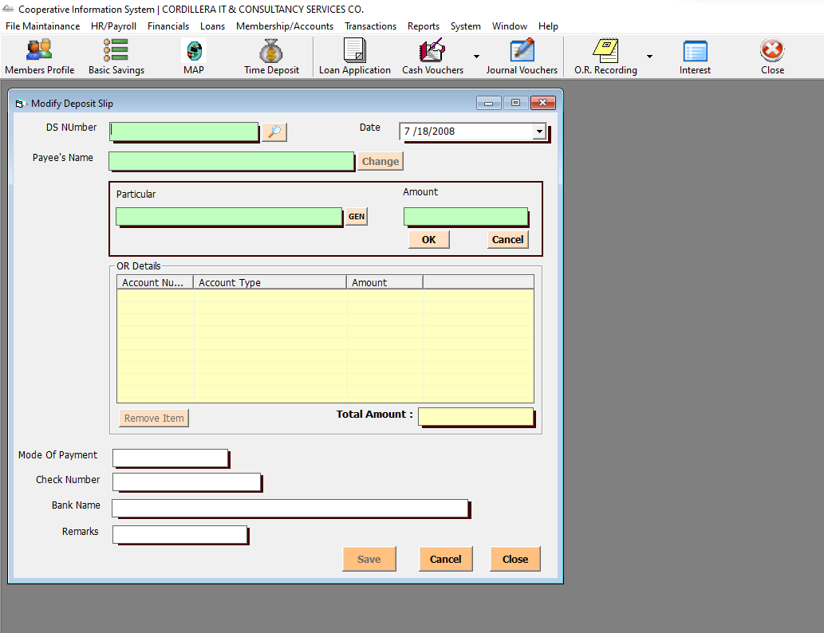

Transactions-> OR Modifications-> Modify OR

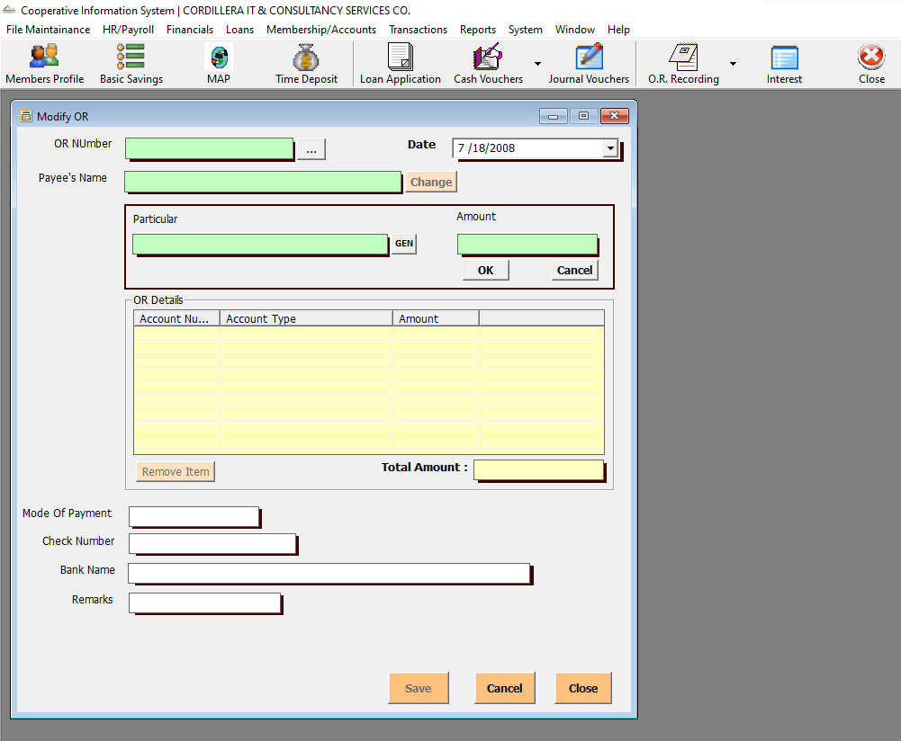

Transactions-> TR Processing-> Accept TR

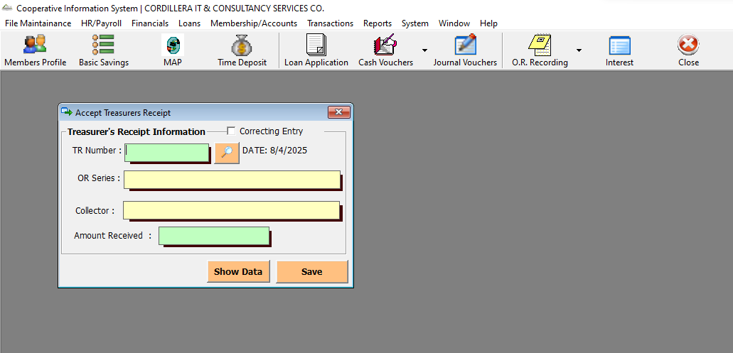

Transactions-> TR Processing-> Validate/View TR

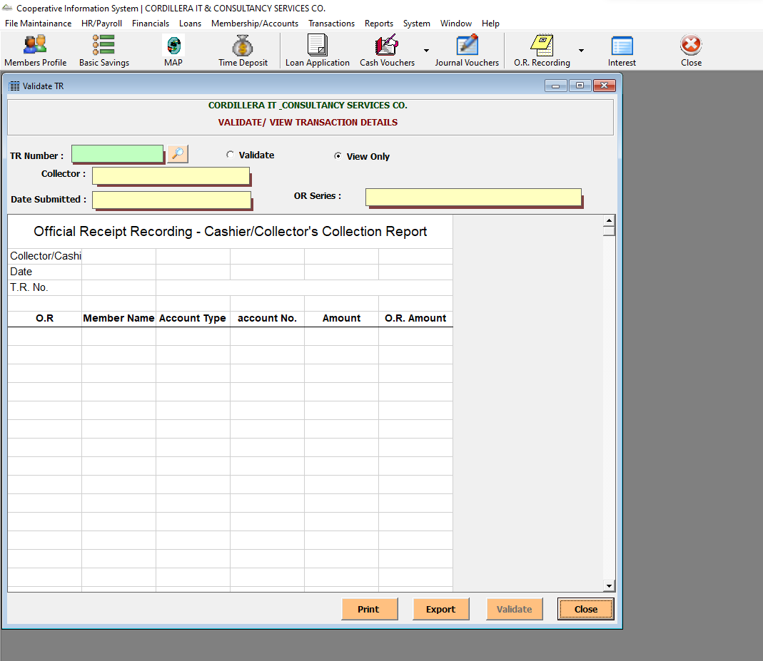

Transactions-> TR Modifications-> Change TR Date

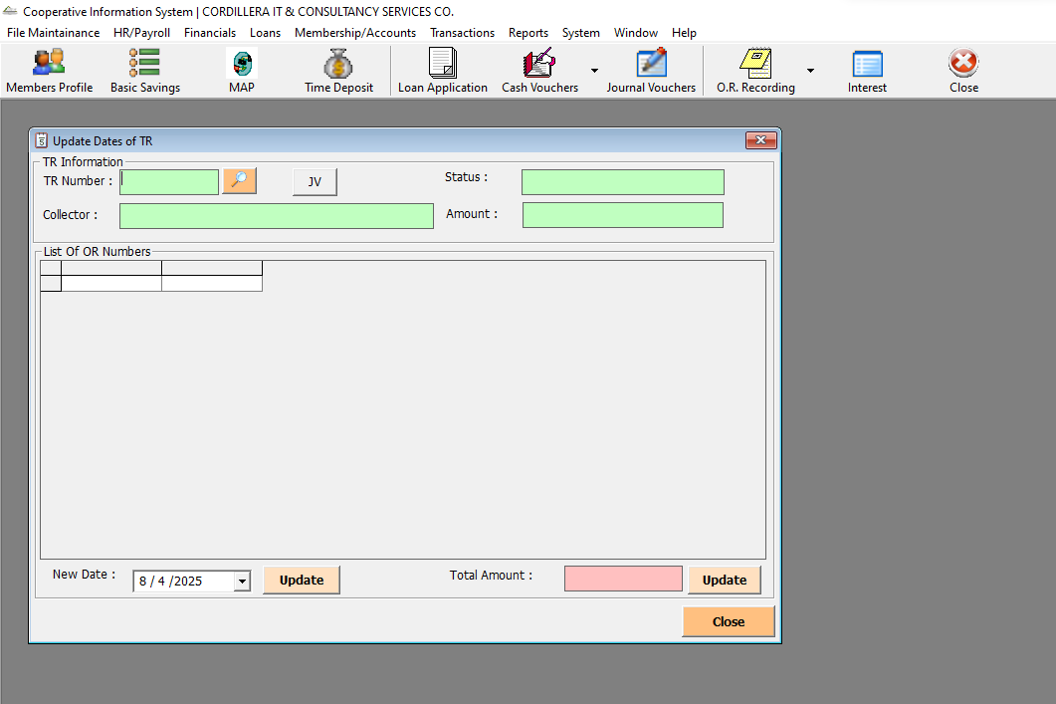

Transactions-> TR Modifications-> Transfer O.R. to Other TR

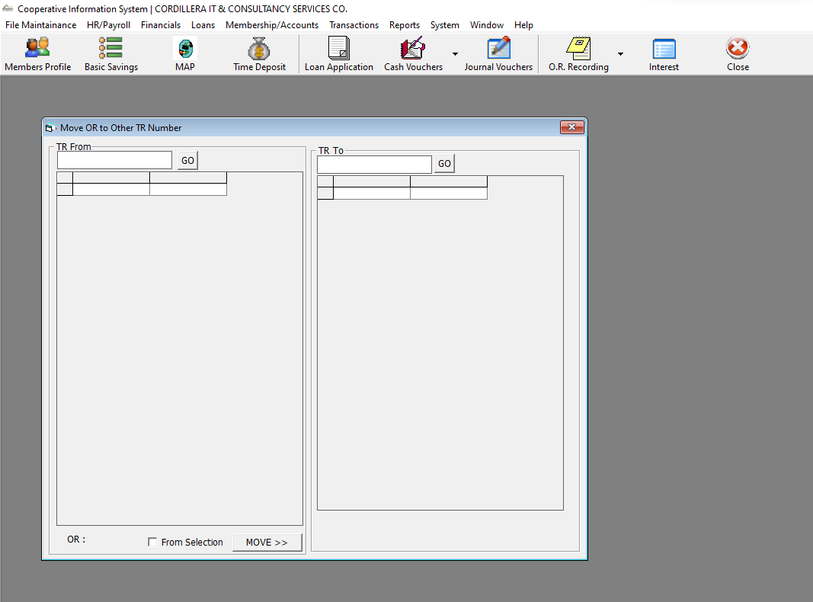

Transactions-> TR Modifications-> Change TR Number

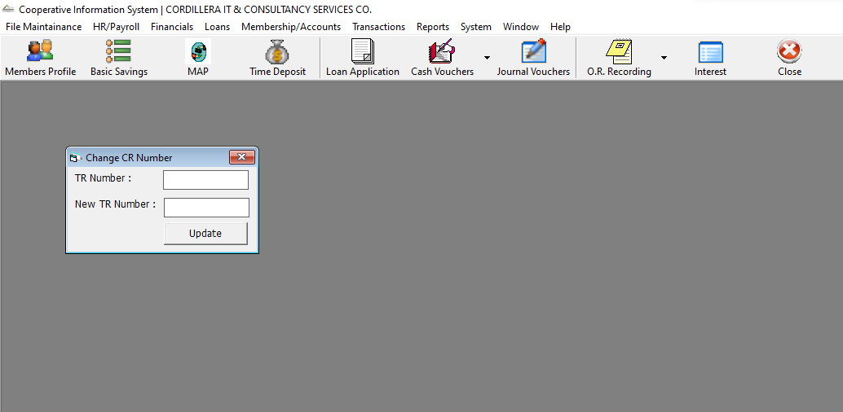

Transactions-> TR Modifications-> Delete TR Number

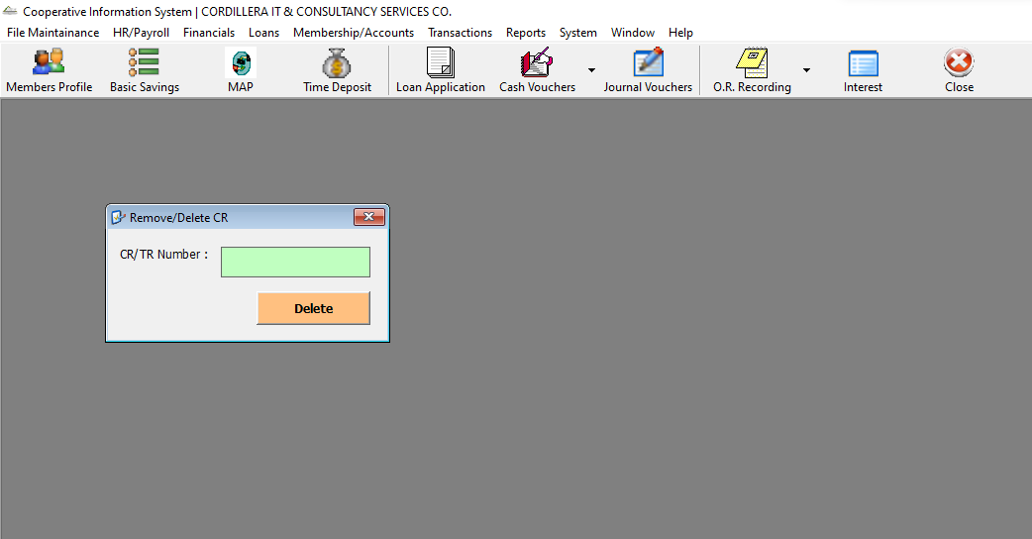

Transactions-> Withdrawals

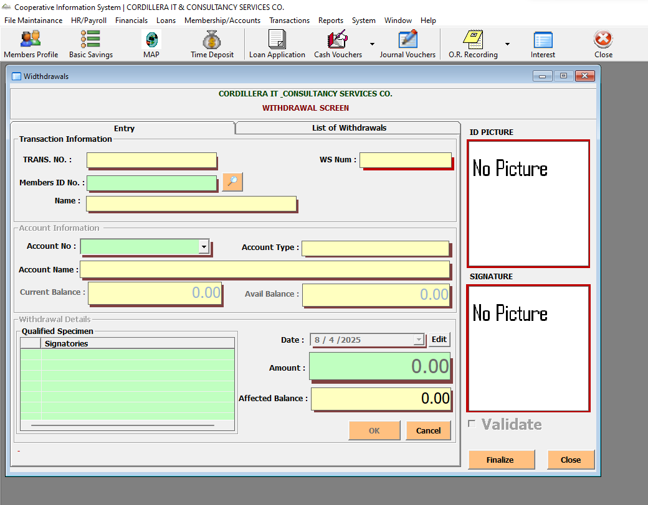

Transactions-> Passbook-> Update Passbook

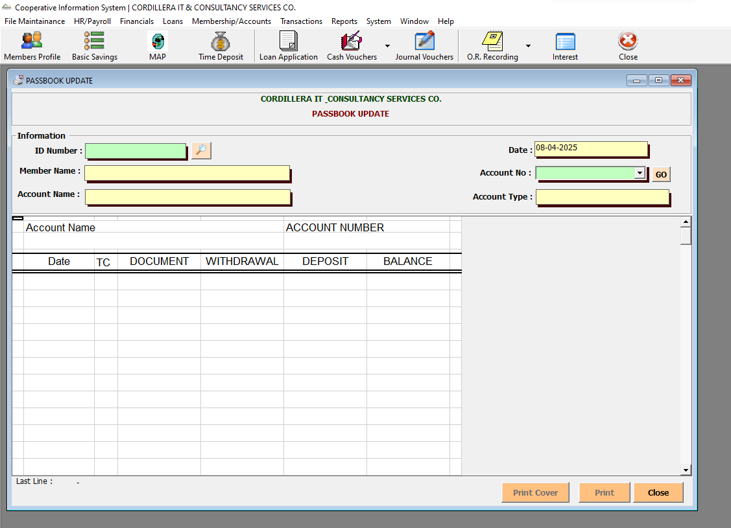

Transactions-> Passbook-> Update Passbook Loans

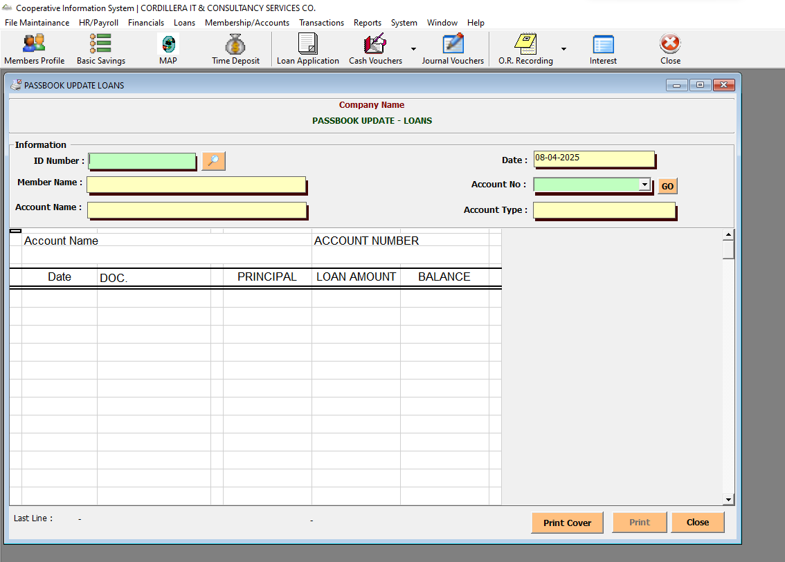

Transactions-> Passbook-> Passbook Logs

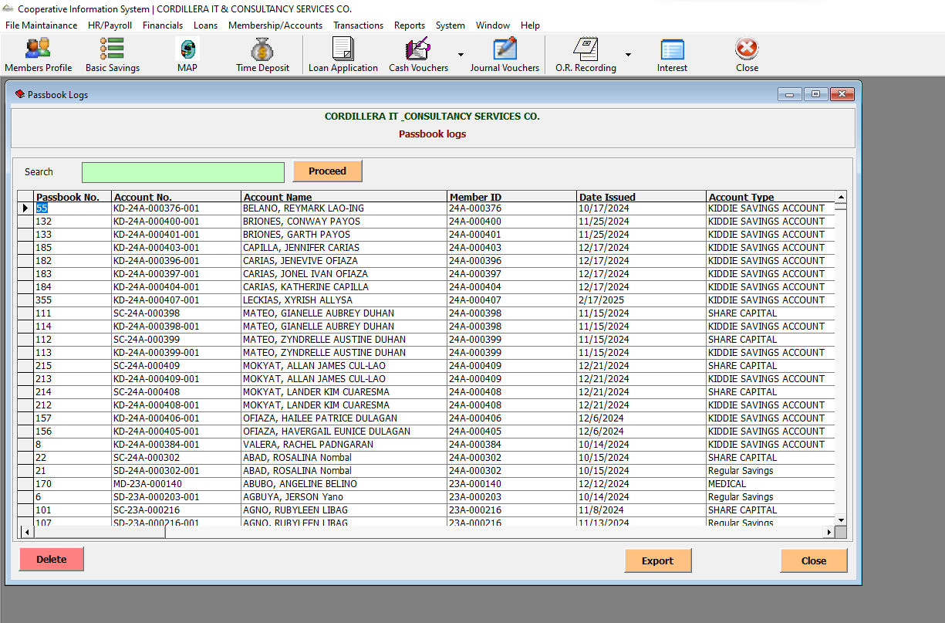

Transactions-> Passbook-> Passbook Fix

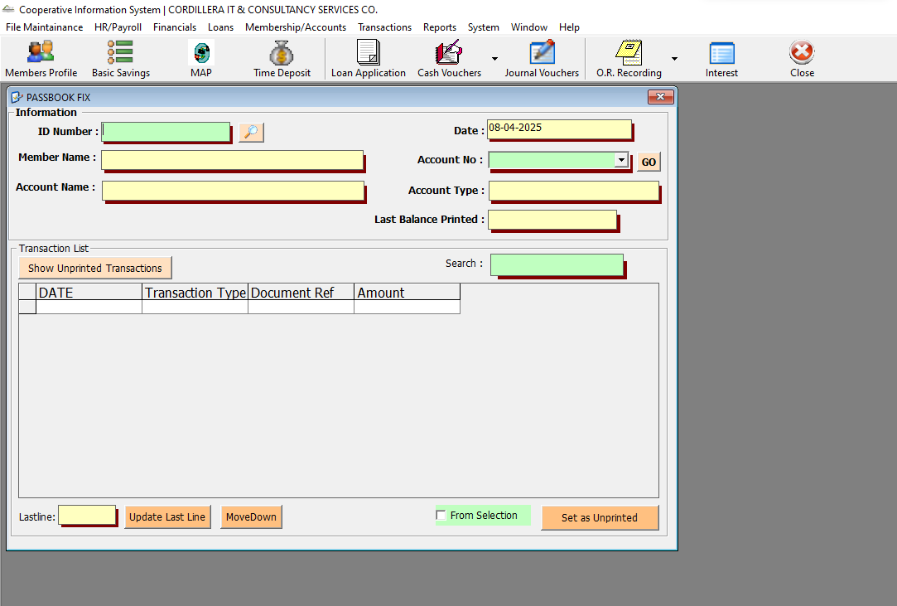

Transactions-> Process MAP Benefit

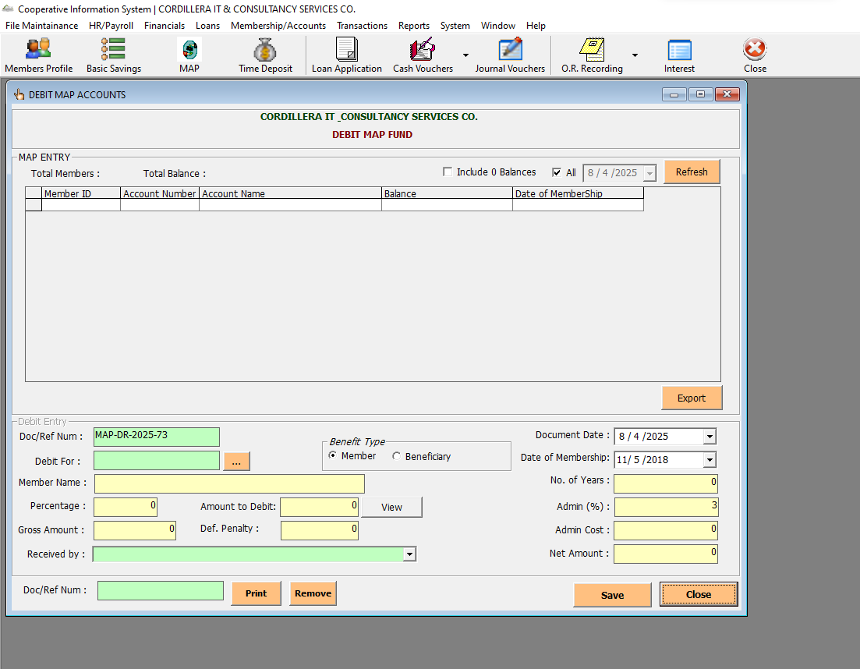

Transactions-> Compute Interest

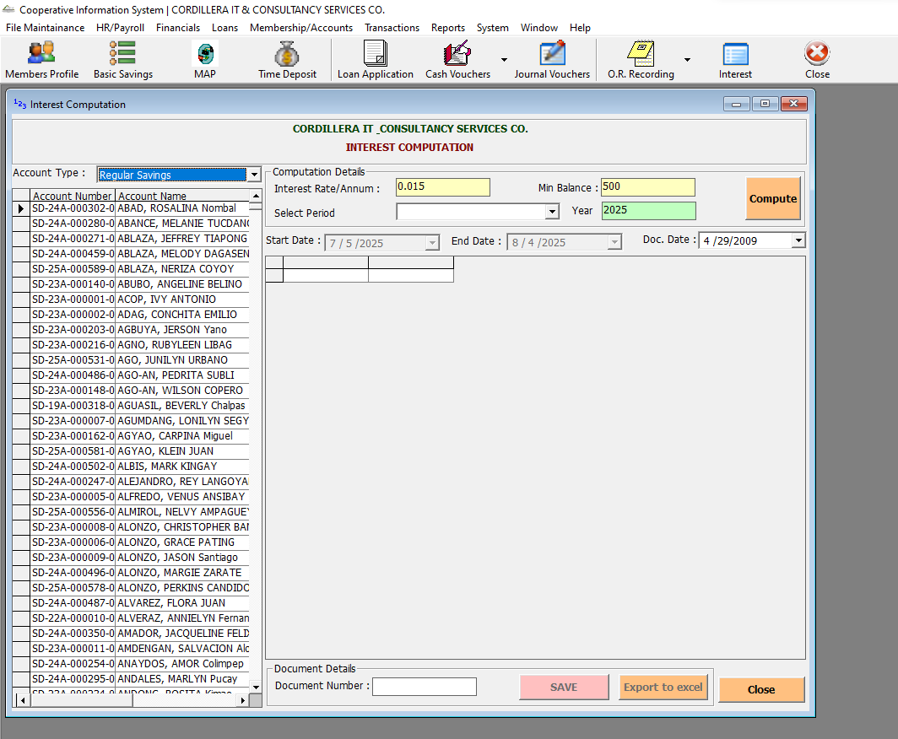

Transactions-> Post Computed Interest

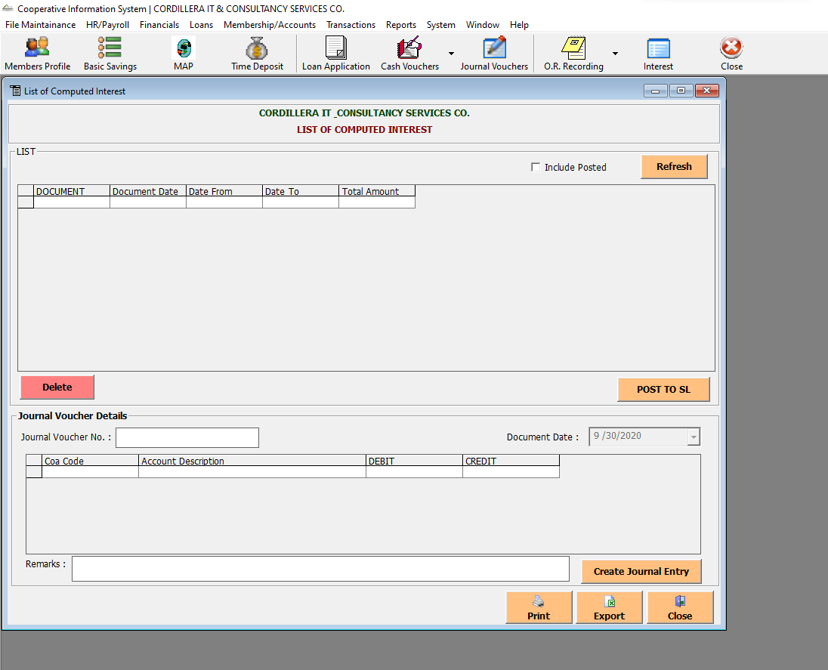

Transactions-> Time Deposit Accrual

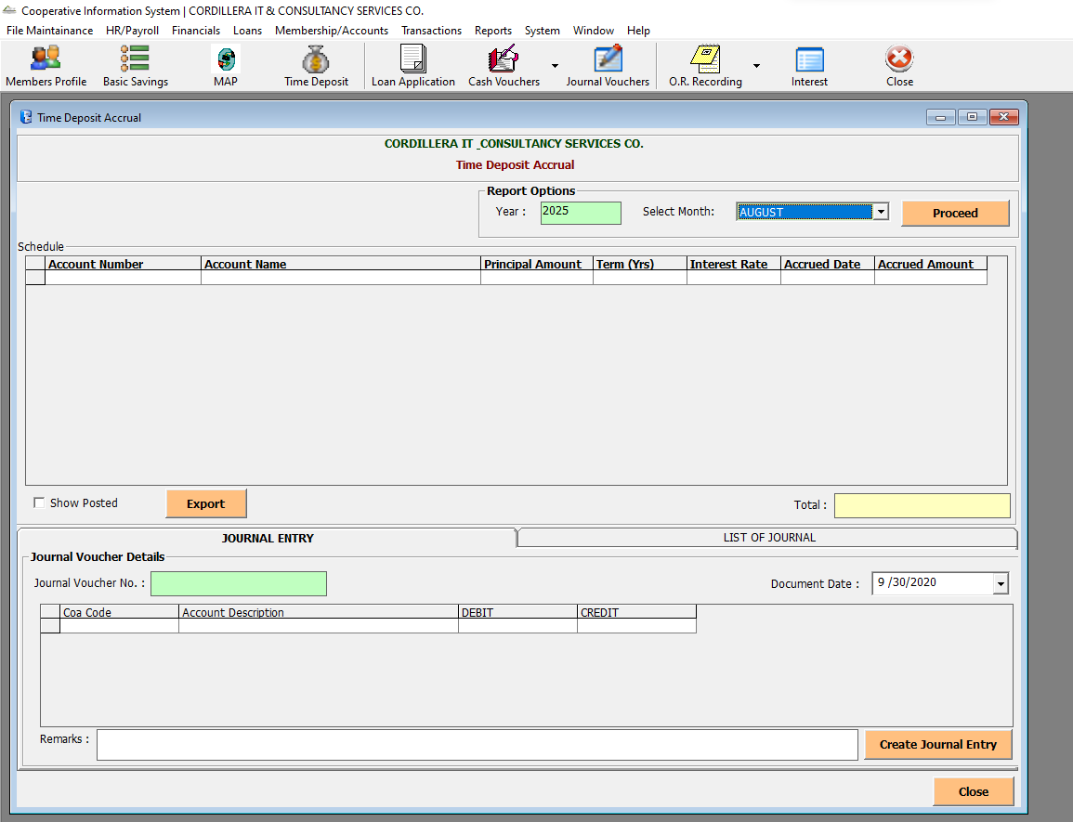

Transactions-> Depreciation Schedule

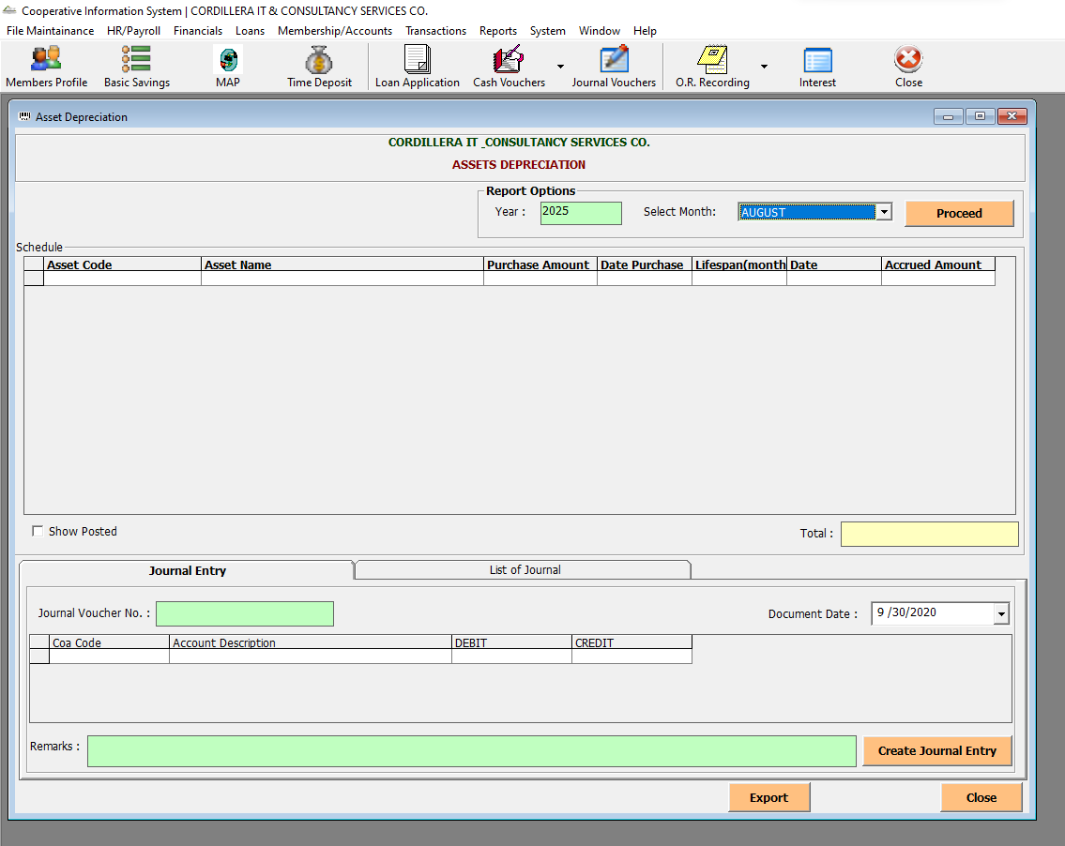

Transactions-> Interest on Share Capital

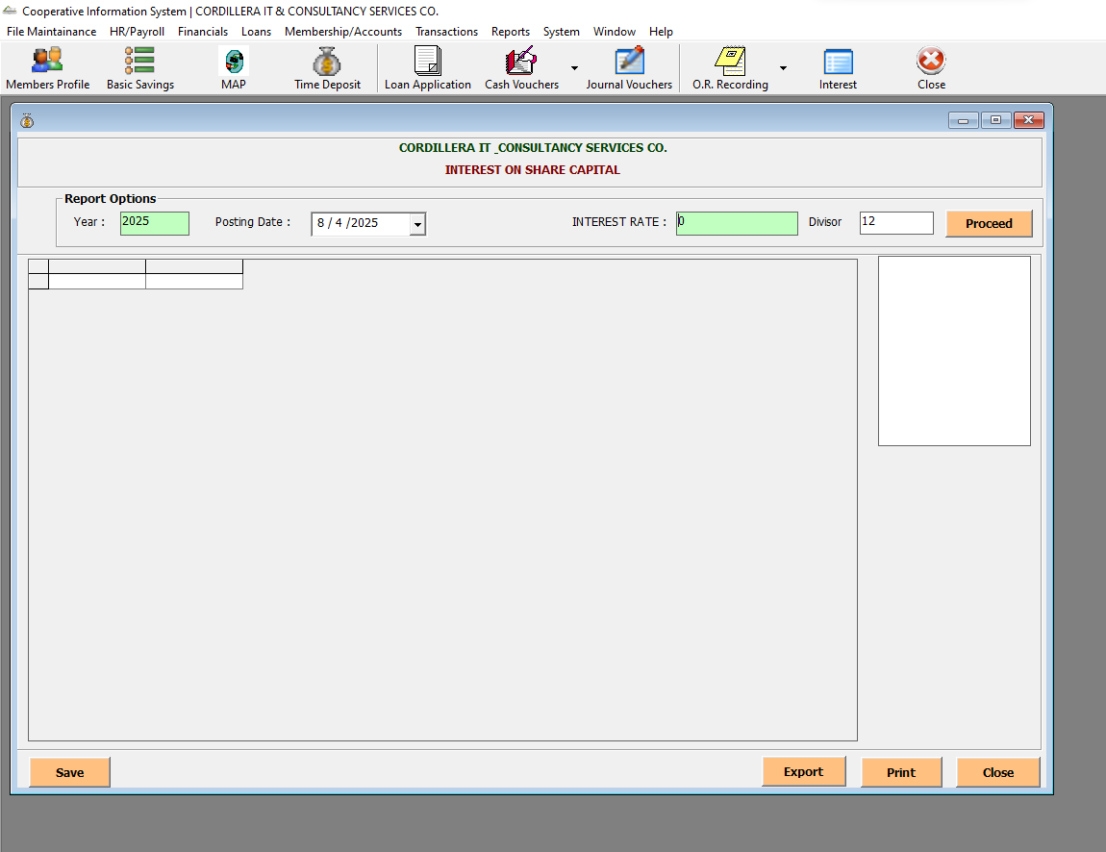

Transactions-> Patronage Refund

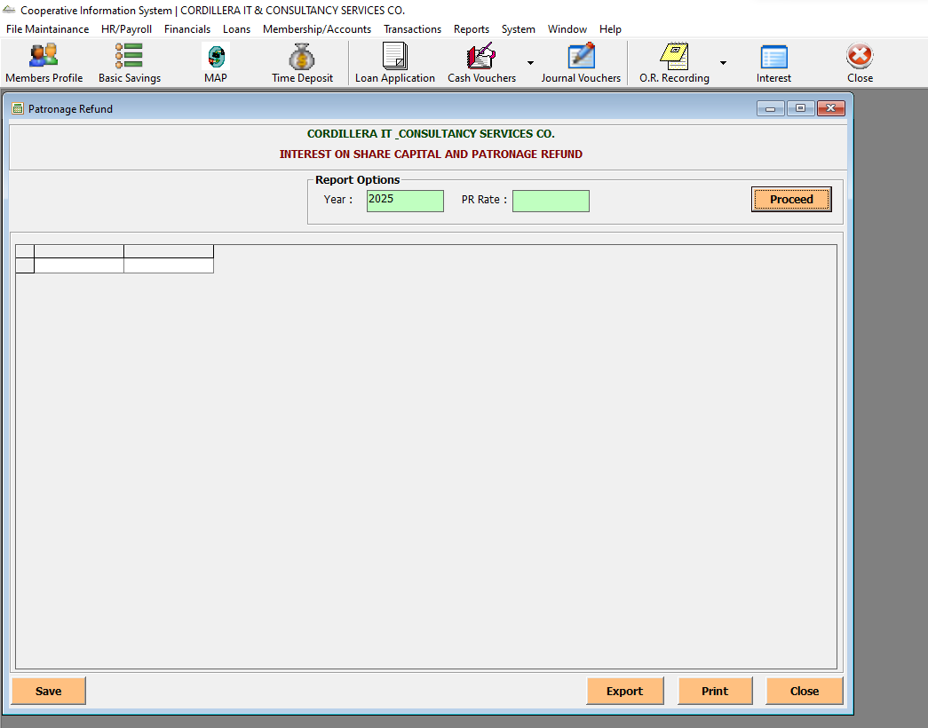

Transactions-> Dividends Distribution

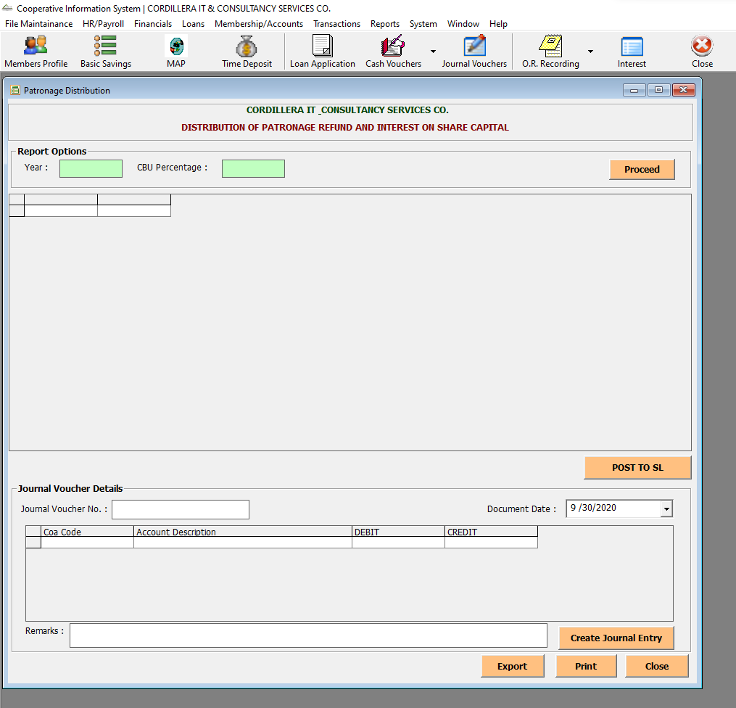

Transactions-> Vouchers-> Cash Voucher – Loans

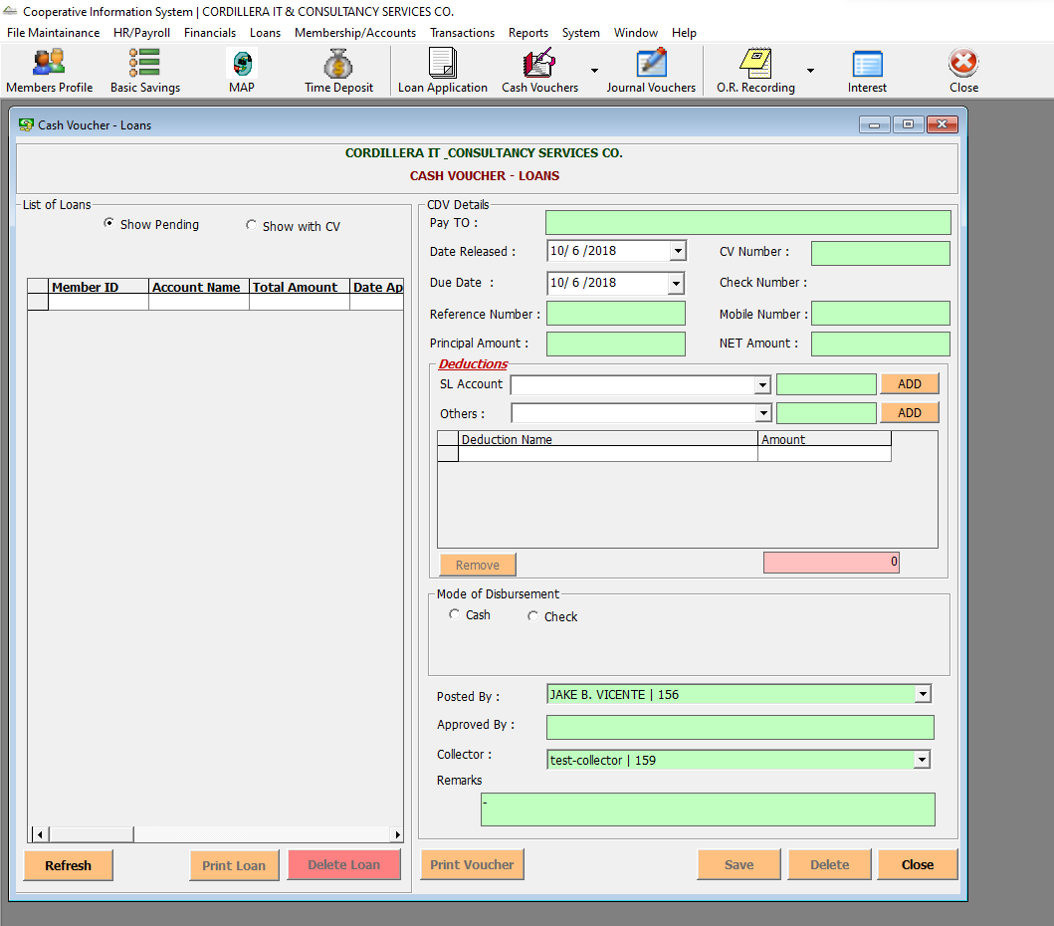

Transactions-> Vouchers-> Cash Voucher – Withdrawals

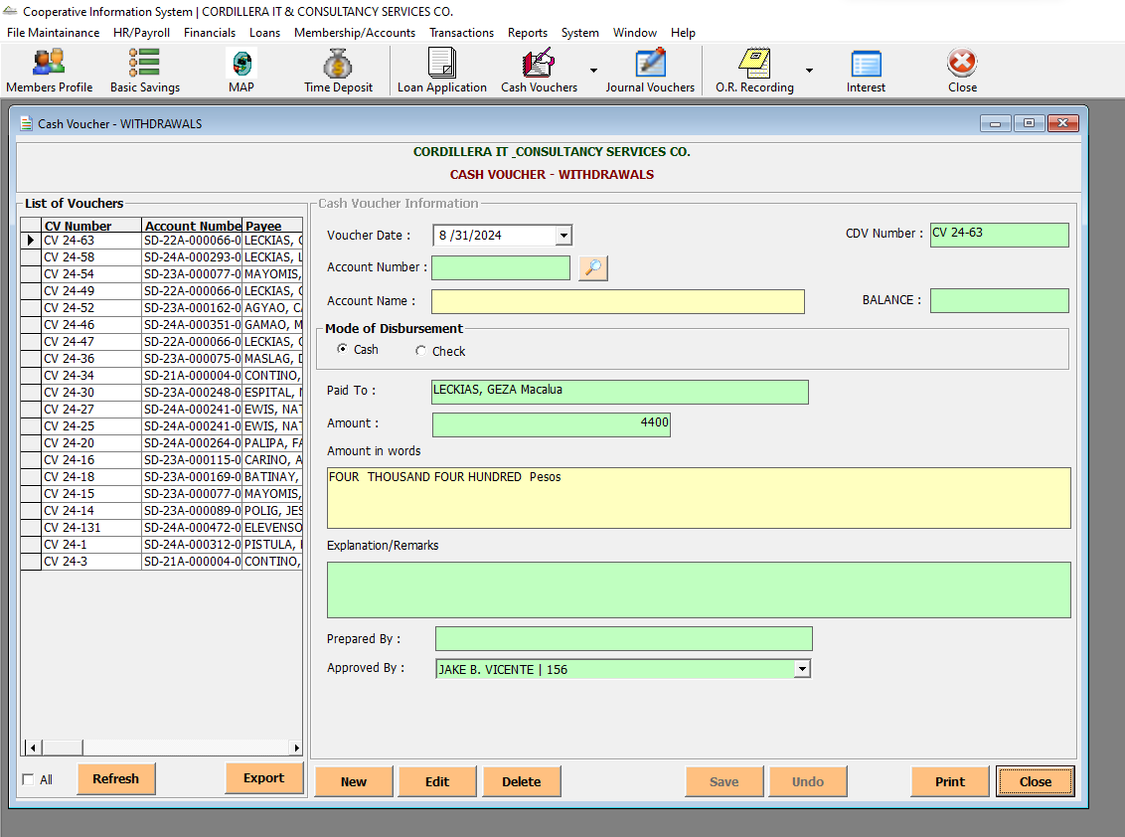

Transactions-> Vouchers-> Cash Voucher – Other

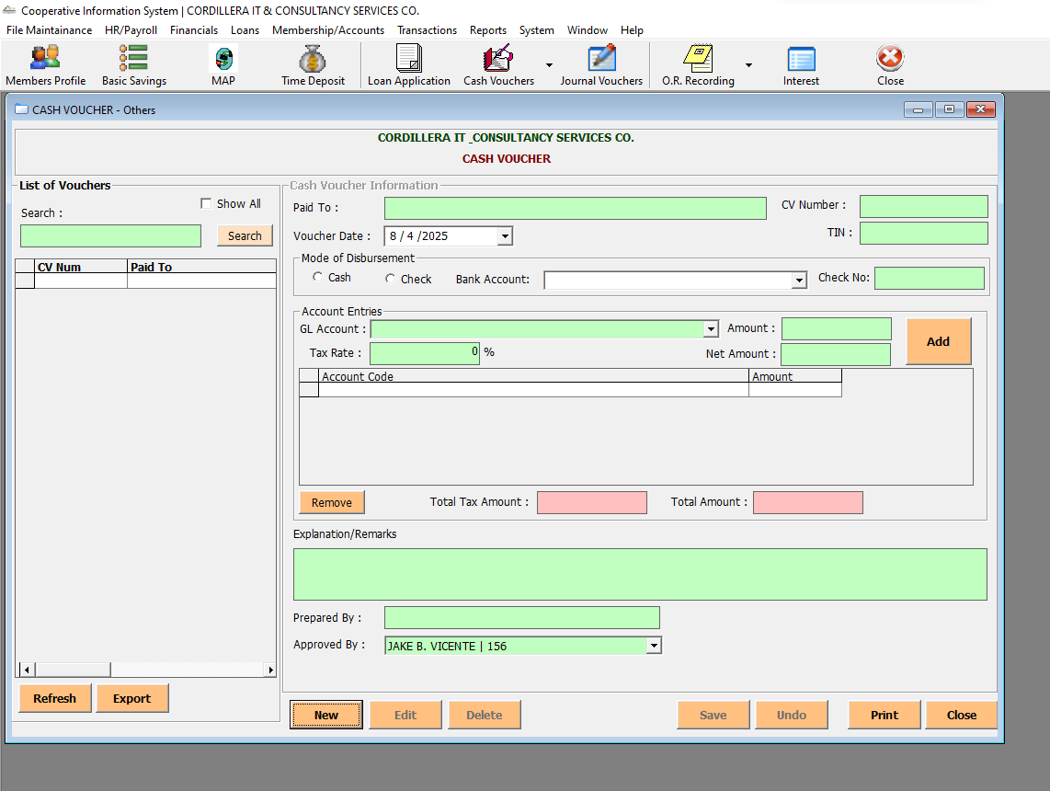

Transactions-> Vouchers-> Cash Voucher – MAP

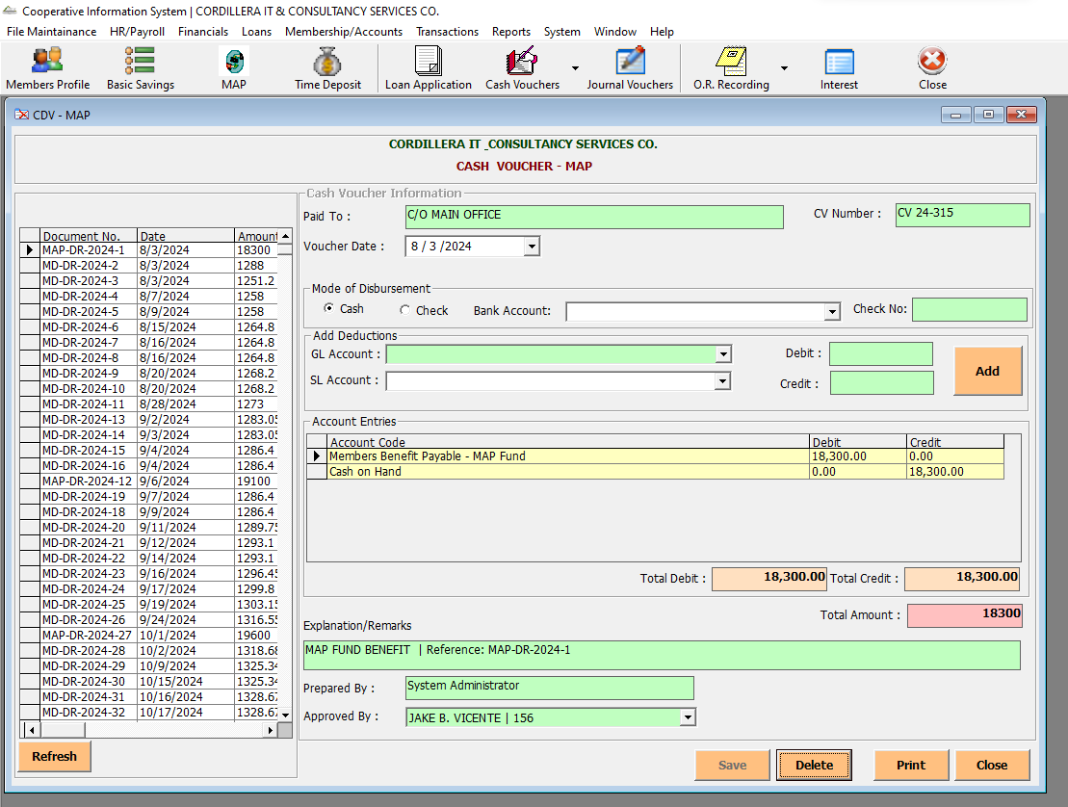

Transactions-> Vouchers-> Cash Voucher - Payroll

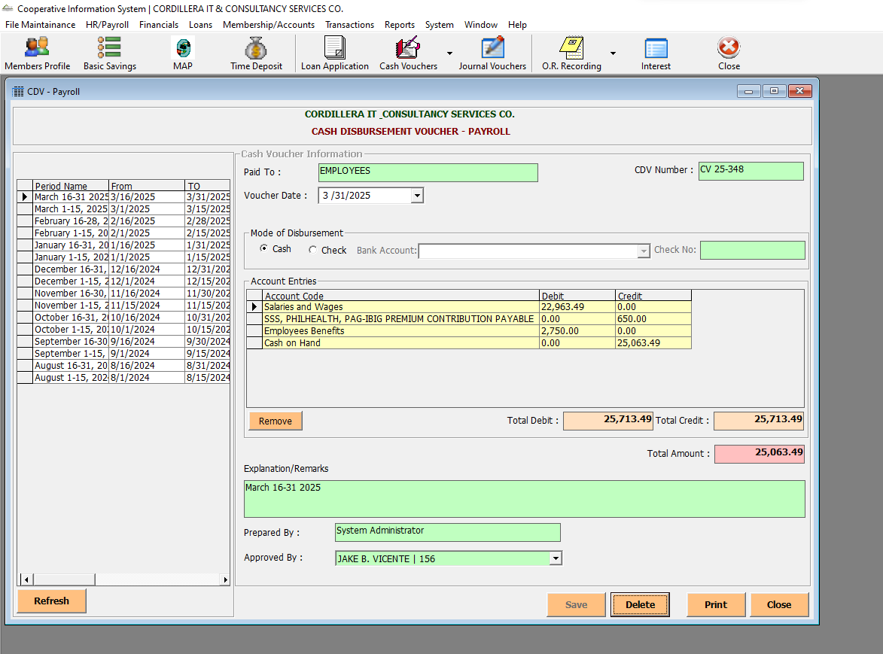

Transactions-> Vouchers-> Cash Voucher – Summary Withdrawals

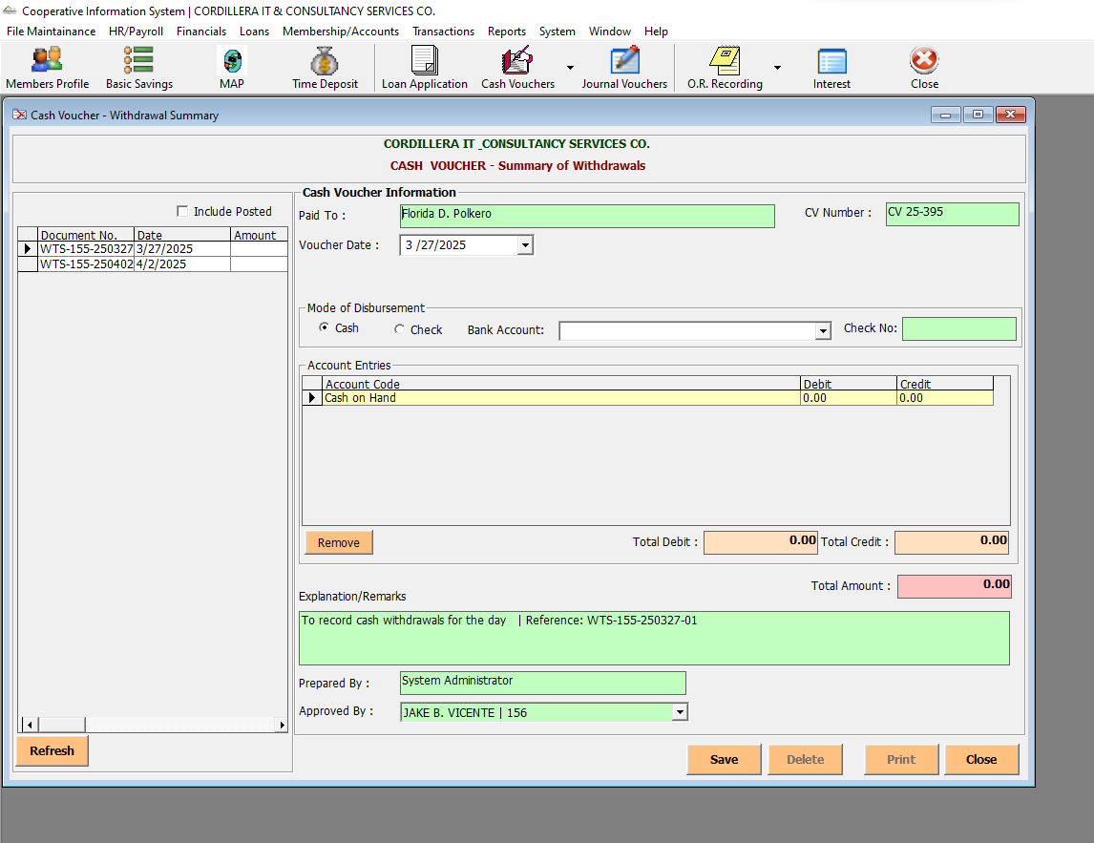

Transactions-> Disbursements-> Cash Disbursement

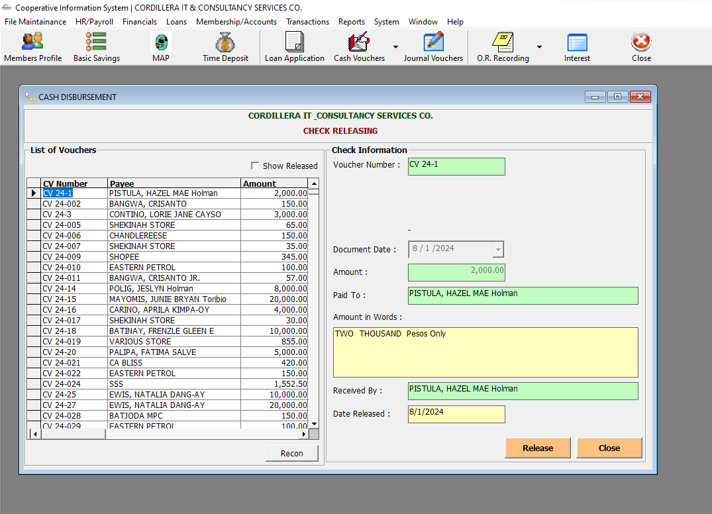

Transactions-> Disbursements-> Check Preparation

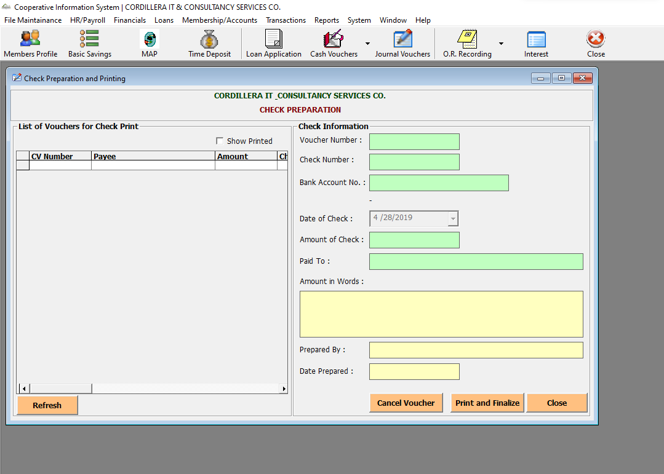

Transactions-> Disbursements-> Check Releasing

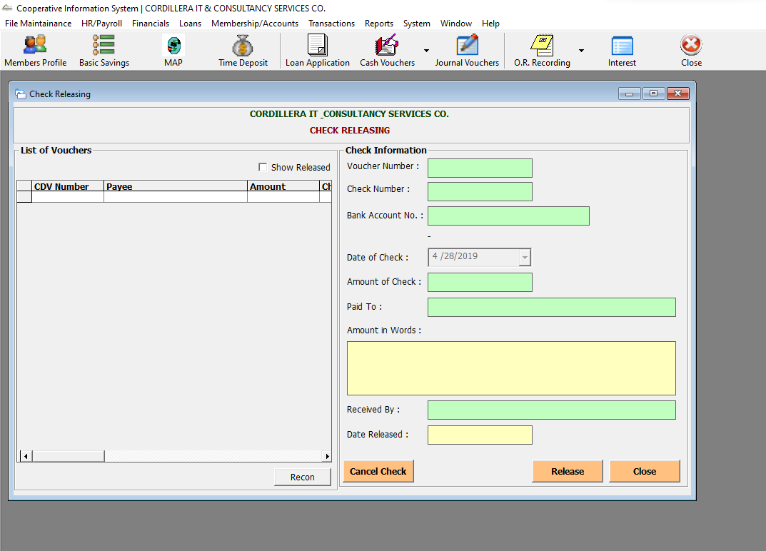

Transactions-> Debit/Credit Memo

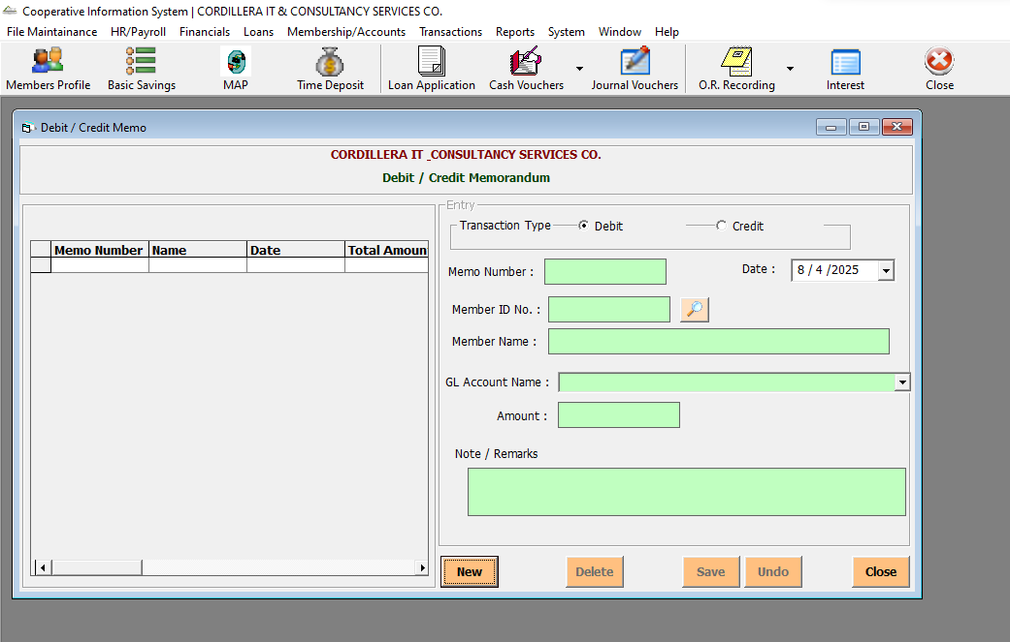

Transactions-> Banking-> Bank Deposits

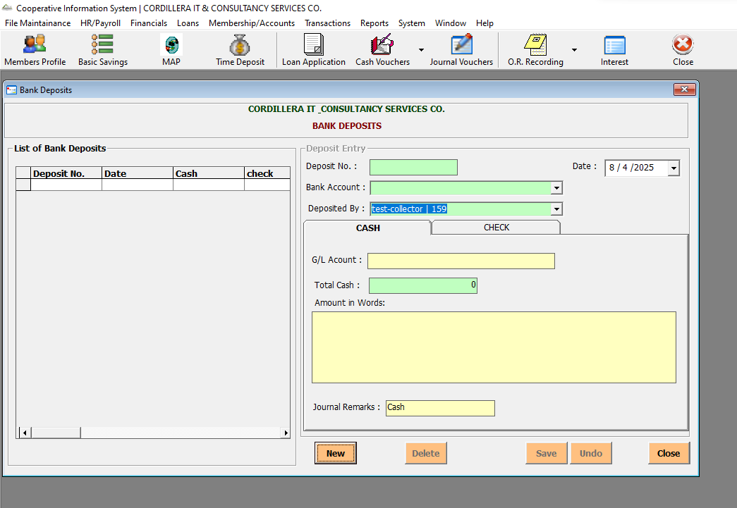

Transactions-> Banking-> Postdated Checks

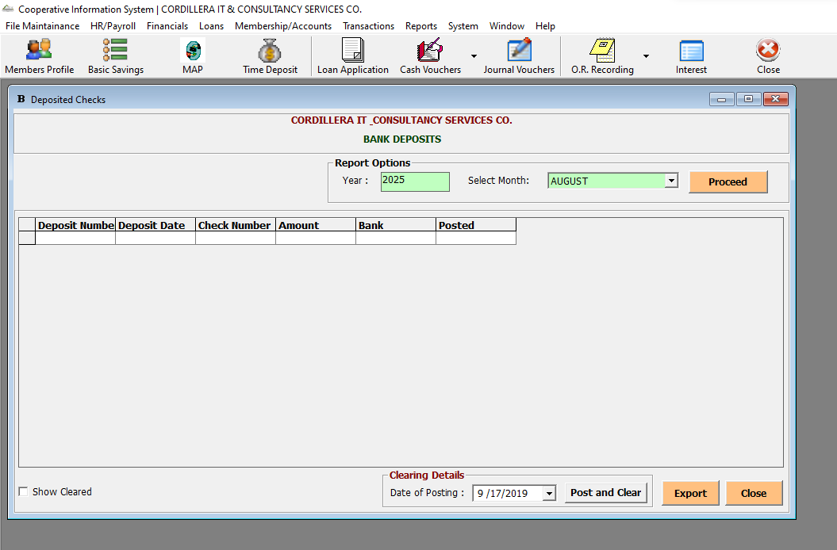

Transactions-> Banking-> Bank Withdrawals

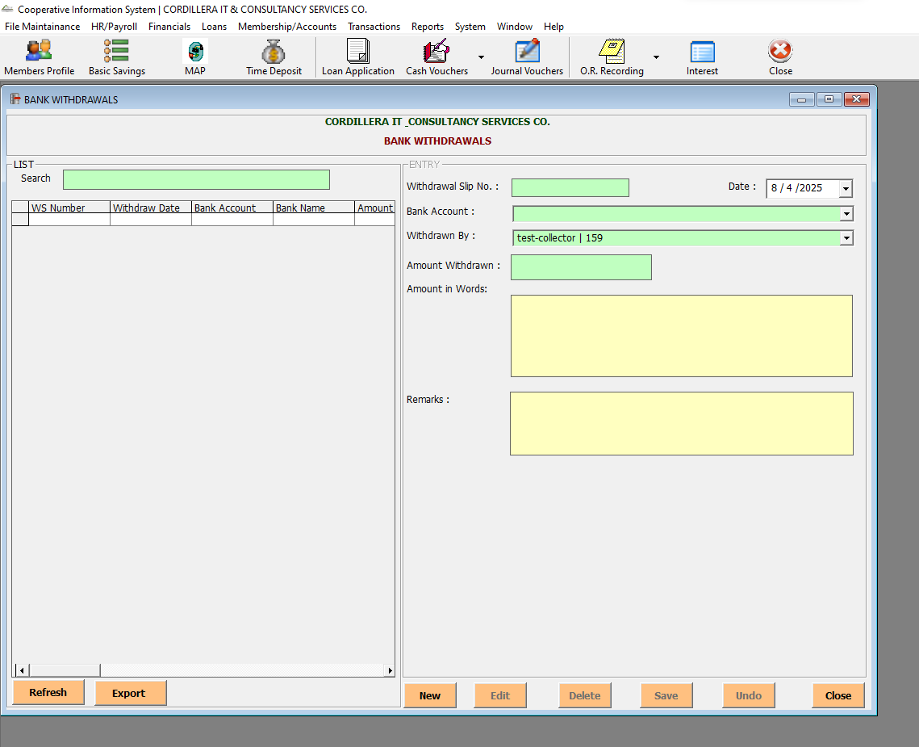

Reports-> Dashboard

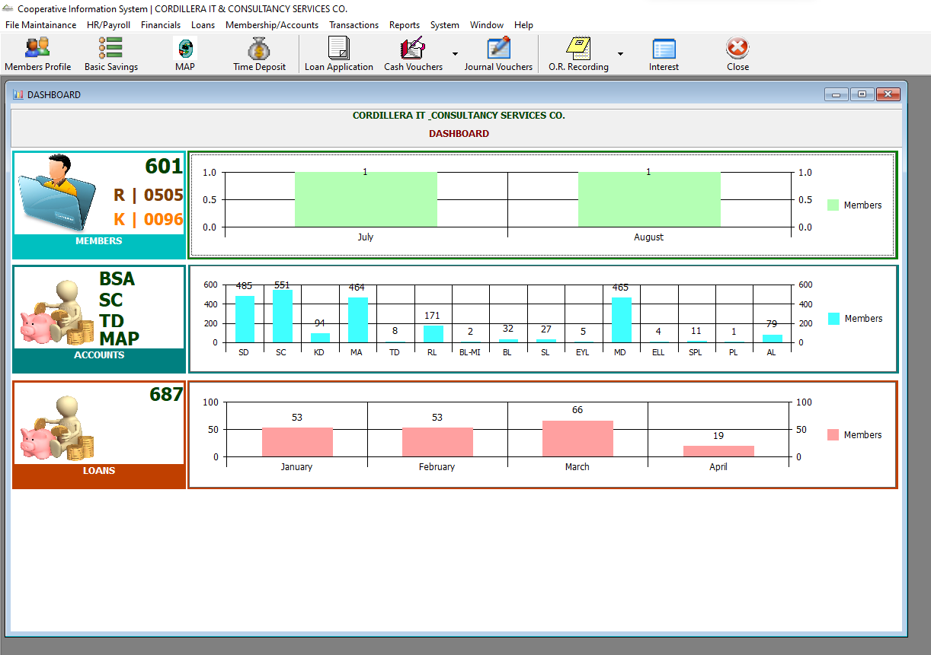

Reports-> Members Report-> Member Listing

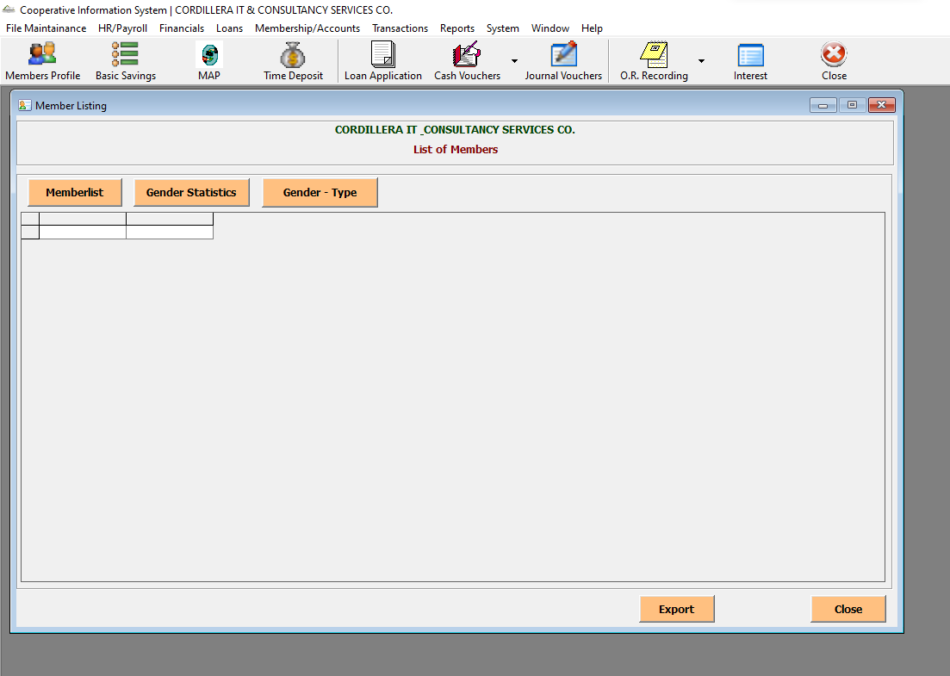

Reports-> Members Report-> List of Members Per Type

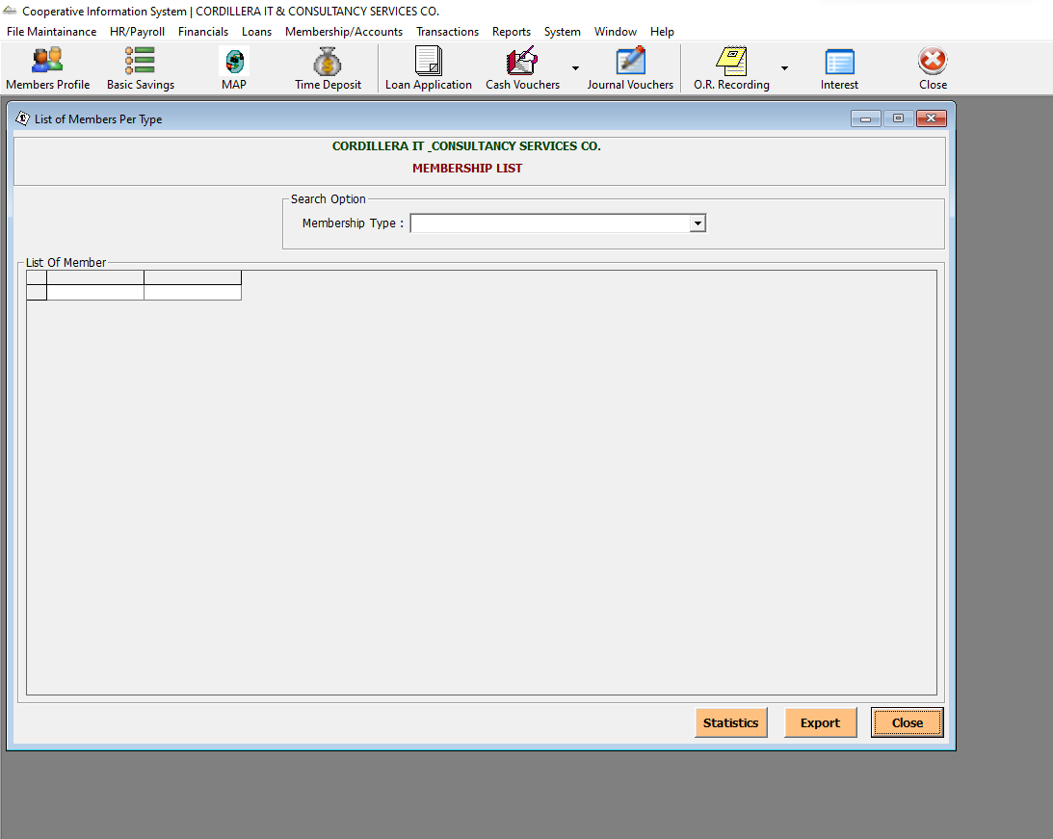

Reports-> Accounts Report-> List of Accounts

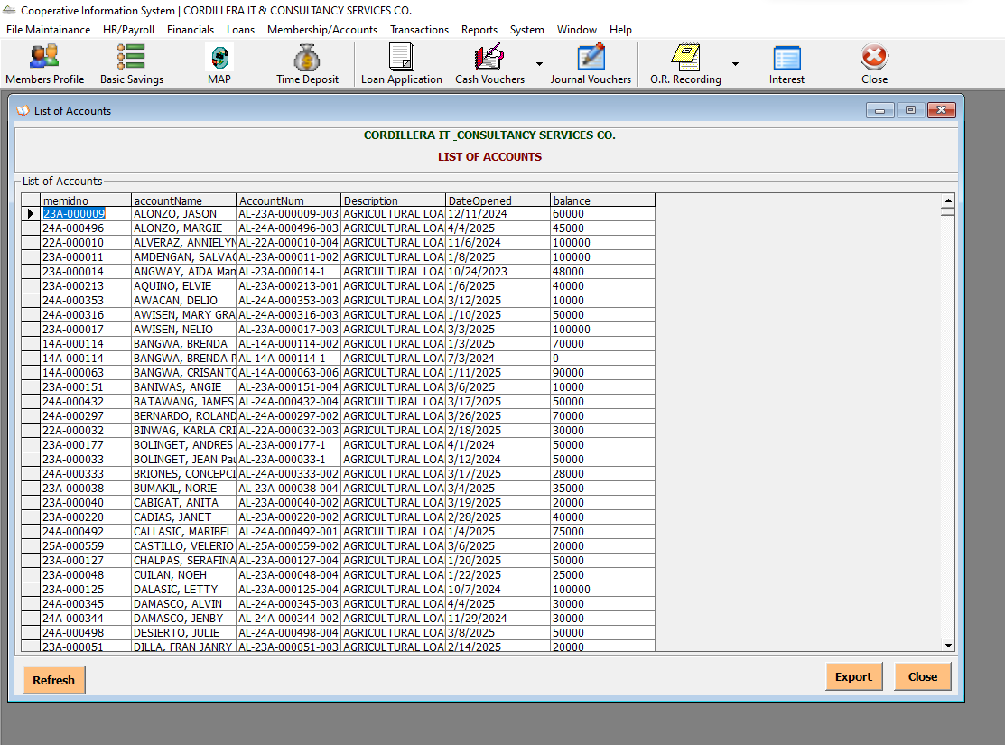

Reports-> Accounts Report-> List of Accounts Per Type

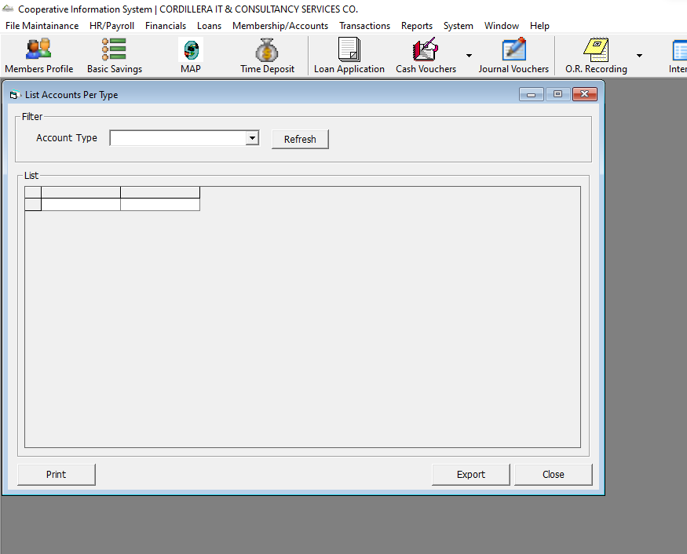

Reports-> Accounts Report-> List of Time Deposits

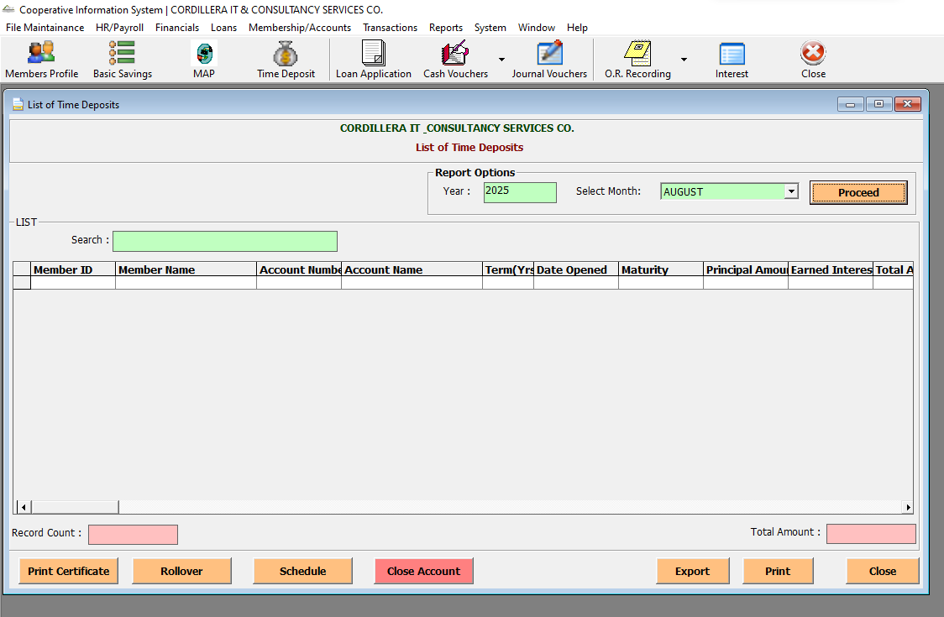

Reports-> Accounts Report-> List of Matured TD

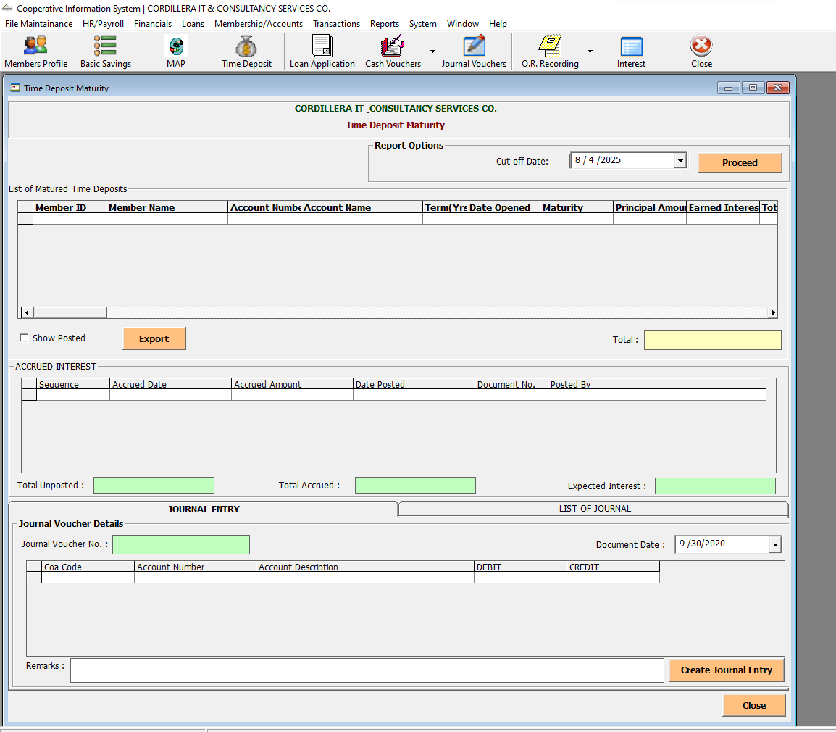

Reports-> Accounts Report-> Members Account

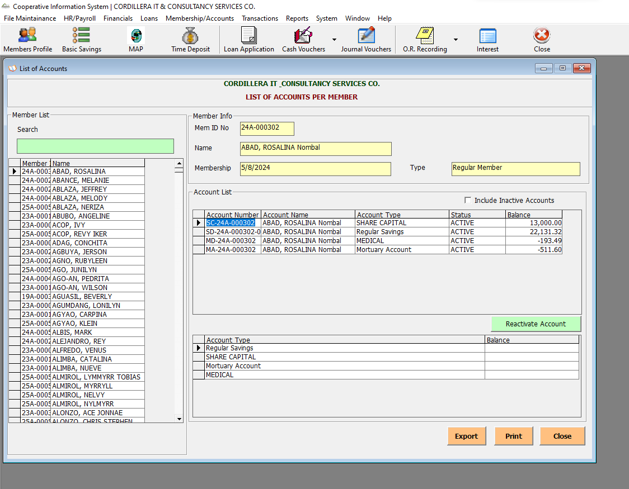

Reports-> Summary Reports-> List of MAP

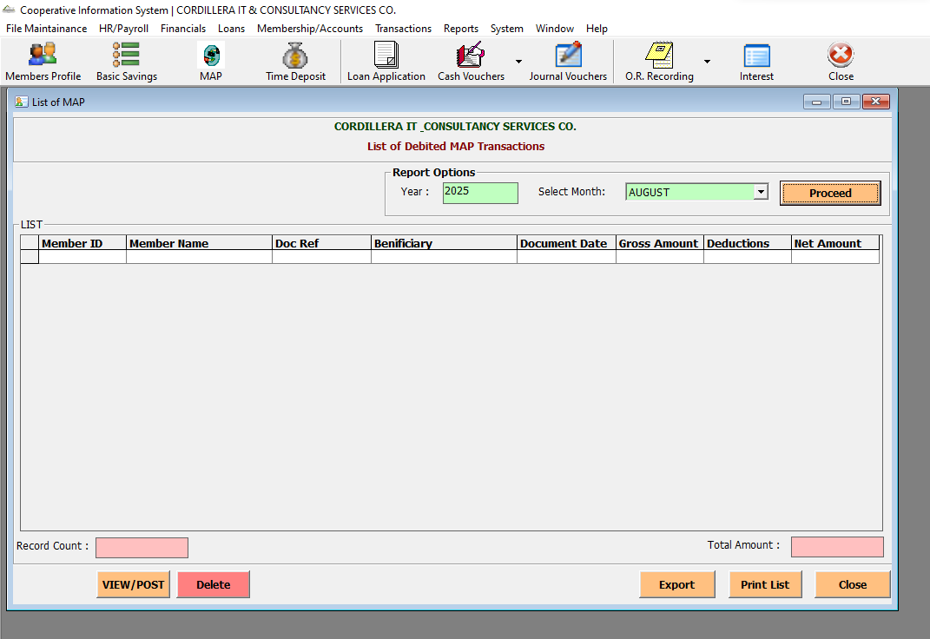

Reports-> Summary Reports-> Summary of Earned Interest

Reports-> Summary Reports-> Collection Per Collector

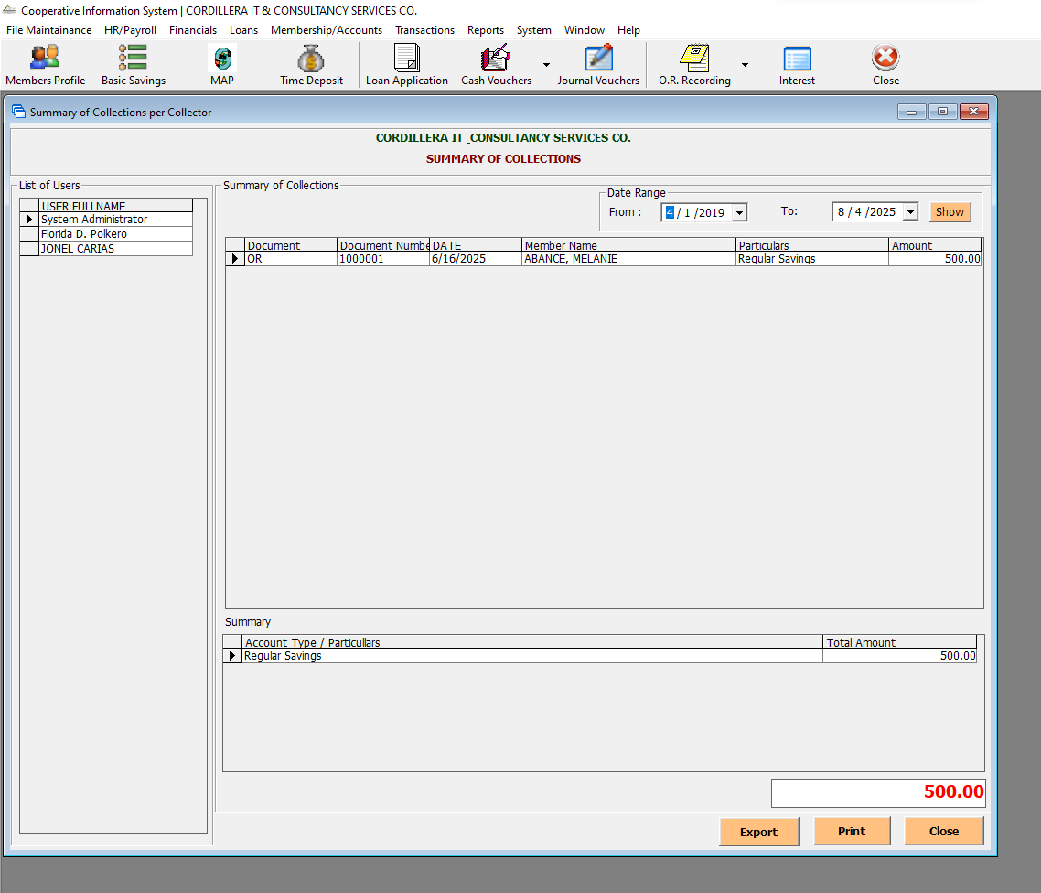

Reports-> Summary Reports-> Withdrawals Summary

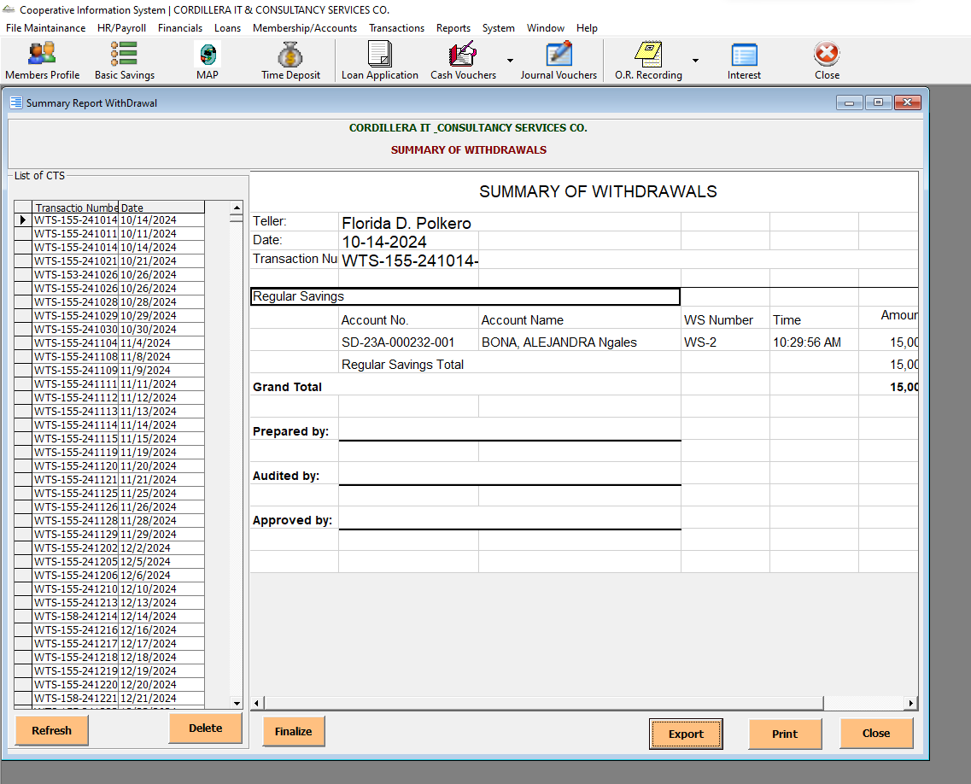

Reports-> Summary Reports-> Official Receipt

Reports-> Summary Reports-> List of Issued OR

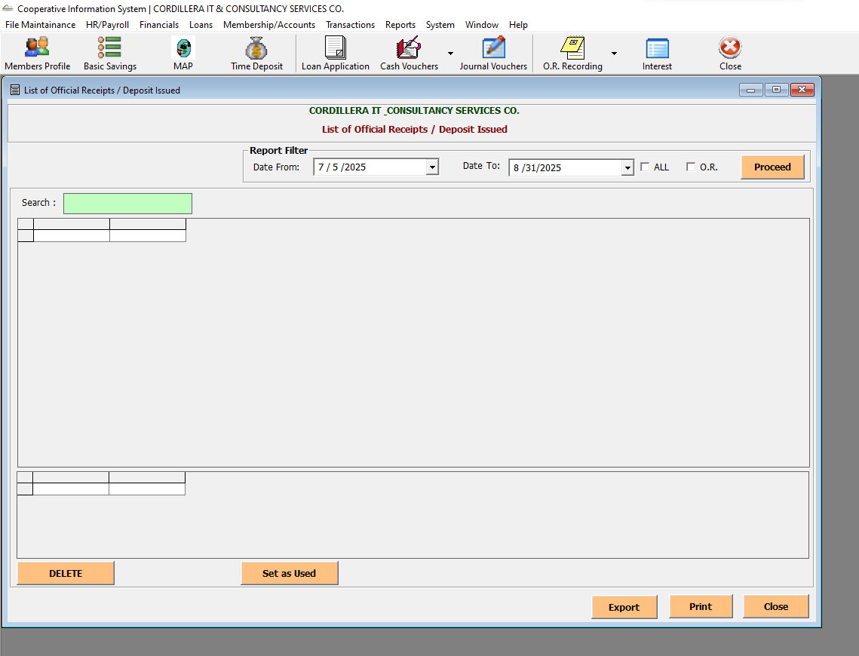

Reports-> Summary Reports-> List of Patronage Refund

Reports-> Collection Report-> Teller’s Blotter

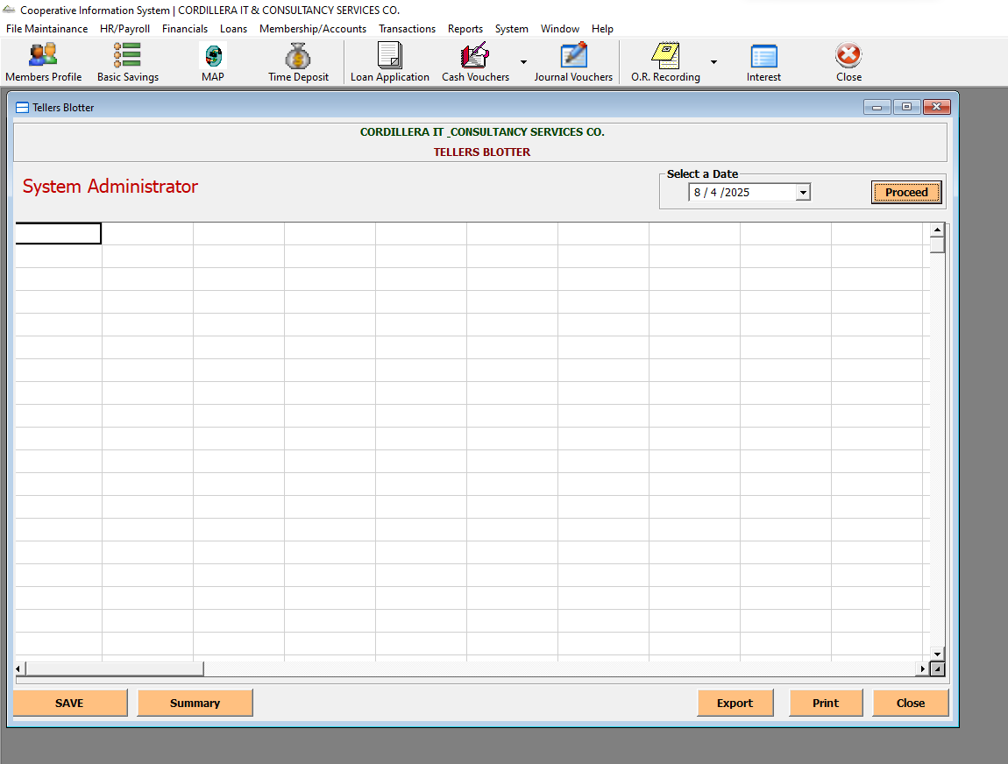

Reports-> Collection Report-> Abstract Total

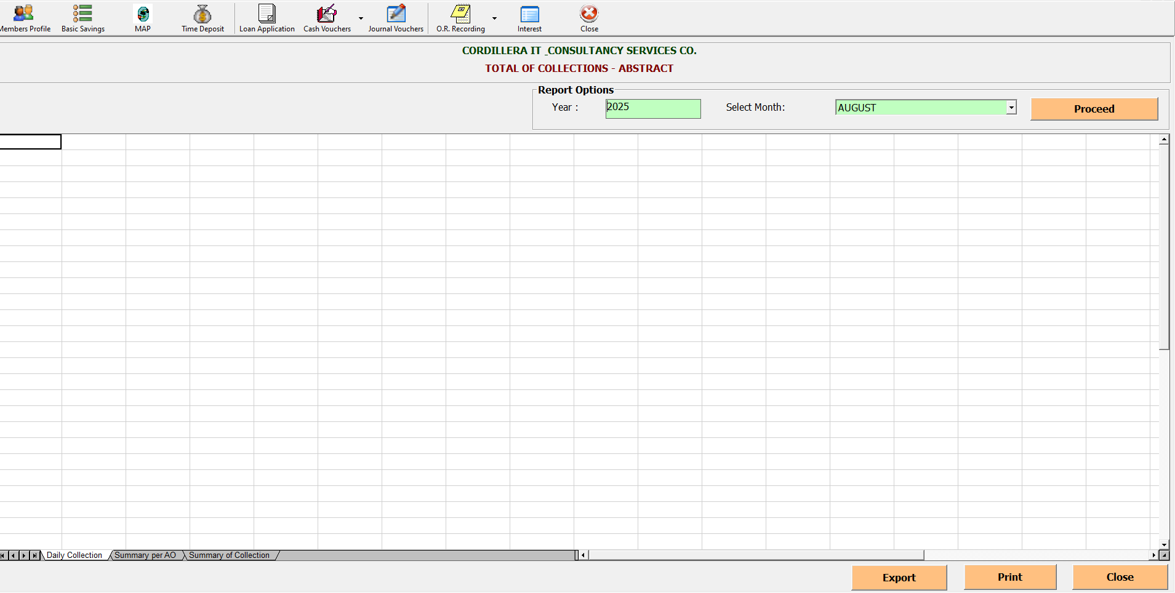

Reports-> Collection Report-> View Over Payments

Reports-> Collection Report-> View O.R.

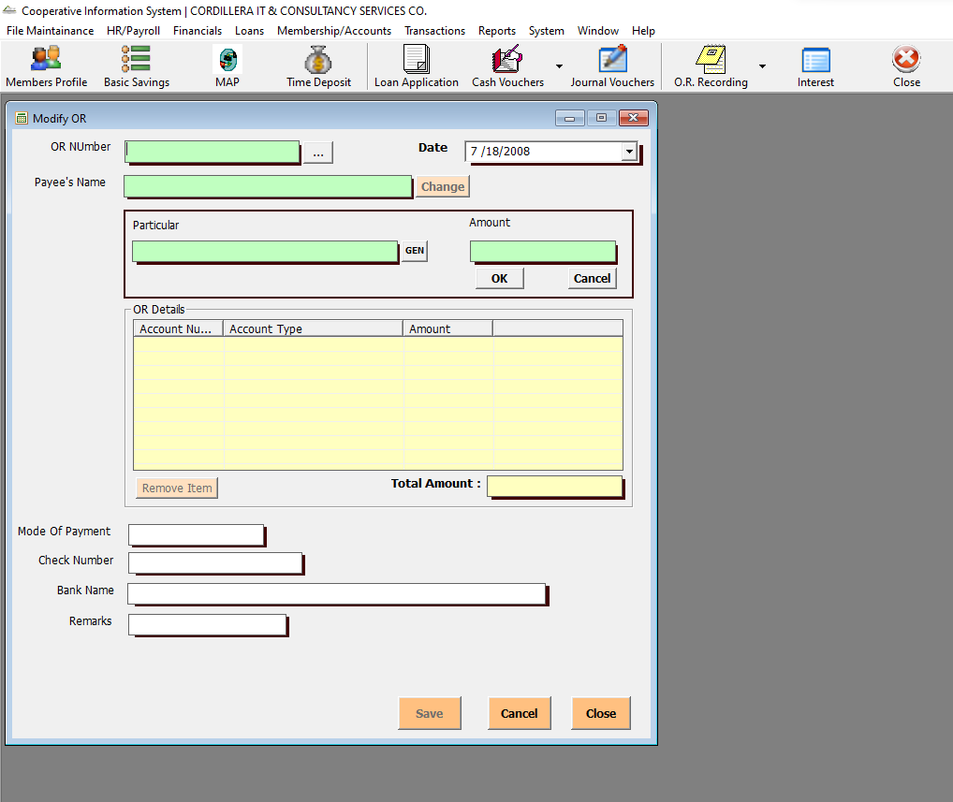

Reports-> Collection Report-> View T.R.

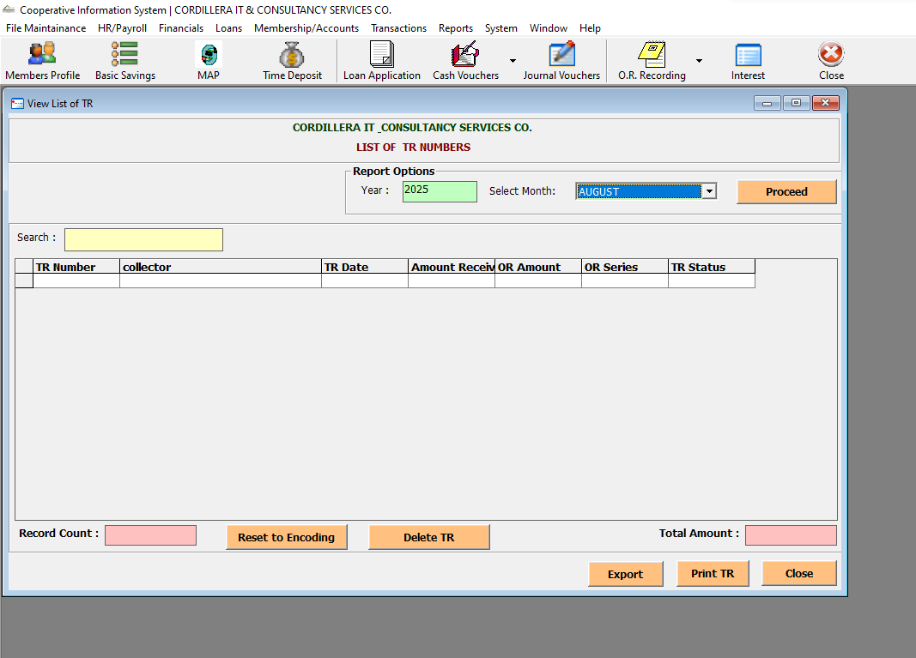

Reports-> Collection Report-> Daily Collections Report

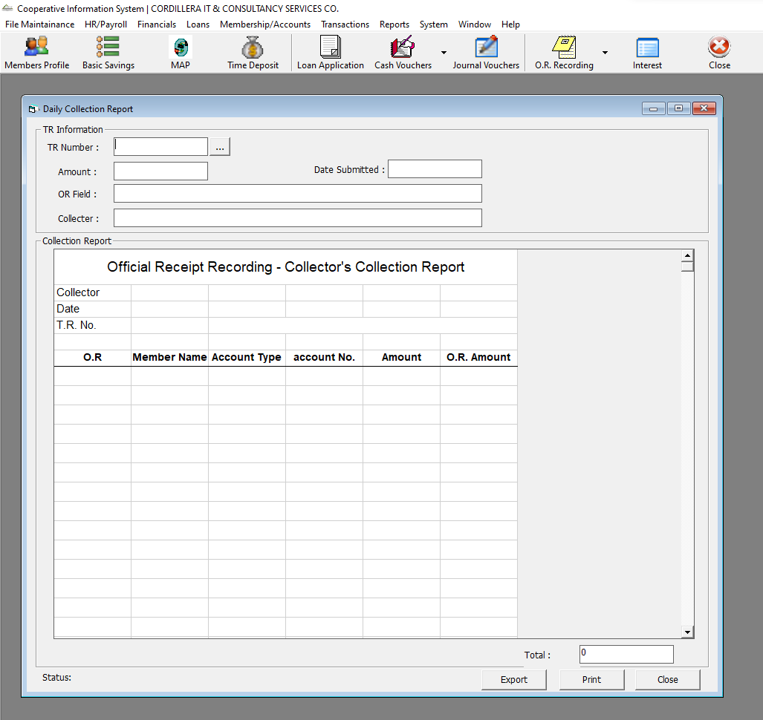

Reports-> Collection Report-> OR Prooflist

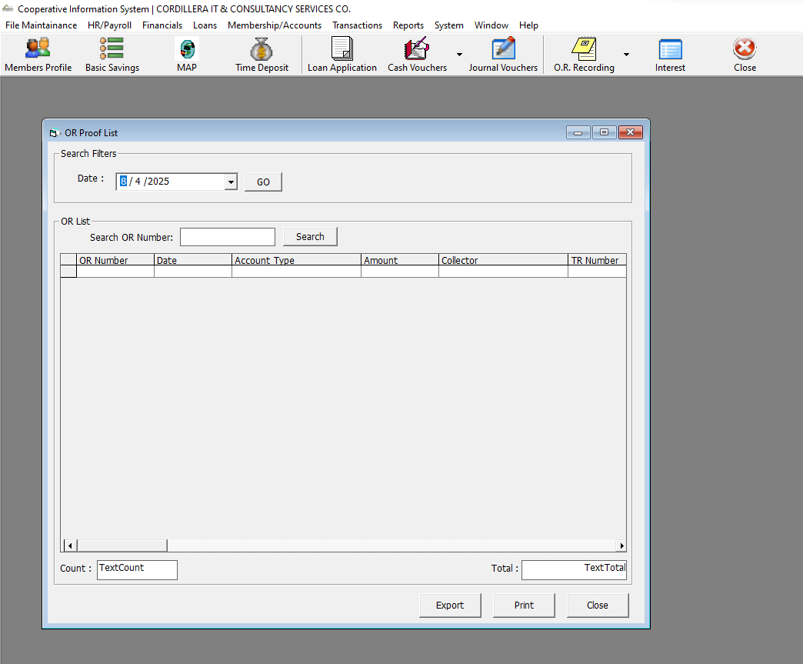

Reports-> Collection Report-> Per Account Type

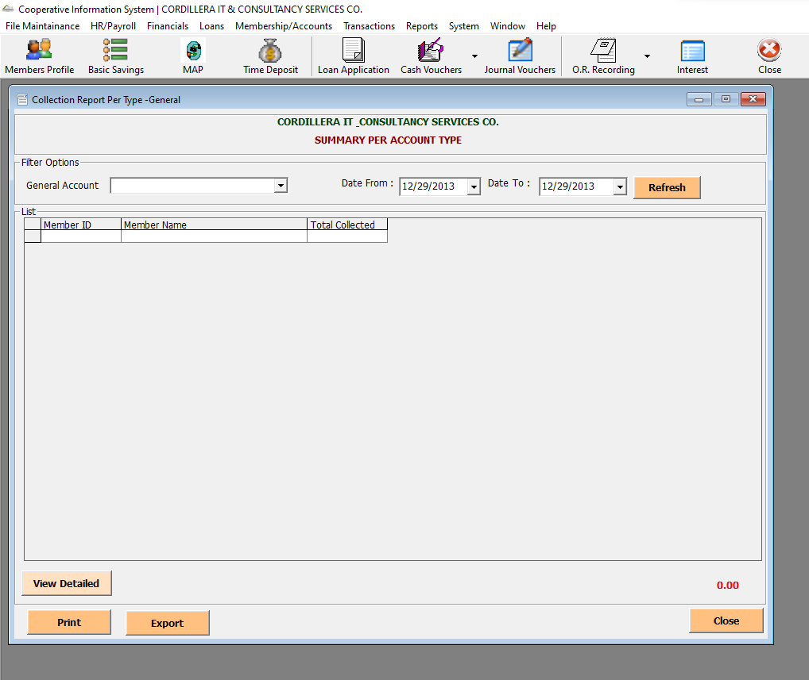

Reports-> Collection Report-> Per SL

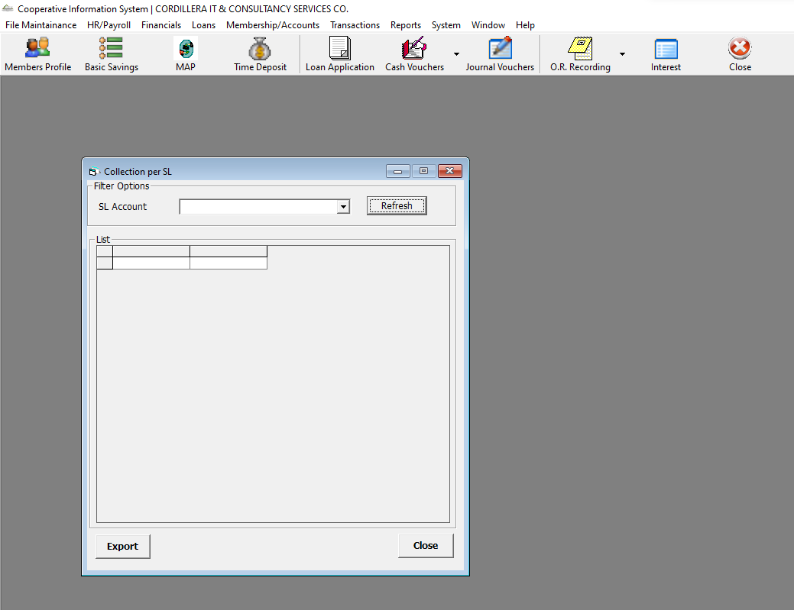

Reports-> Collection Report-> Per Member

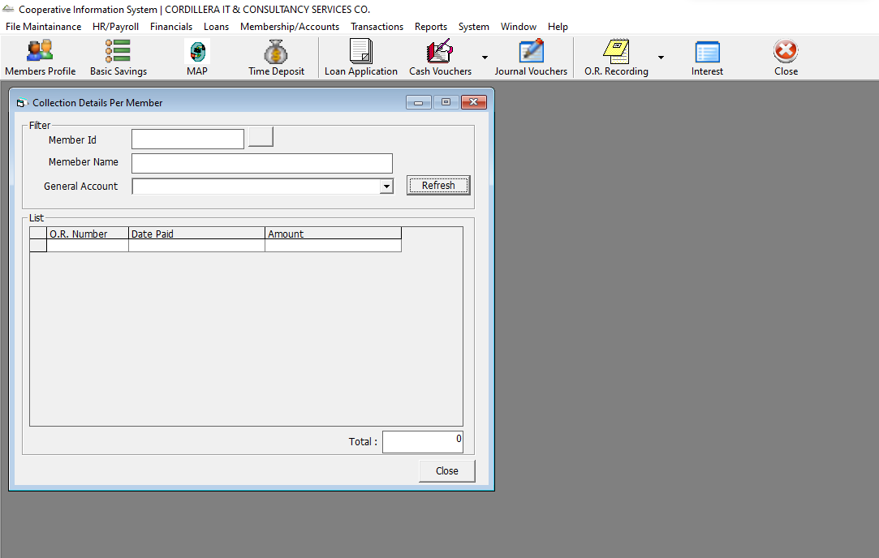

Reports->Loan Report-> PAR-> PAR – Ammortization

Reports->Loan Report-> PAR-> PAR – General

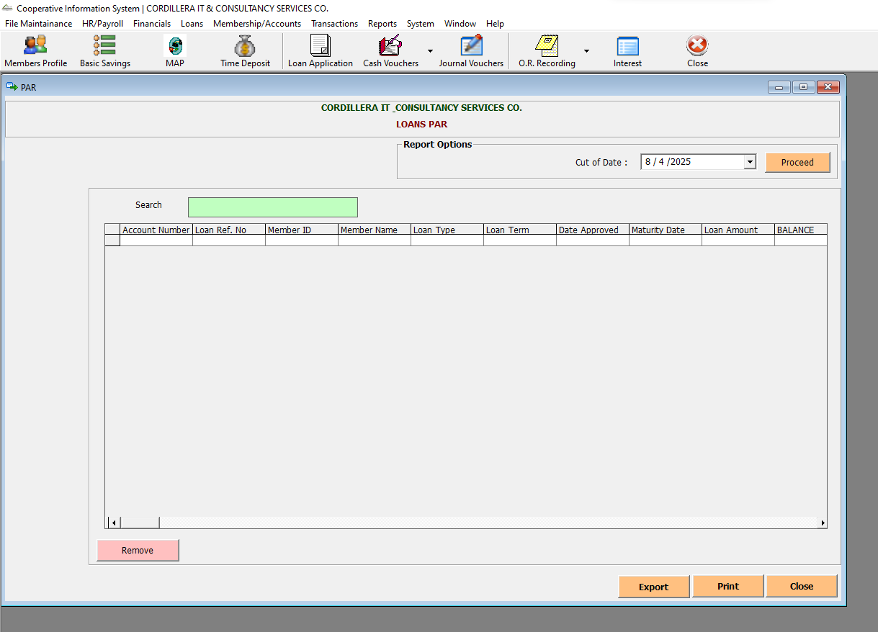

Reports->Loan Report->Loans Monitoring

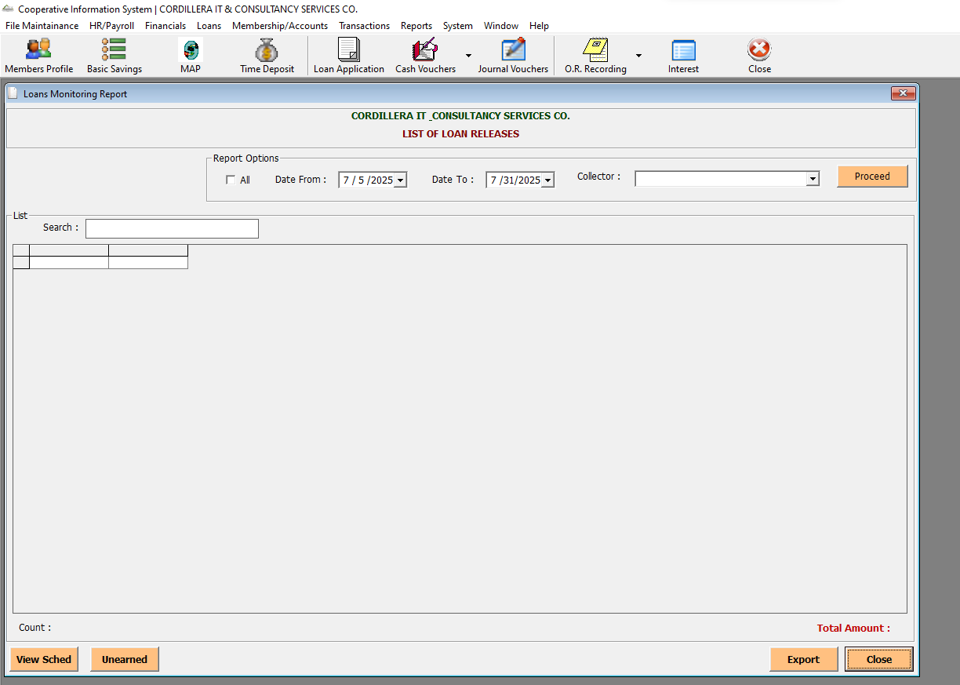

Reports->Loan Report-> Loans History

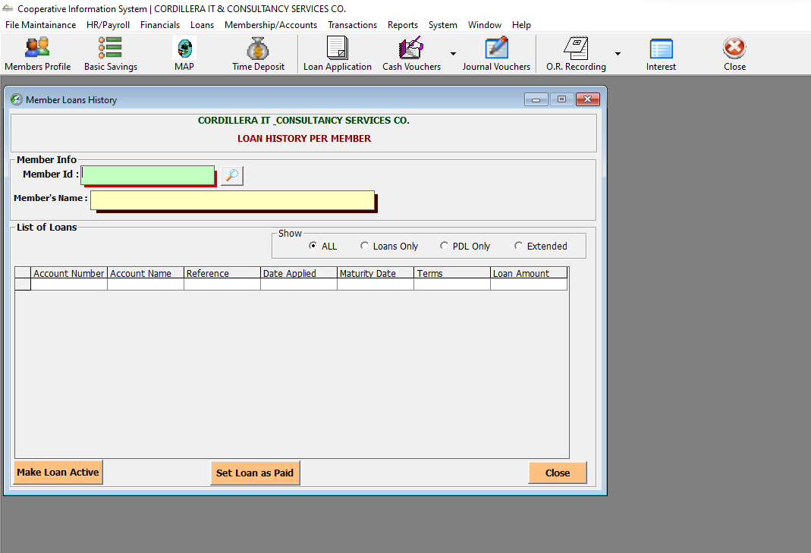

Reports->Loan Report-> Loans Due Dates

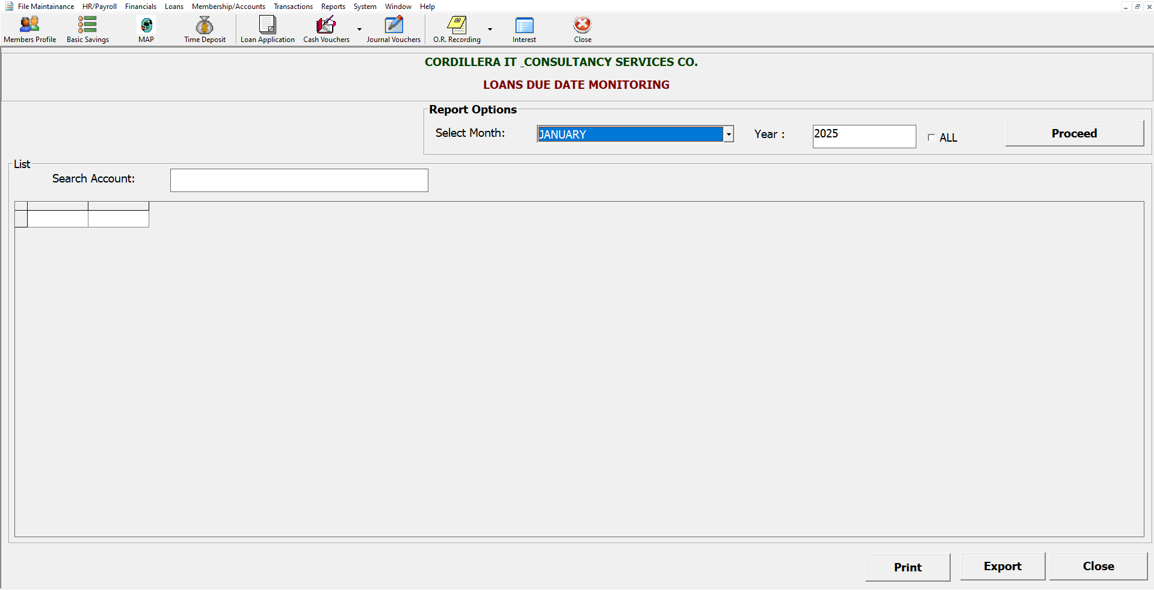

Reports->Loan Report-> Loans Notice

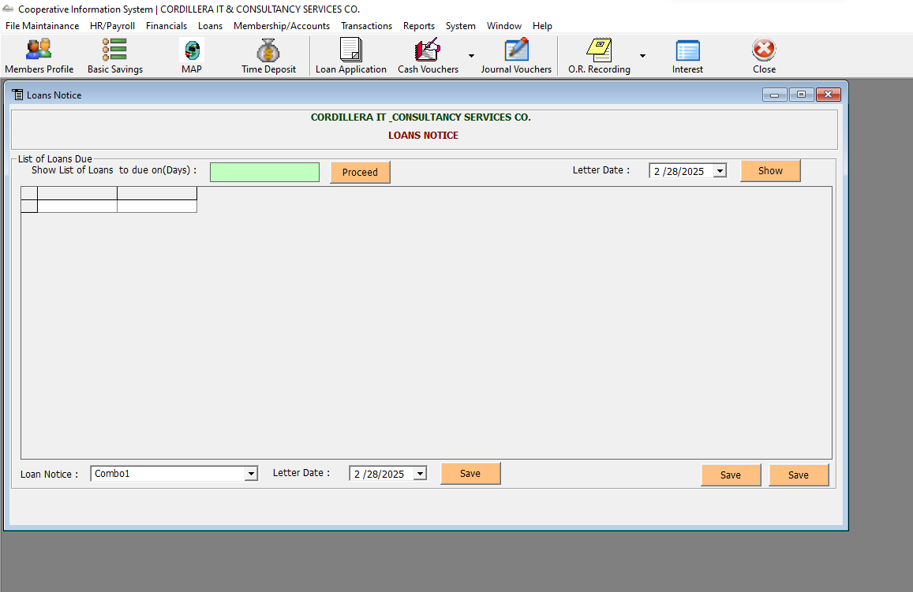

Reports->Loan Report-> Past Due Loans – View

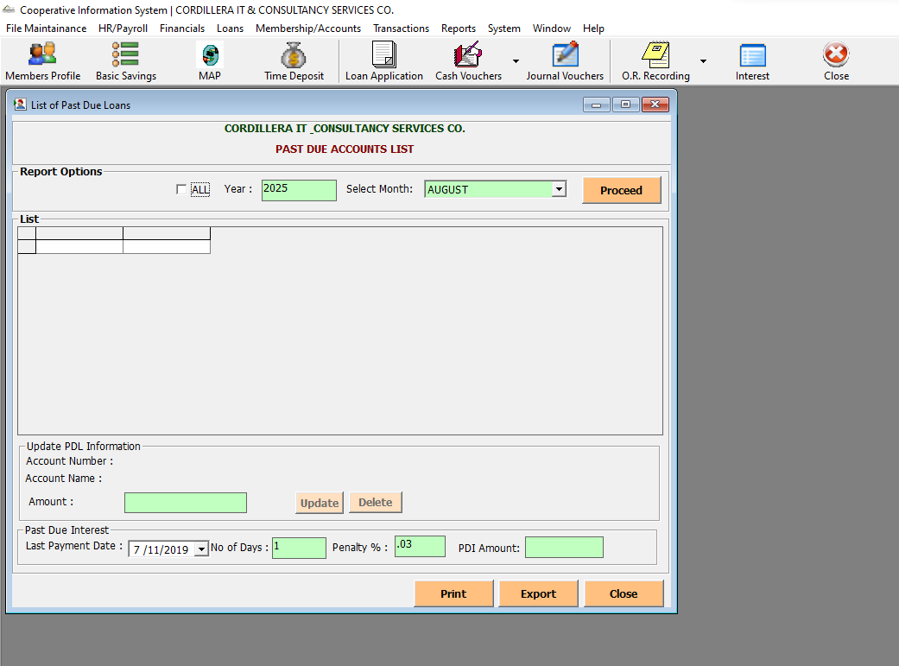

Reports->Loan Report-> Summary of Loans

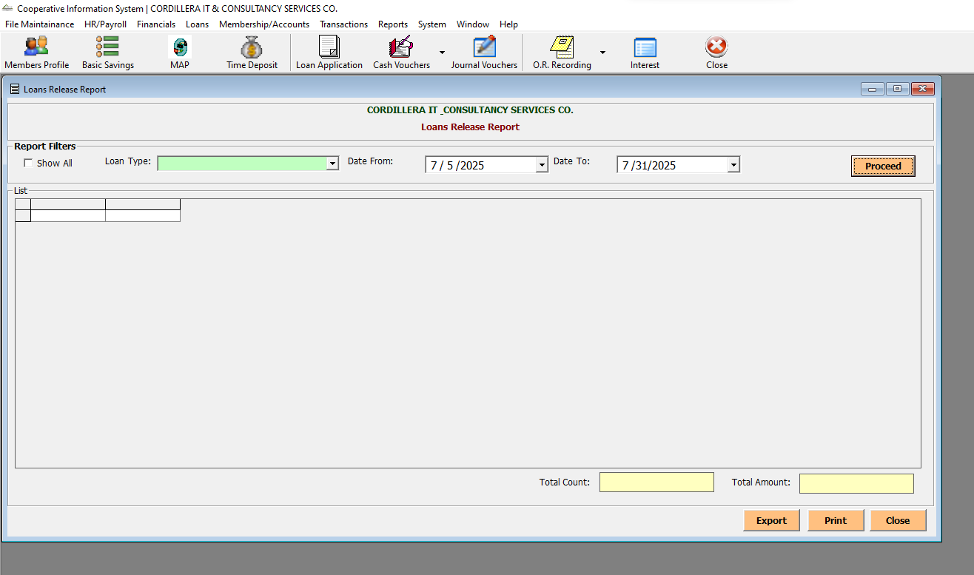

Reports->Loan Report-> Members Payments

Reports->Loan Report-> Summary of Loan Payments

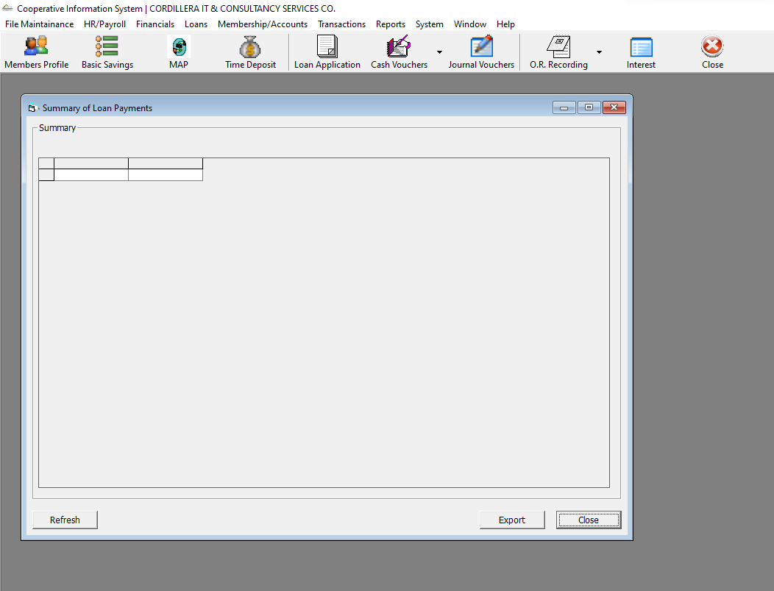

Reports->Loan Report-> Loan Deductions Summary

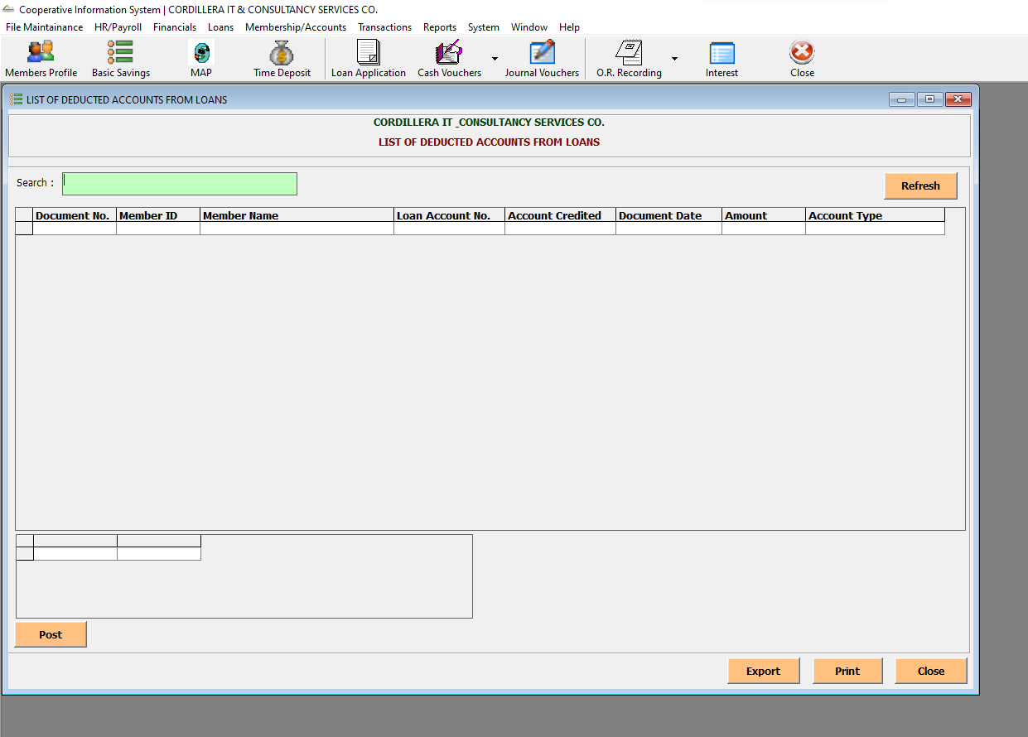

Reports->Loan Report-> Co Makers List

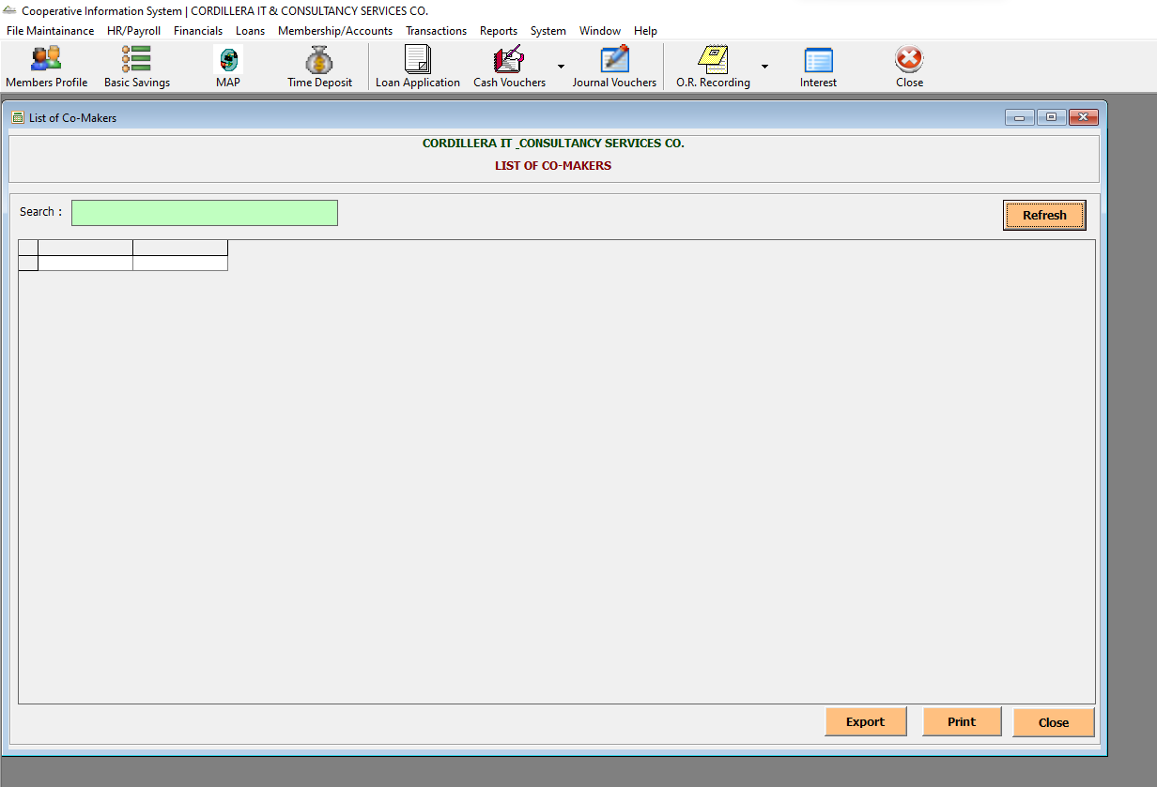

Reports->Loan Report-> Loans Collectors

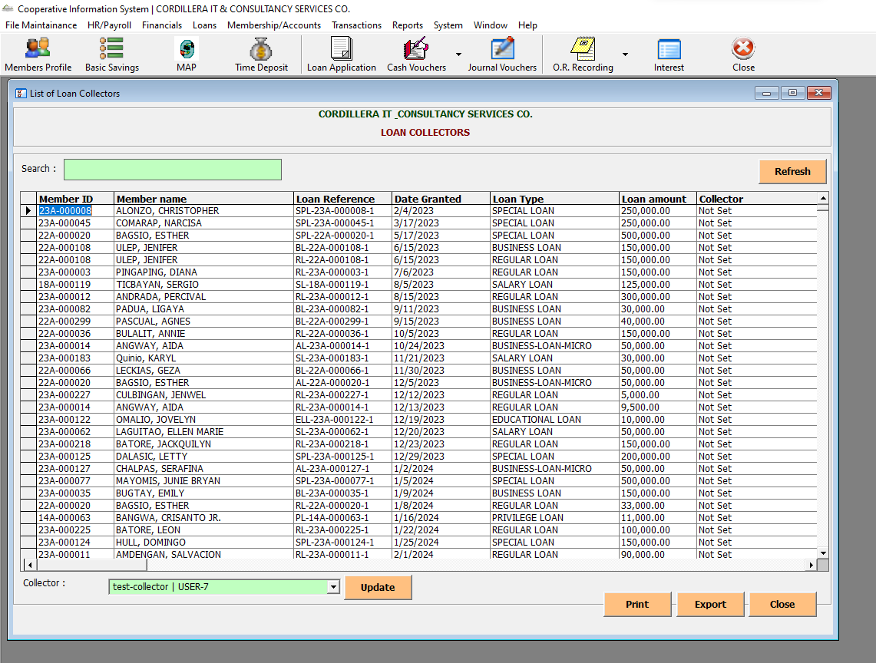

Reports->Schedule-> UnEarned Interest

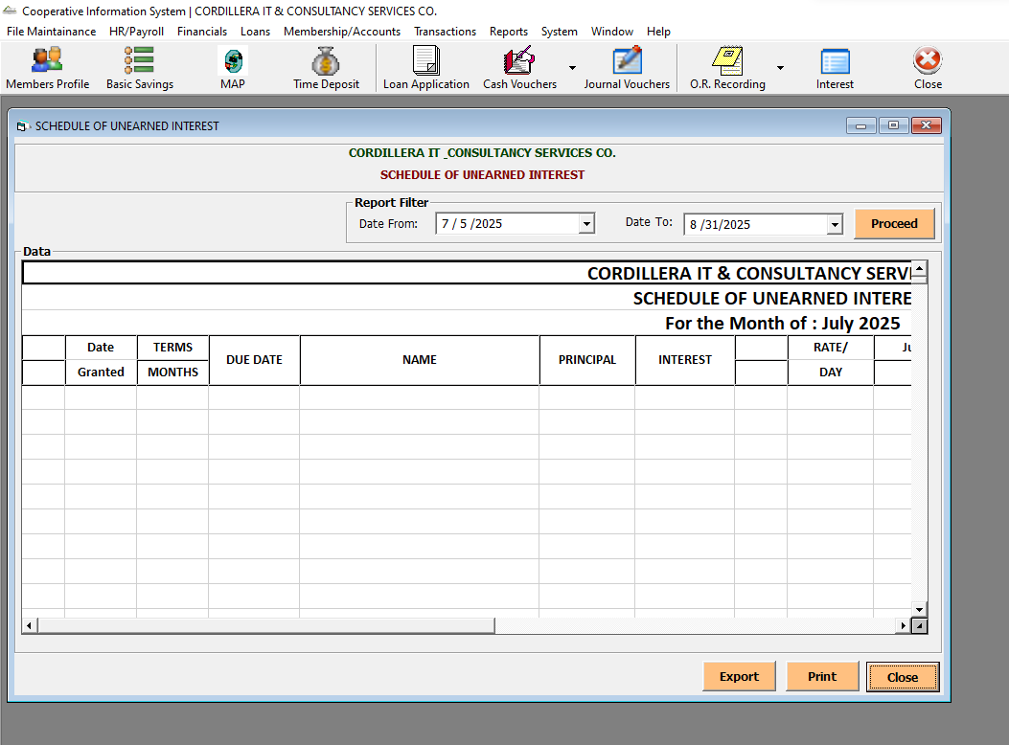

Reports->Schedule-> Schedule of Accounts

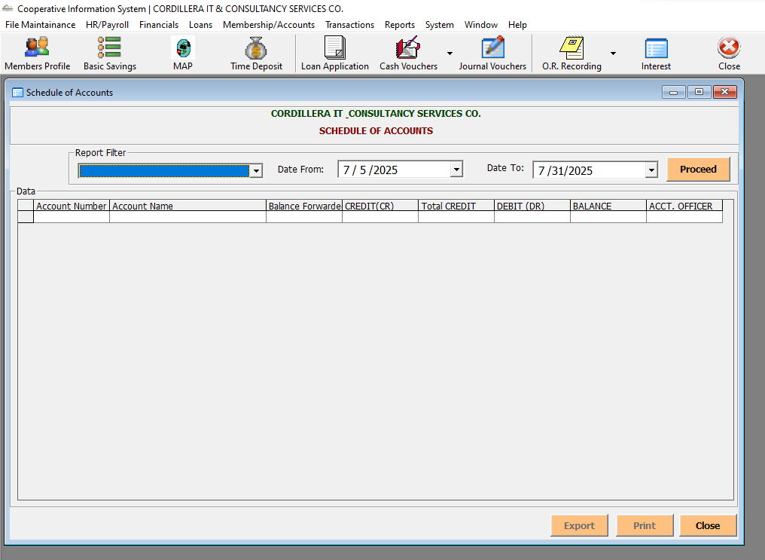

System-> Interest Upload

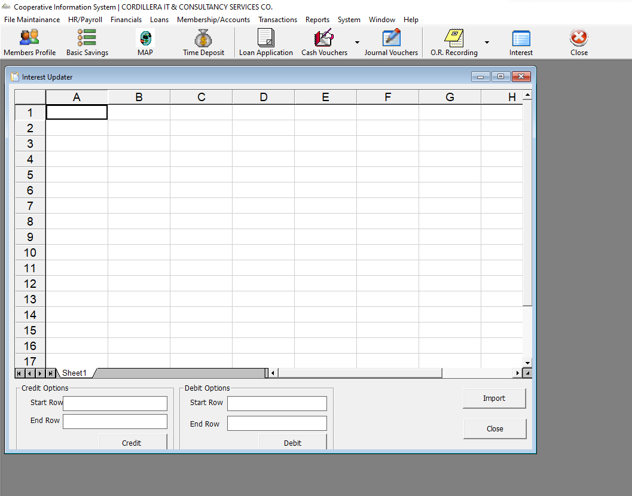

System-> Fix Unposted

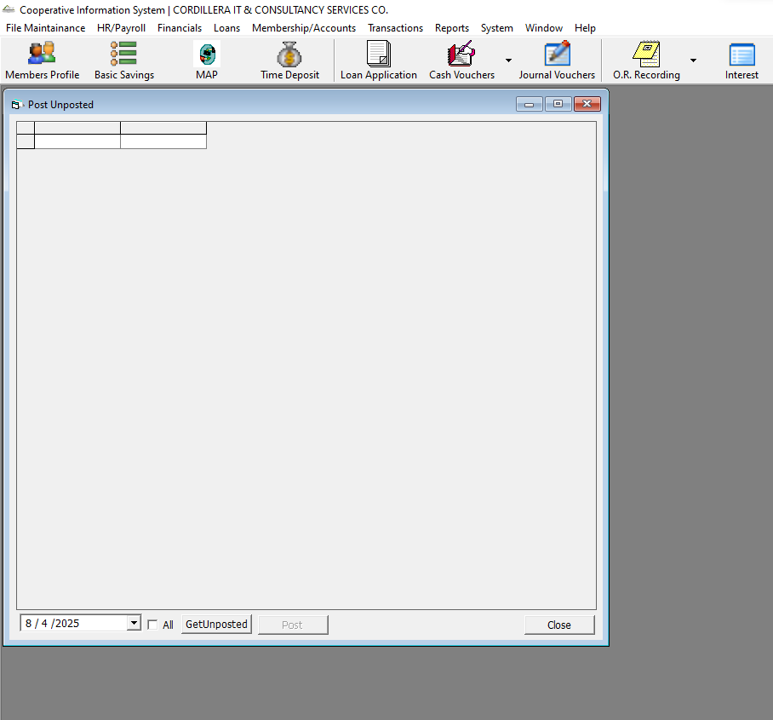

System-> Move a WS num to another CDV

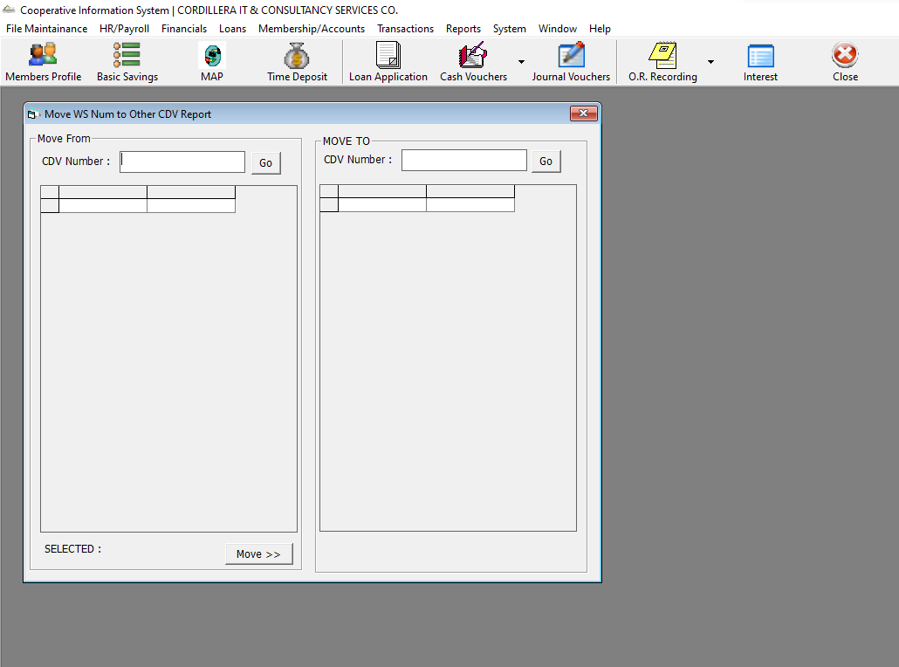

System-> Member ID Update

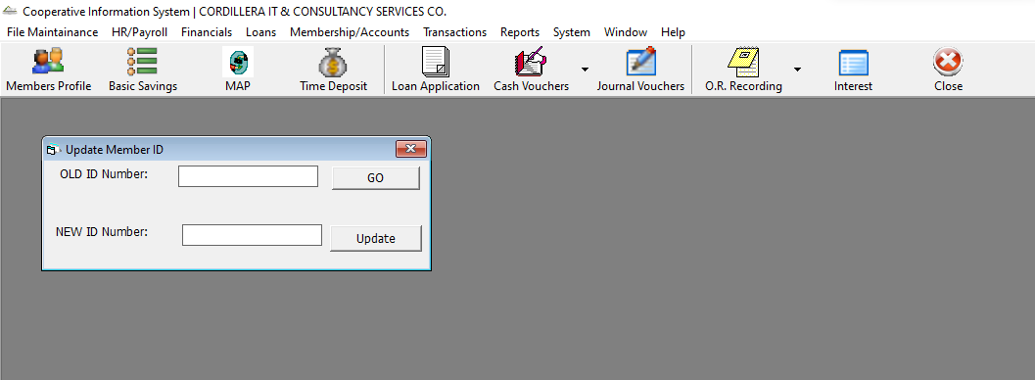

System-> Update Passbook Top Margin

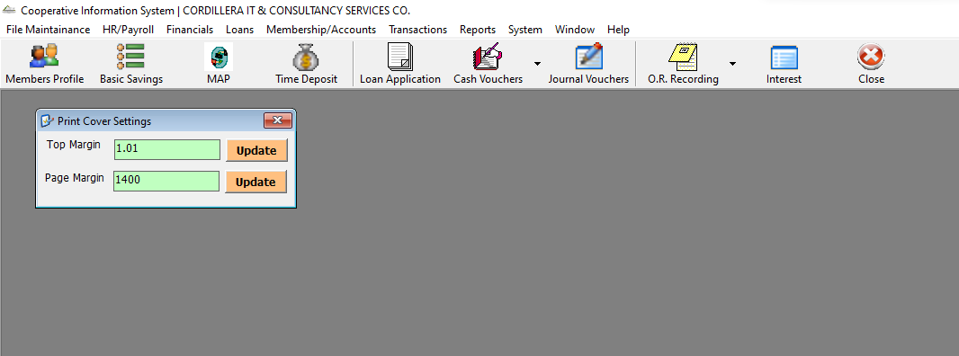

System-> Set Withdraw Limit

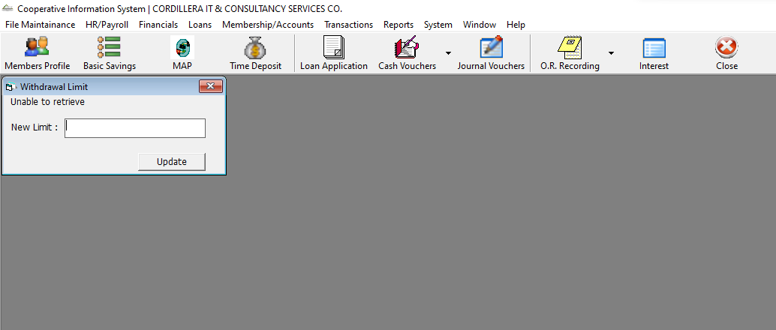

System-> Change Account Prefix

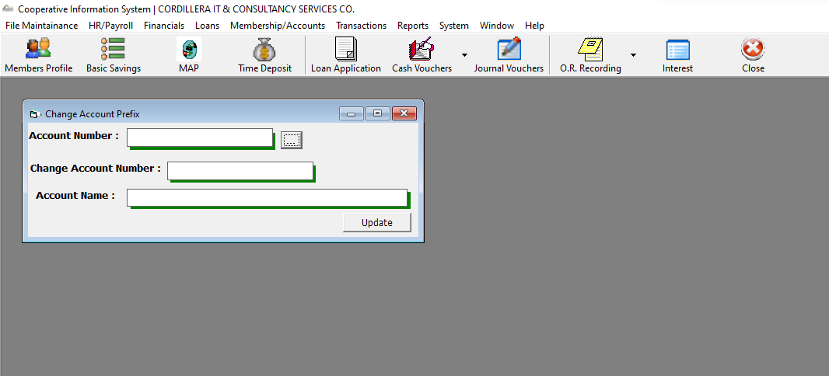

System-> Audit Logs

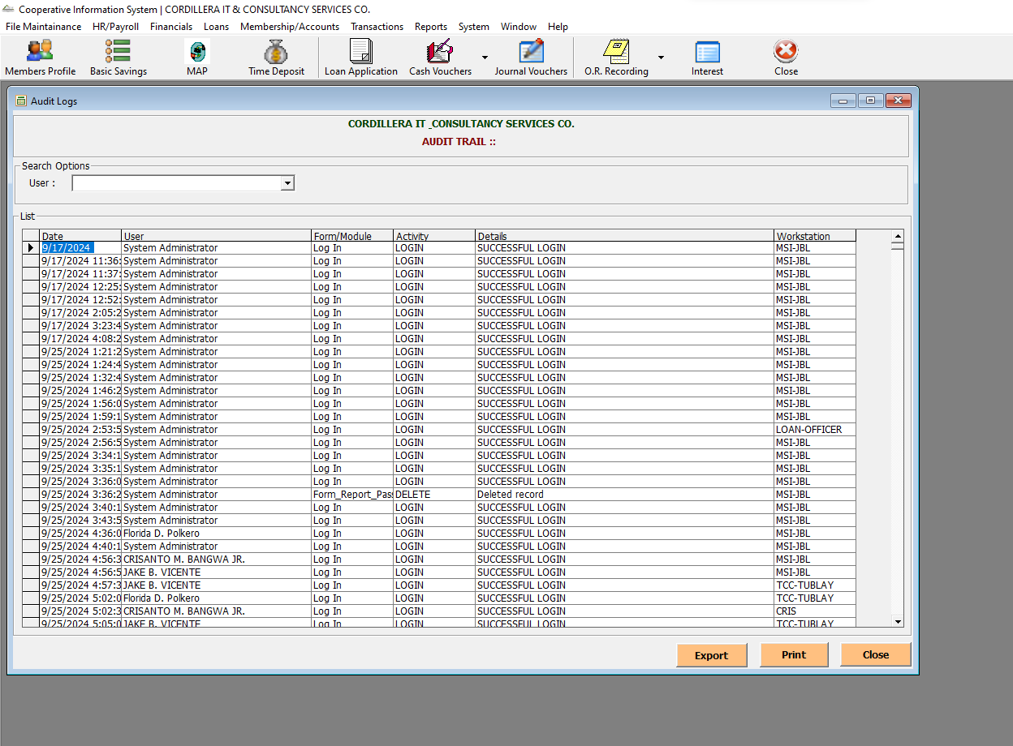

System-> Change Password

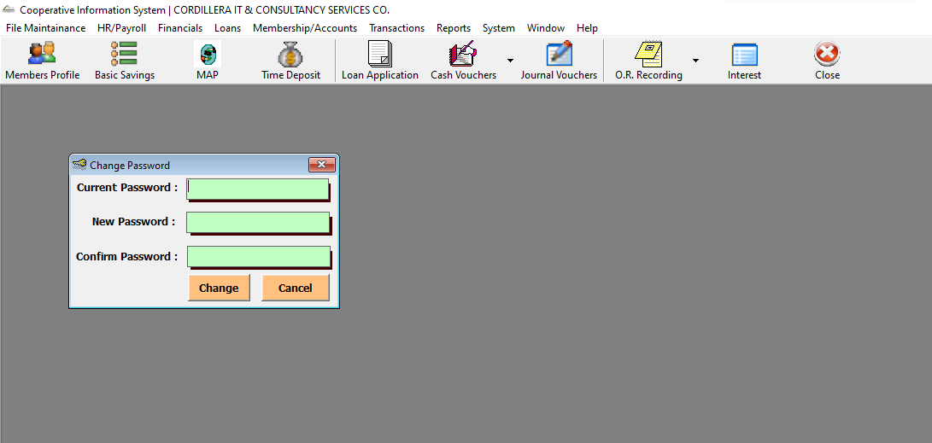

System-> Set Active Year

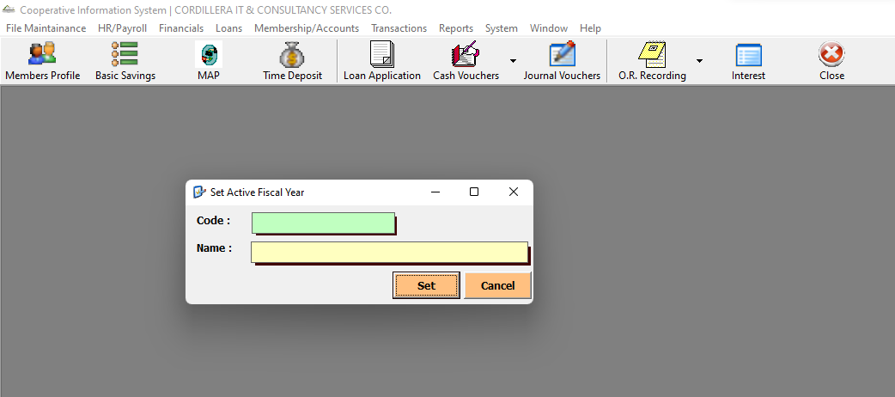

Members Profile Icon

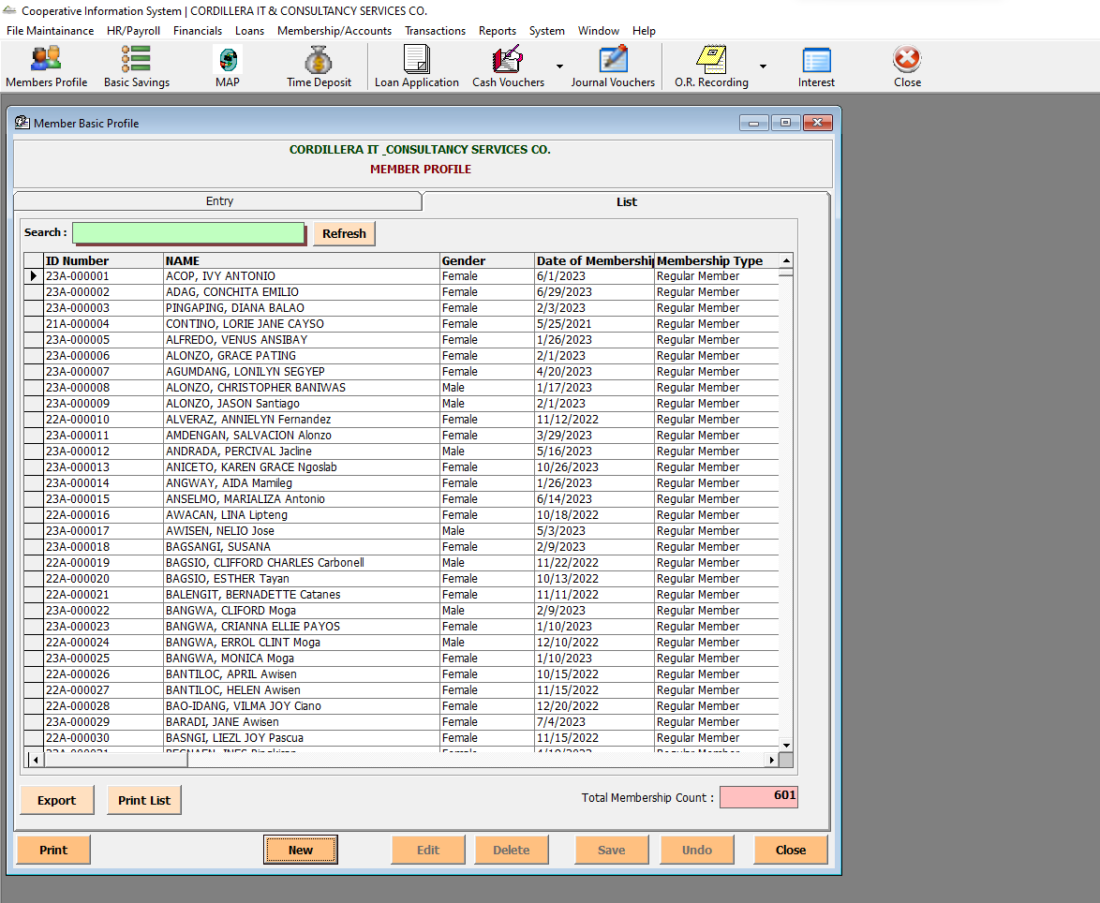

Basic Savings Icon

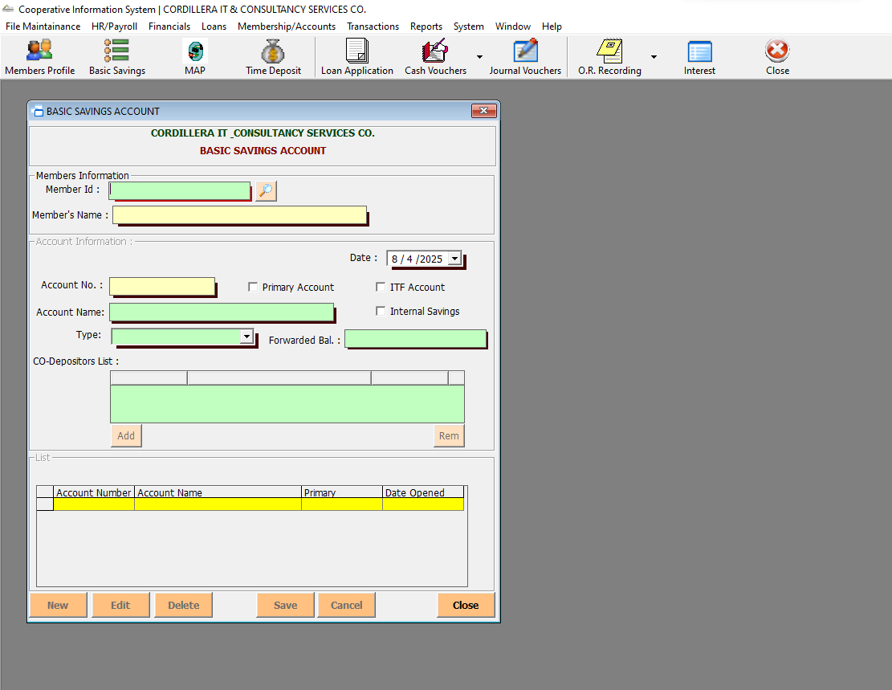

MAP Icon

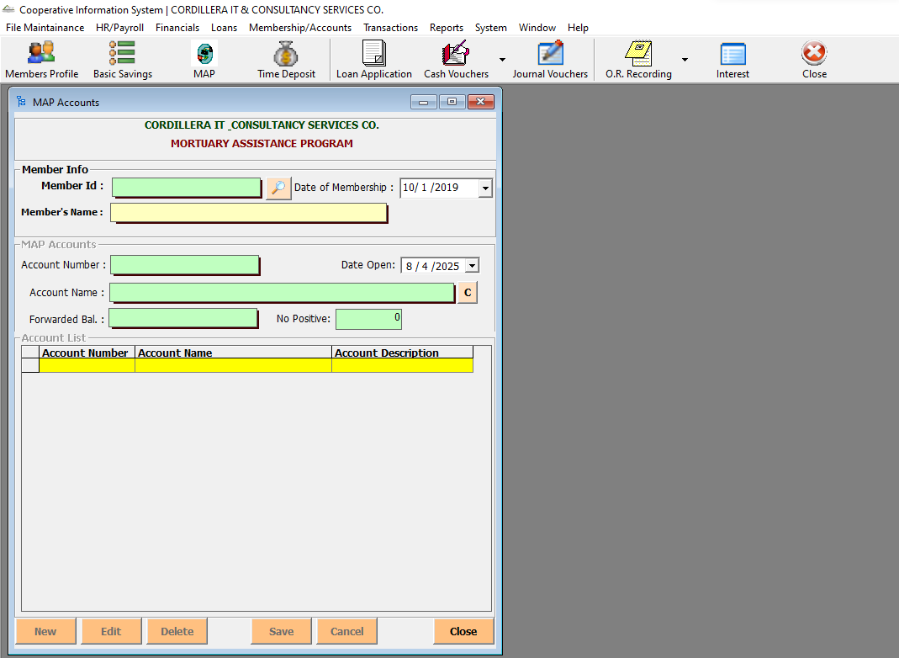

Time Deposit Icon

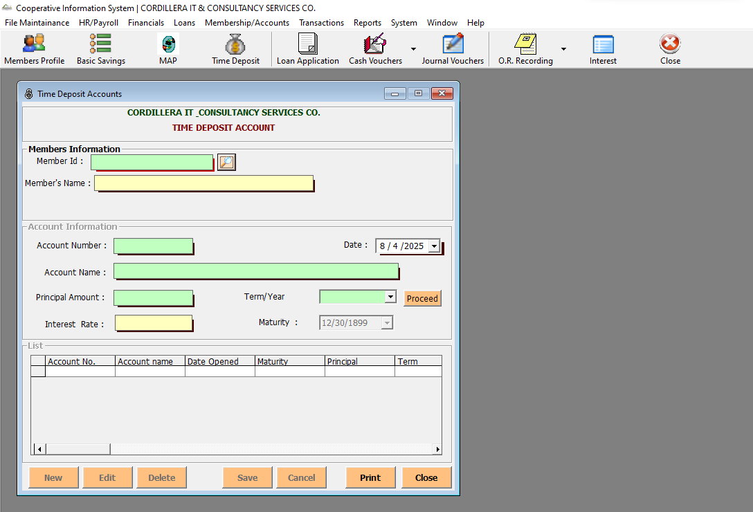

Loan Application Icon

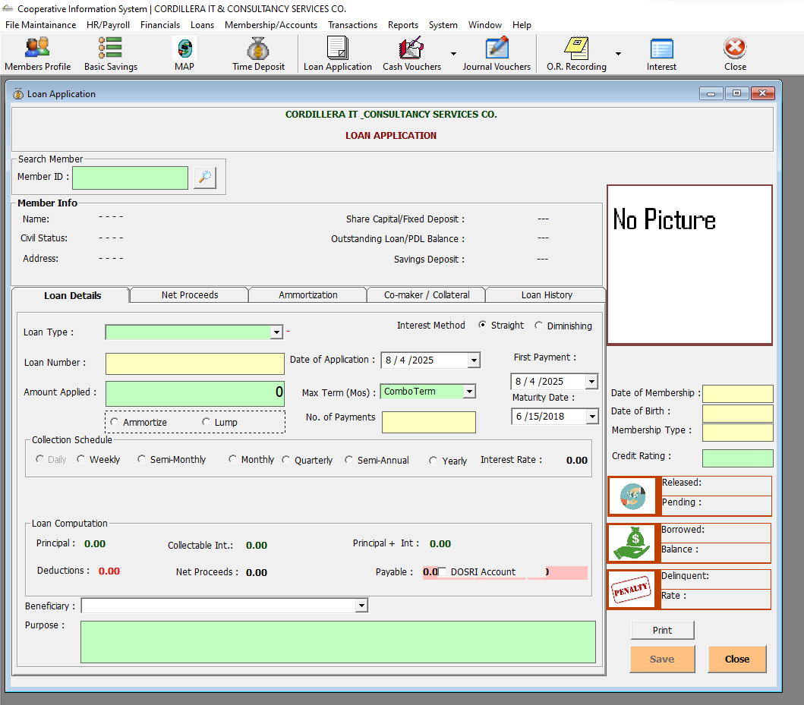

Cash Vouchers Icon-> Loans

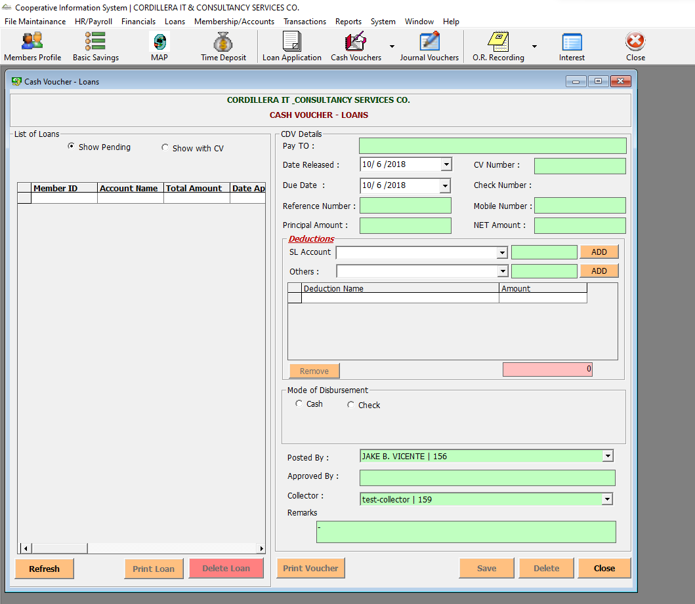

Cash Vouchers Icon-> Others

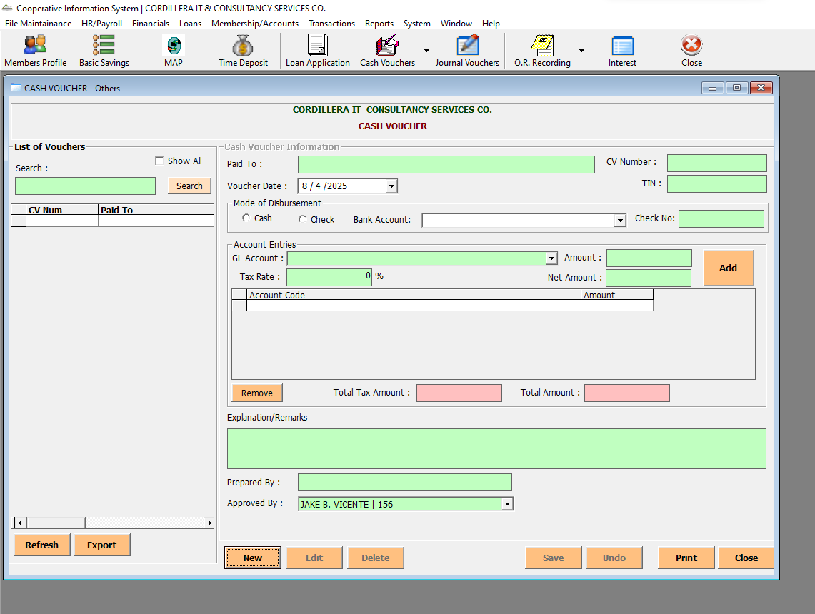

Cash Vouchers Icon-> Payroll

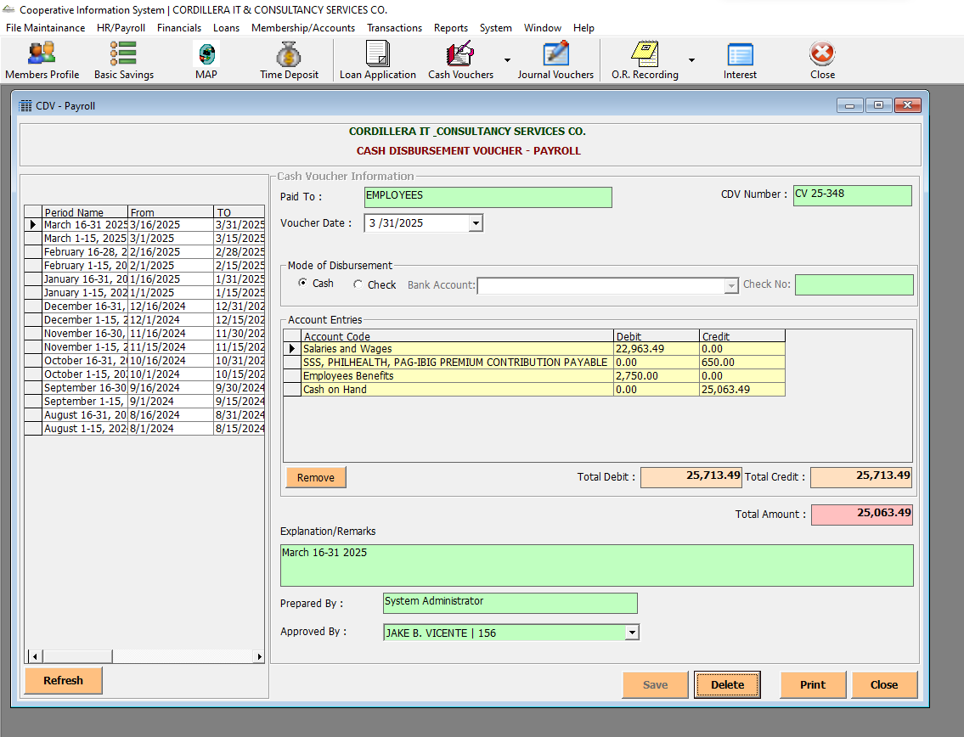

Cash Vouchers Icon-> Withdrawals

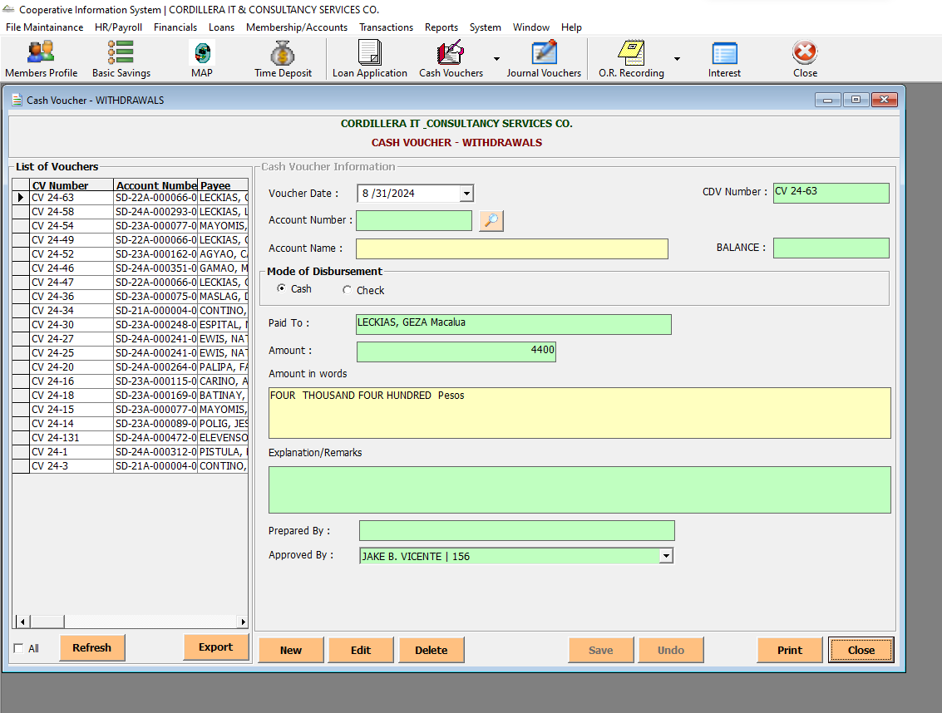

Cash Vouchers Icon-> MAP

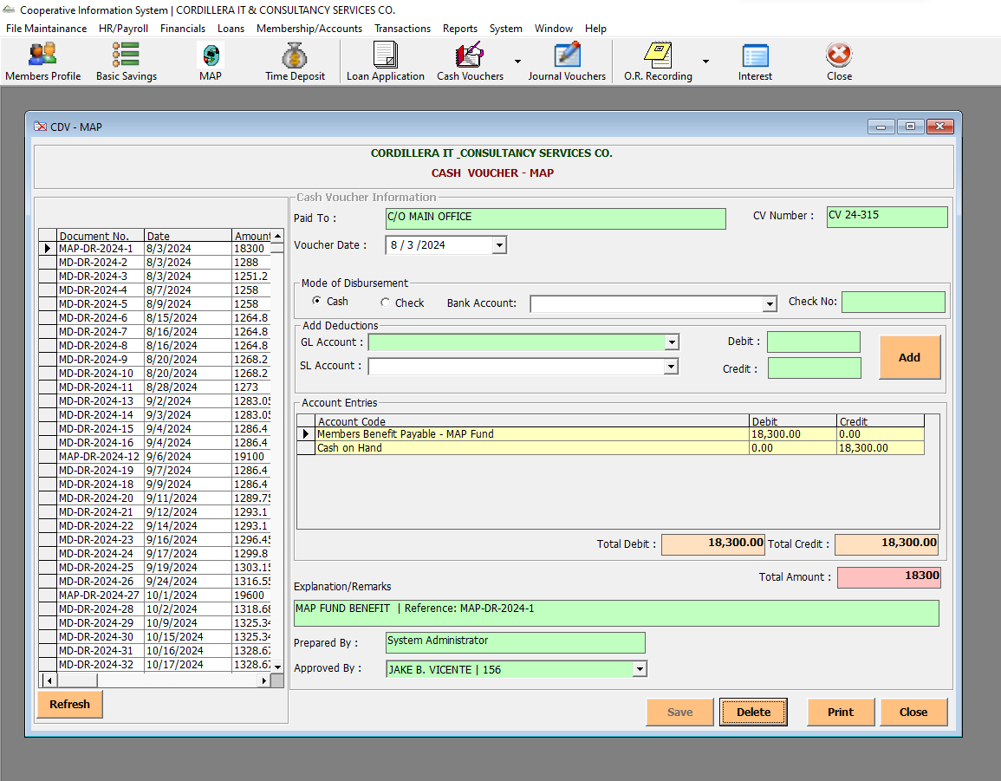

Journal Vouchers

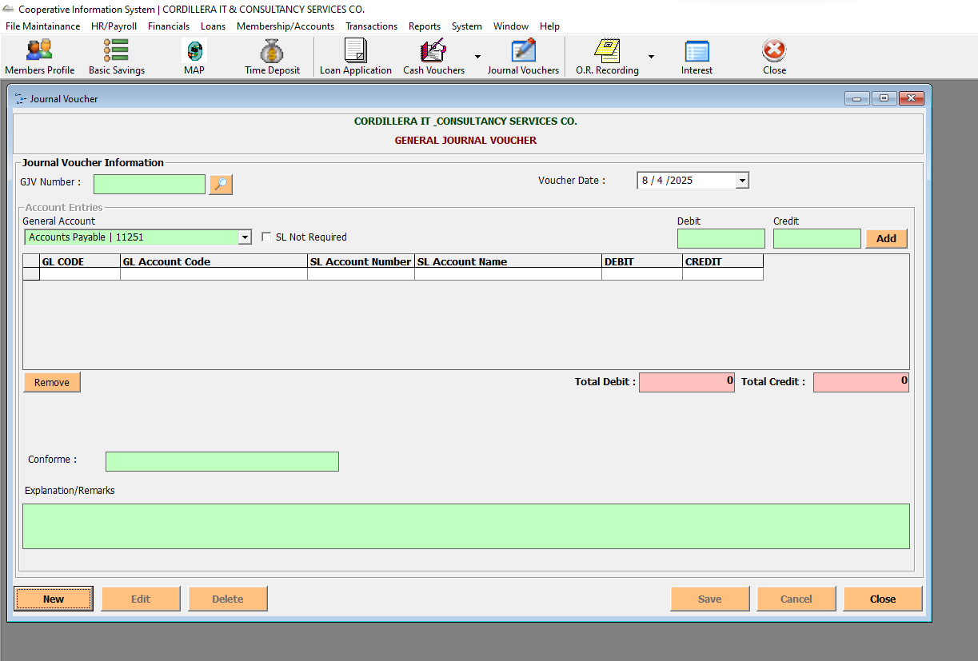

O.R. Recording-> Official Receipt

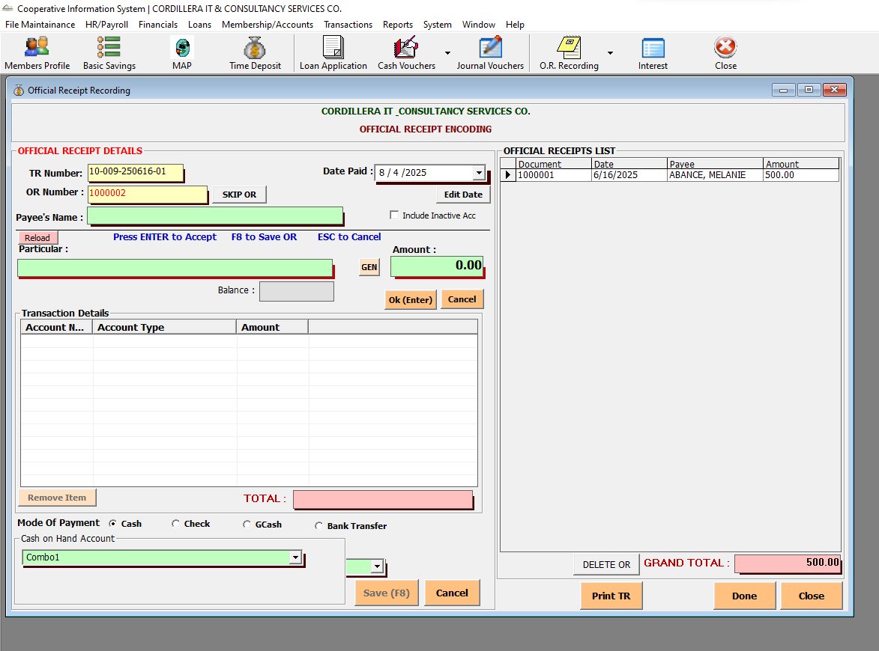

O.R. Recording-> Deposit Slip

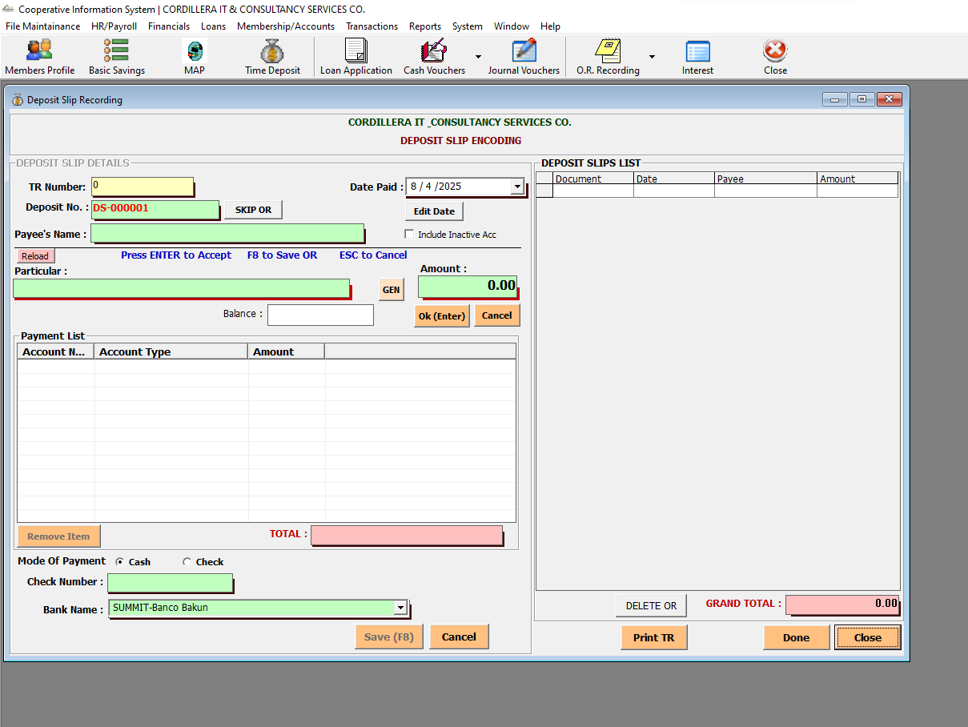

Interest

